**Phase 2: Analyzing the infrastructure of the monolithic application**

**Task 2.1: Verify that the monolithic application is available**

1. Configuration of EC2 instance hosting the monolithic web application:

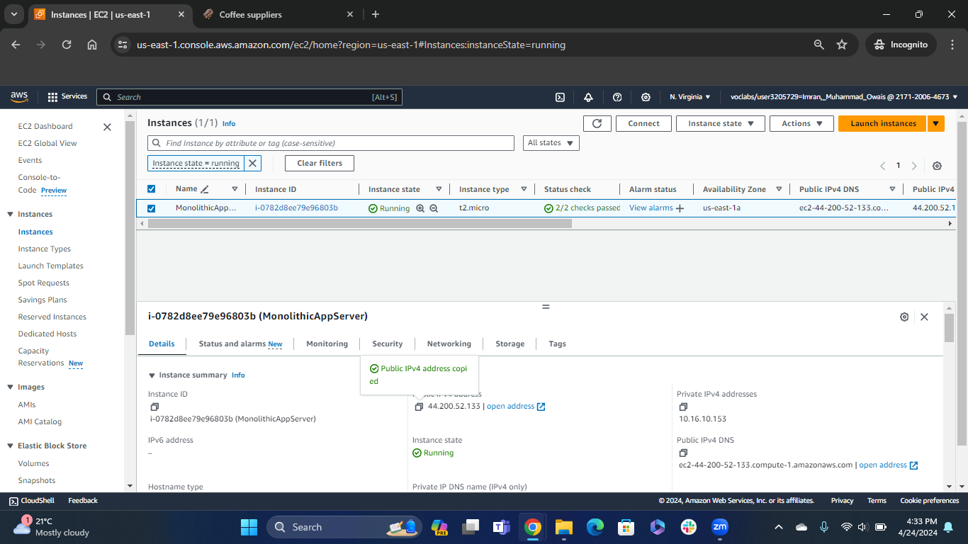

### **Task 2.2: Test the monolithic web application**

1. List of Suppliers Web Page of monolithic web application:

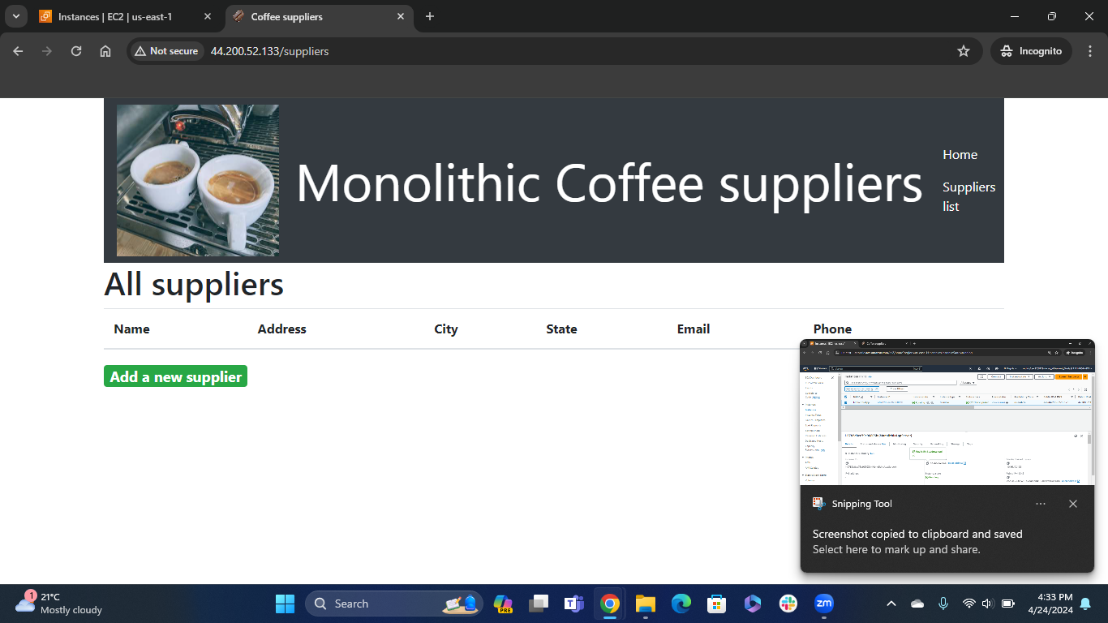

1. Adding a New Supplier:

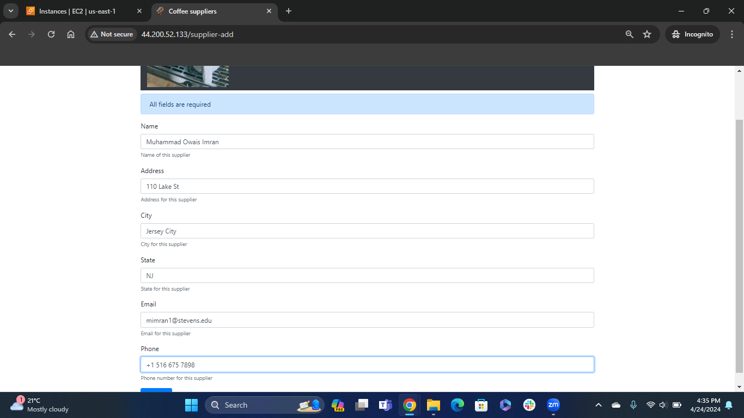

1. Verifying if the supplier is added to the monolithic web application:

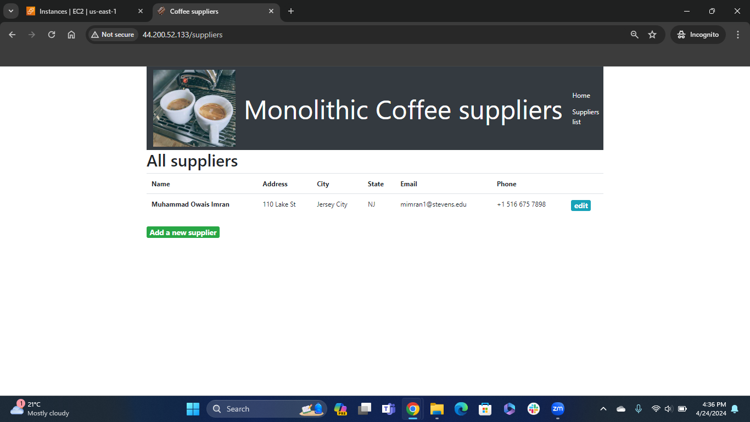

1. Editing the newly added supplier state from NJ to New Jersey to check Edit Functionality of Monolithic Web Application:

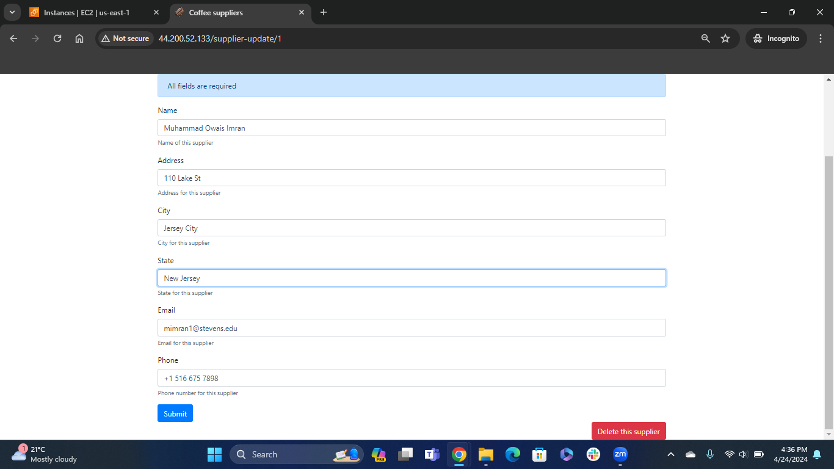

1. Verifying if the edit is saved successfully:

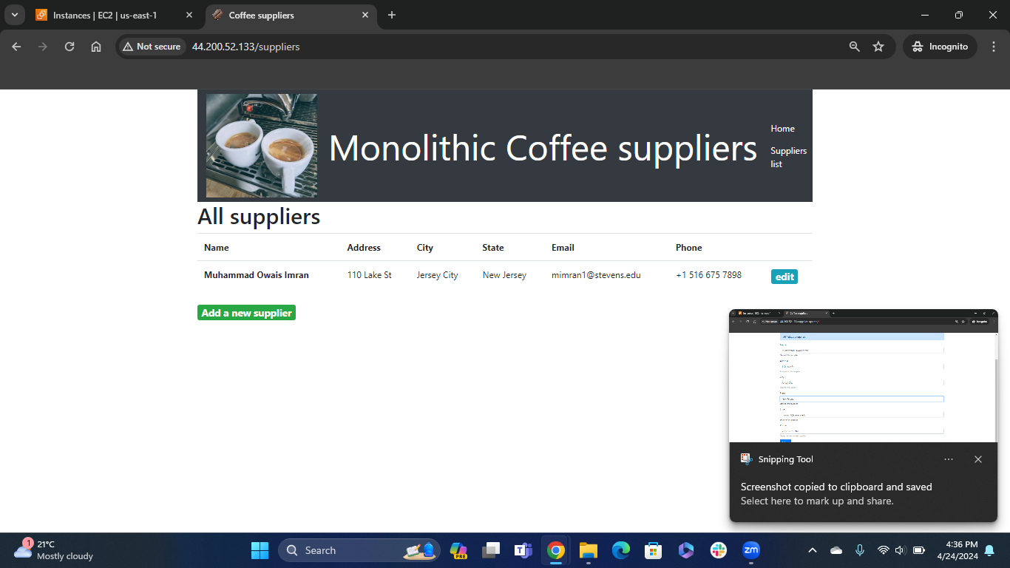

### **Task 2.3: Analyze how the monolithic application runs**

1. After connecting to the ec2 instance using AWS SSH Connect service.
2. Executing sudo lsof -i :80 , this command shows us the information of the application process executing on port 80

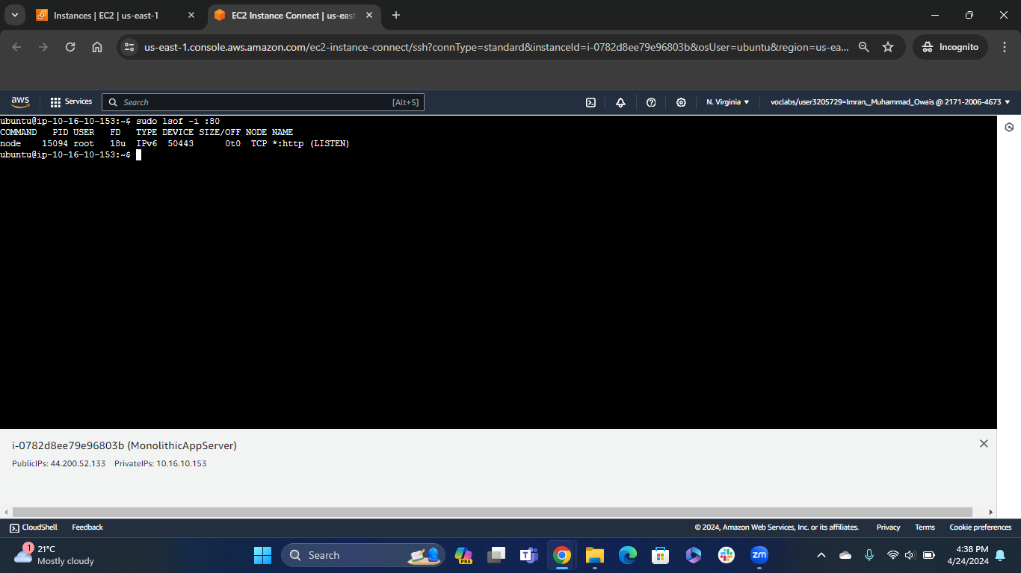

1. Executing ps -ef | head -1; ps -ef | grep node this command gives us the information of all pid involved with the process executing node, the PID of process being executed by root matches the PID returned in above step i.e. step 2 of task 2.3.

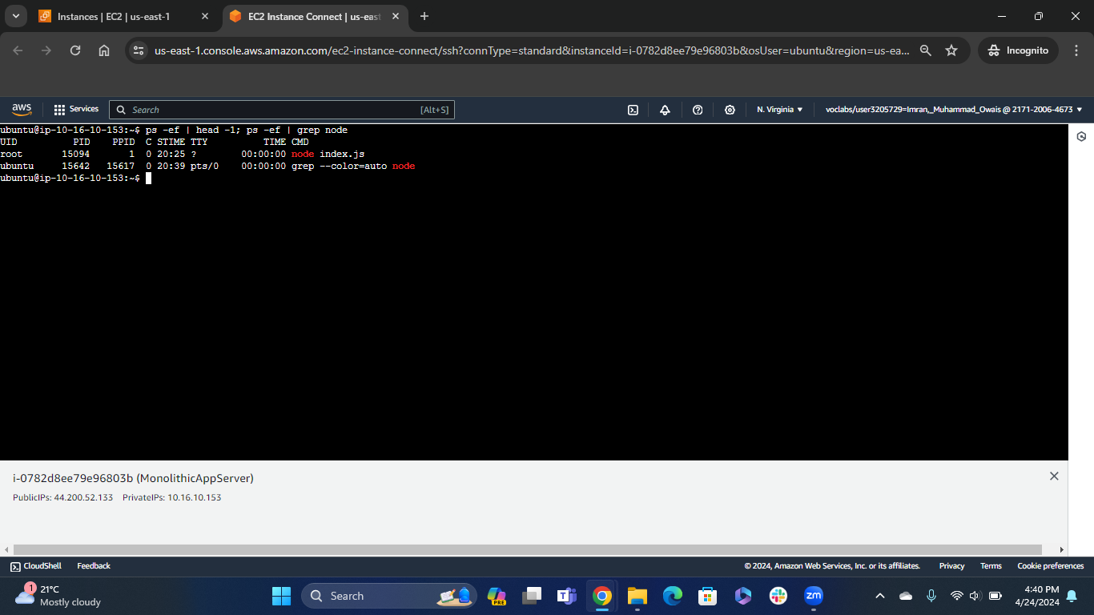

1. Analyzing the Monolithic Application file structure:

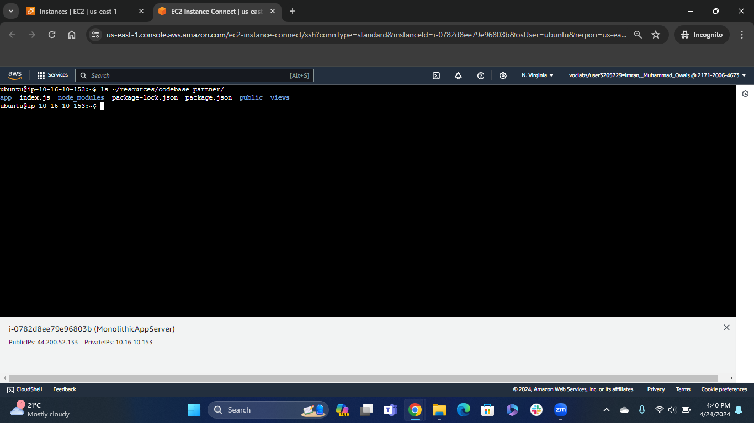

Based on the current analysis, we can conclude that a system command is configured to be executed on the ec2 instance which runs the node application as root process on port 80 of the ec2 instance. The application is configured to store data into some remote database.

1. Connecting to MySQL instance to analyze the data by getting the RDS endpoint and exploring the contents present in the database.

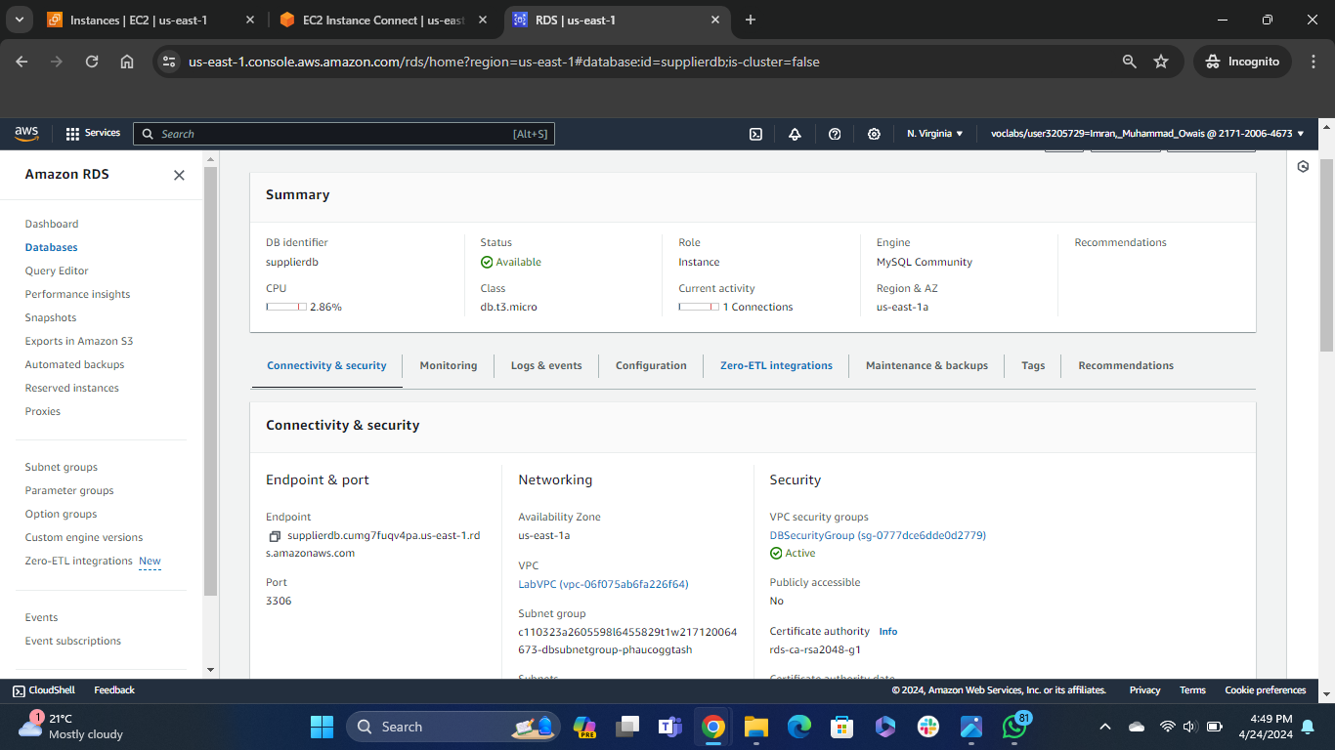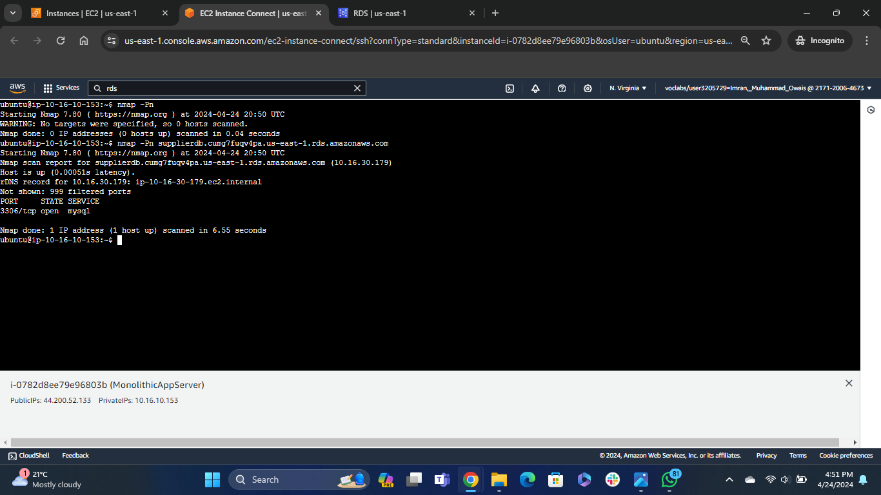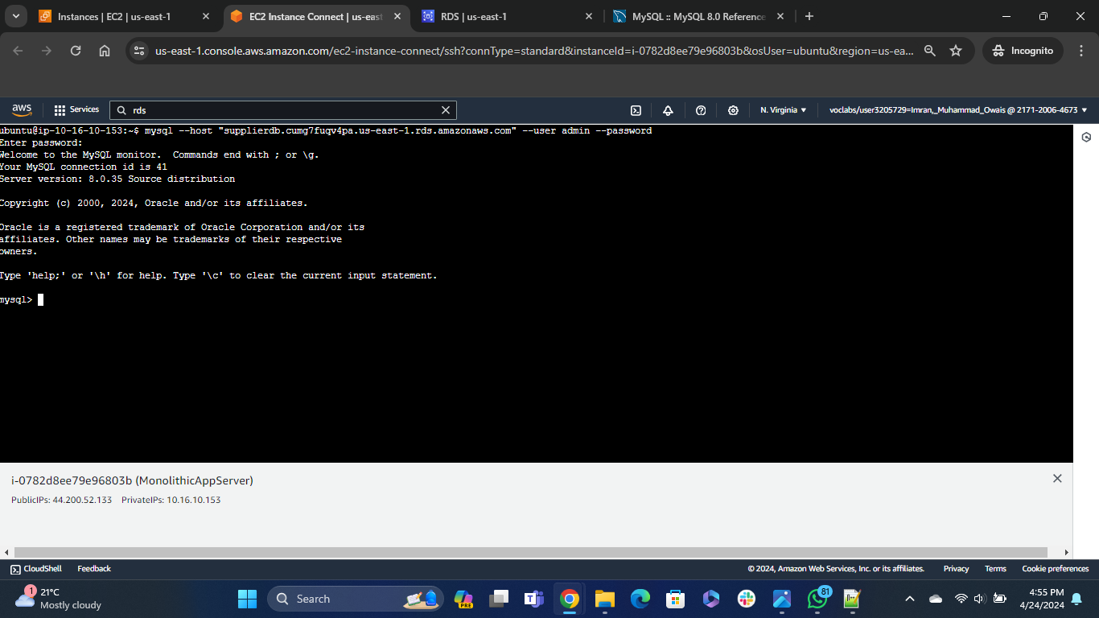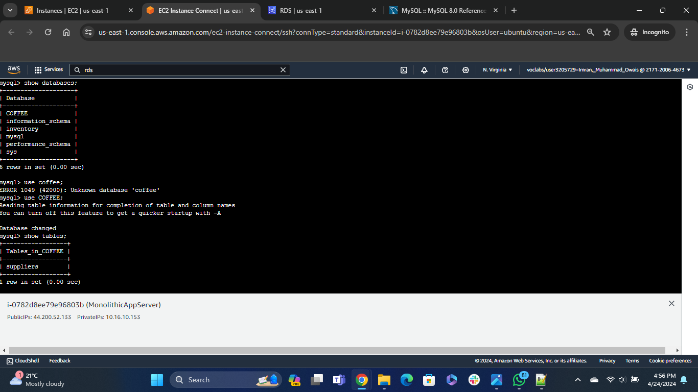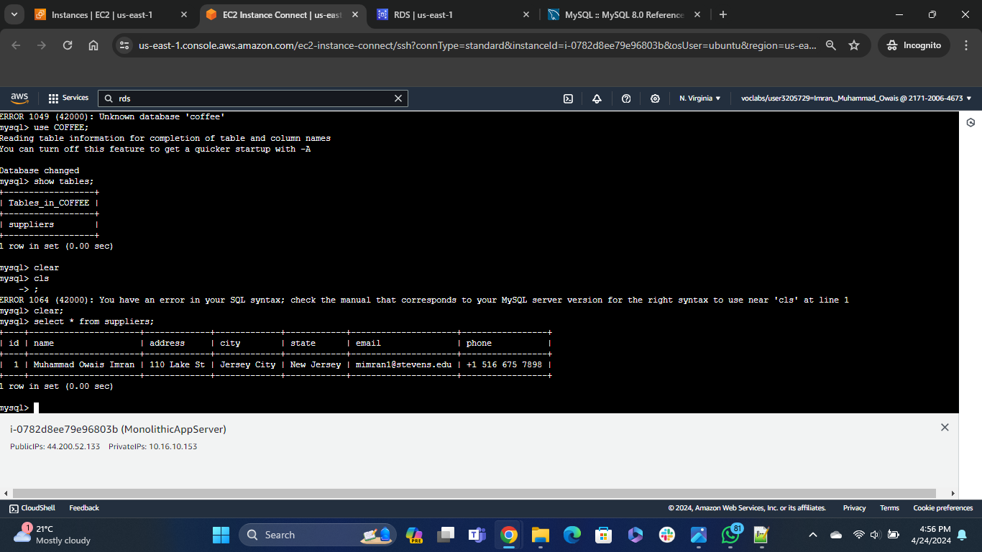

### **Significance & Importance of this Task**

This task helps in determining:

* How the monolithic application works
* Possible ways to identity core services of the monolithic application
* Possible ways to break system into multiple microservices by knowing their dependencies on each other and their workflow pattern

## **Phase 3: Creating a development environment and checking code into a Git repository**

### **Task 3.1: Create an AWS Cloud9 IDE as your work environment**

1. Creating an AWS Cloud9 IDE, and observing the configuration of launched EC2 instance by the Cloud IDE.

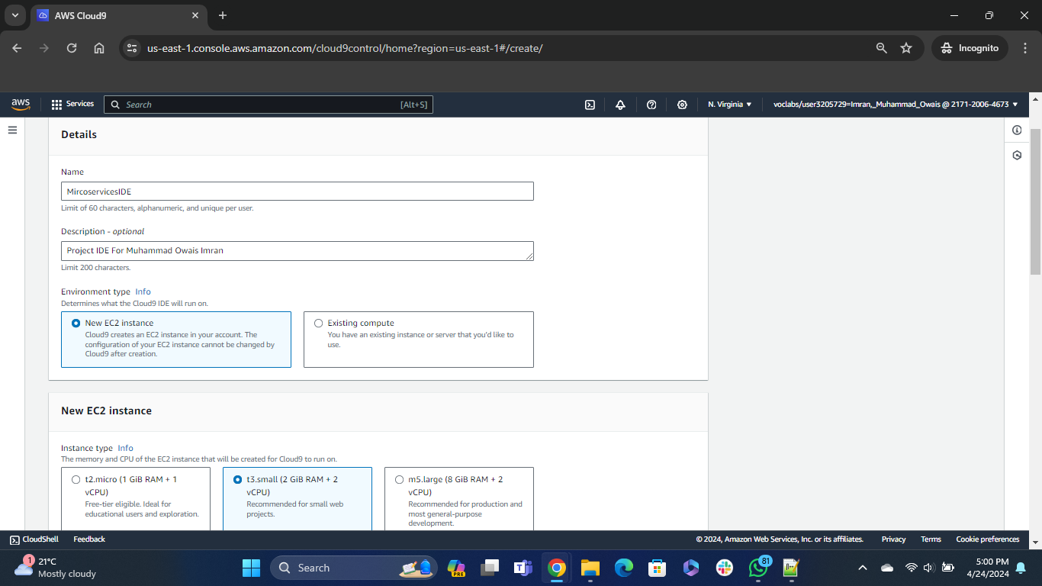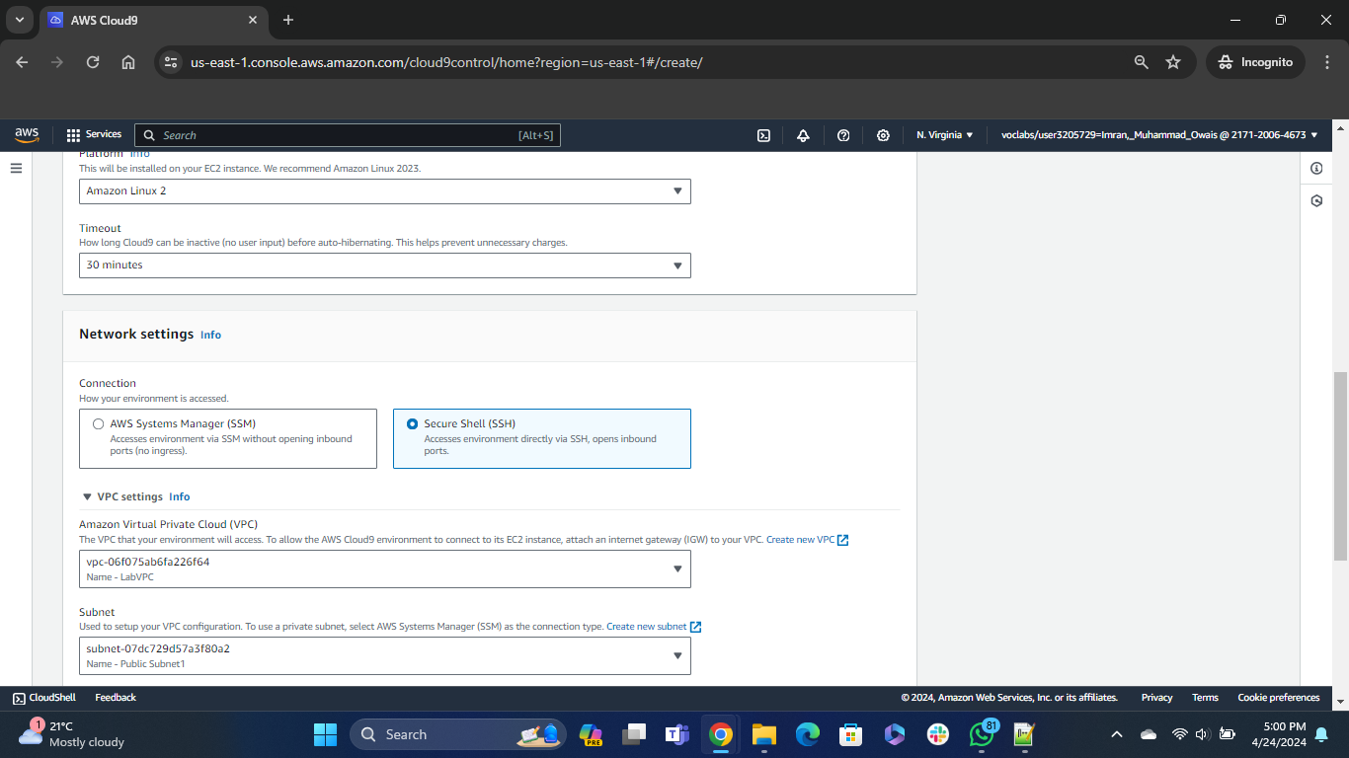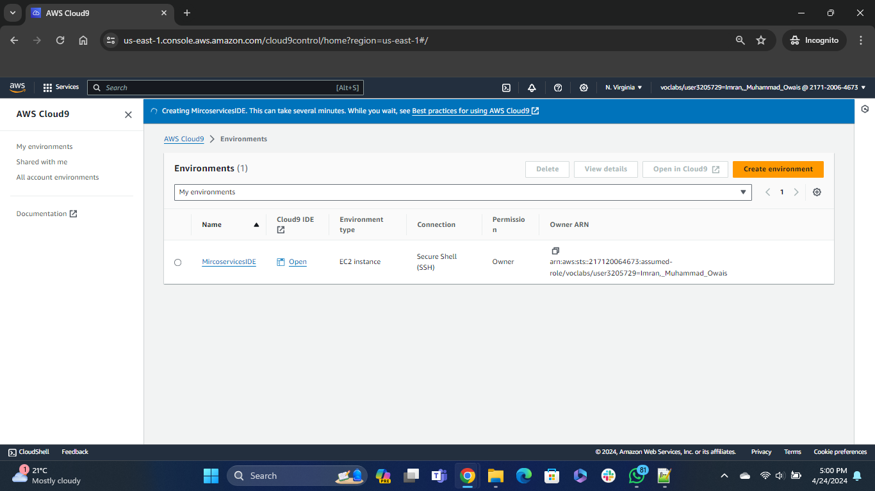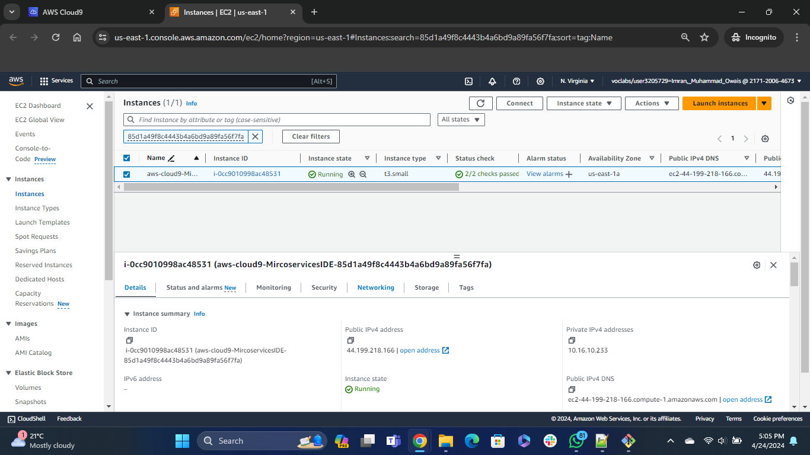

### **Task 3.2: Copy the application code to your IDE**

1. Create a temp directory in Cloud9 IDE, and copying the codebase of Monolithic application by uploading the KeyPair for connecting with the monolithic application ec2 instance to the Cloud9 instance, and the use of scp to copy all the files.

Following commands were executed to complete the said task:

* Download the KeyPair to the local system and uploaded it to cloud9
* Change the permissions of KeyPair file to make it executable using chmod 400 ./labsuser.pem
* scp -r -i ~/environment/labsuser.pem ubuntu@$appServerPrivIp:/home/ubuntu/resources/codebase_partner/* ~/environment/temp/

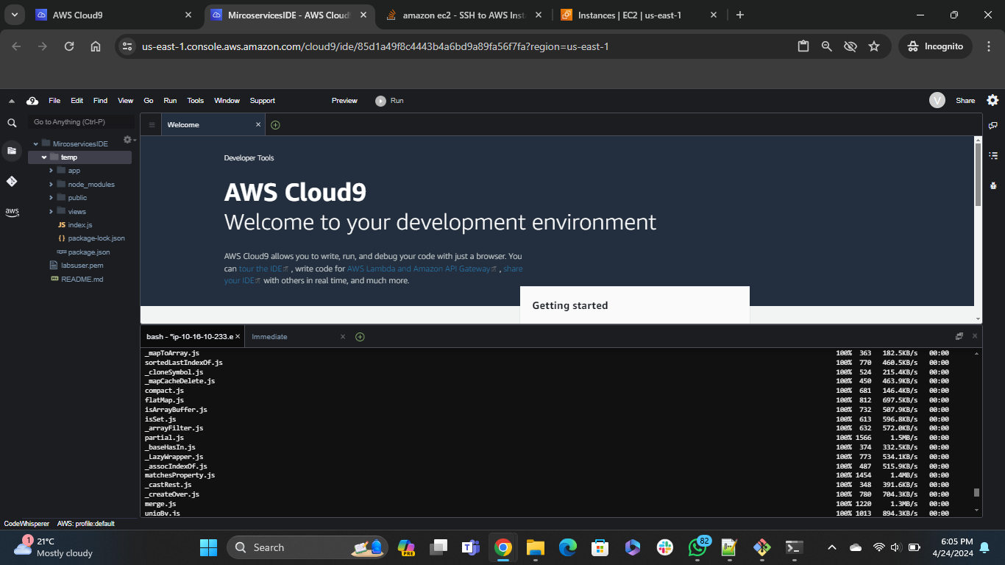

All files of Monolithic Web Application are now copied to the temp directory of Cloud9 IDE.

### **Task 3.3: Create working directories with starter code for the two microservices**

Execute the following commands to complete this task:

* cd ~/environment
* mkdir microservices && cd microservices
* mkdir customer, employee
* cd customer && cp -r ./../temp/* ./ && cd ./../
* cd employee && cp -r ./../temp/* ./ && cd ./../
* rm -rf temp

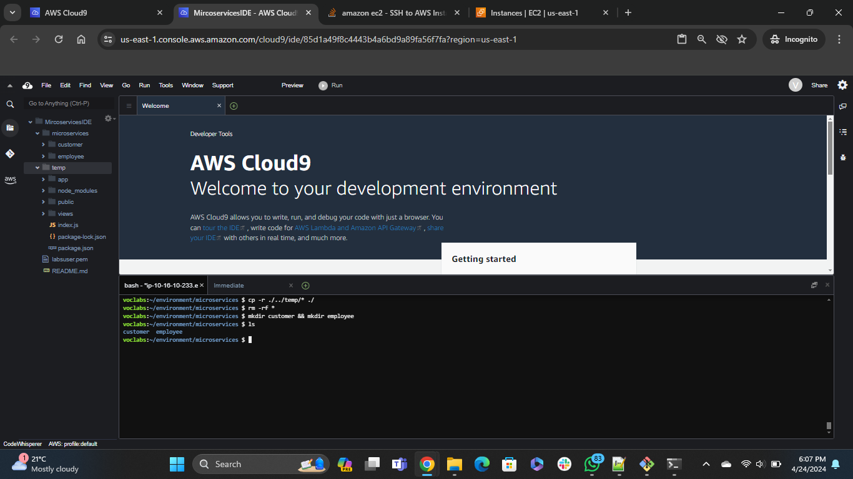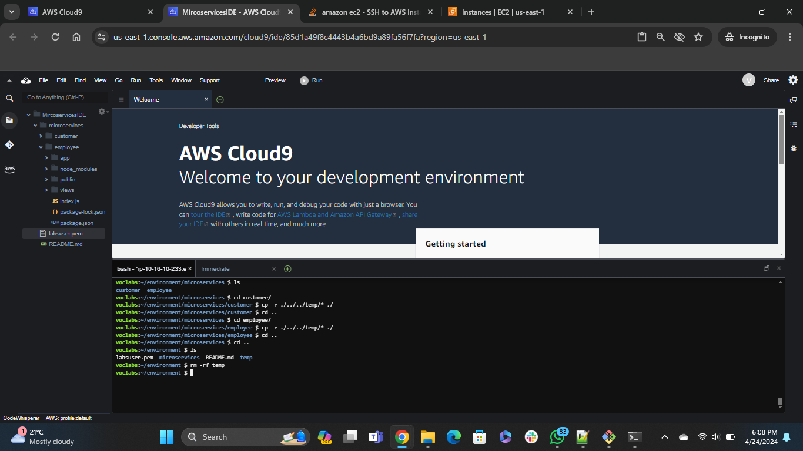

### **Task 3.4: Create a Git repository for the microservices code and push the code to CodeCommit**

1. Create a code commit repository by the name of “microservices” and verifying if code commit repository is created.

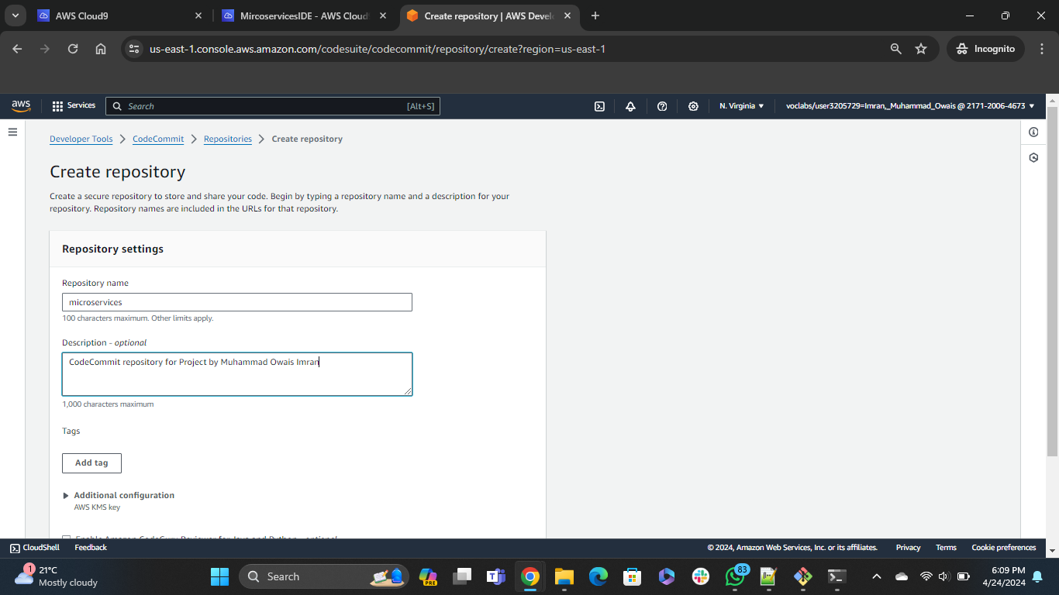

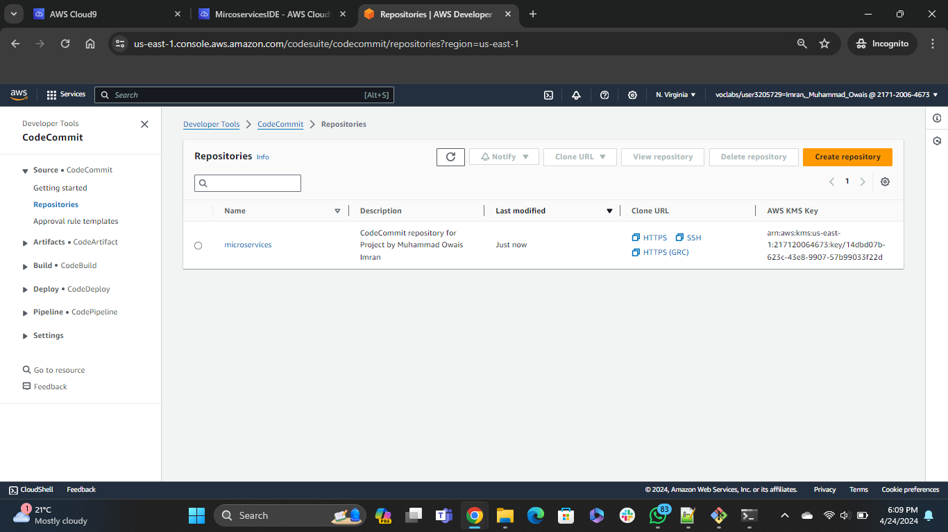

1. Executing the following commands to configure this as a git repository on Cloud9 IDE:

* git init
* git branch -m dev
* git add .
* git commit -m “two unmodified copies of the application code”
* git remote add origin REMOTE_URL_COPY
* git push origin -u dev
* git config –-global user.name “MUHAMMAD_OWAIS_IMRAN”
* git config –-global user.email [mimran1@stevens.edu](mailto:mimran1@stevens.edu)

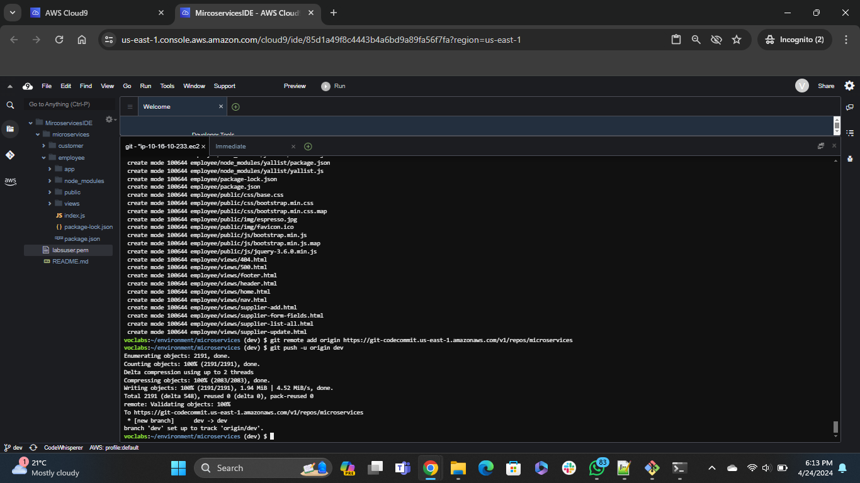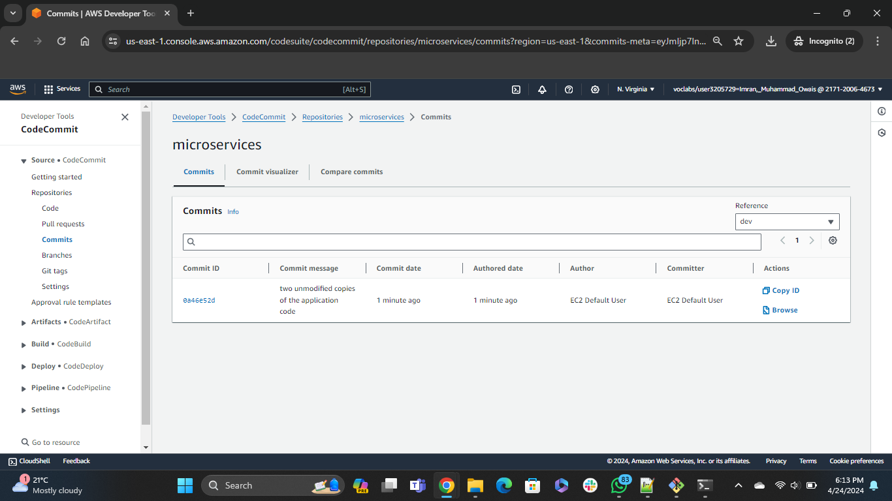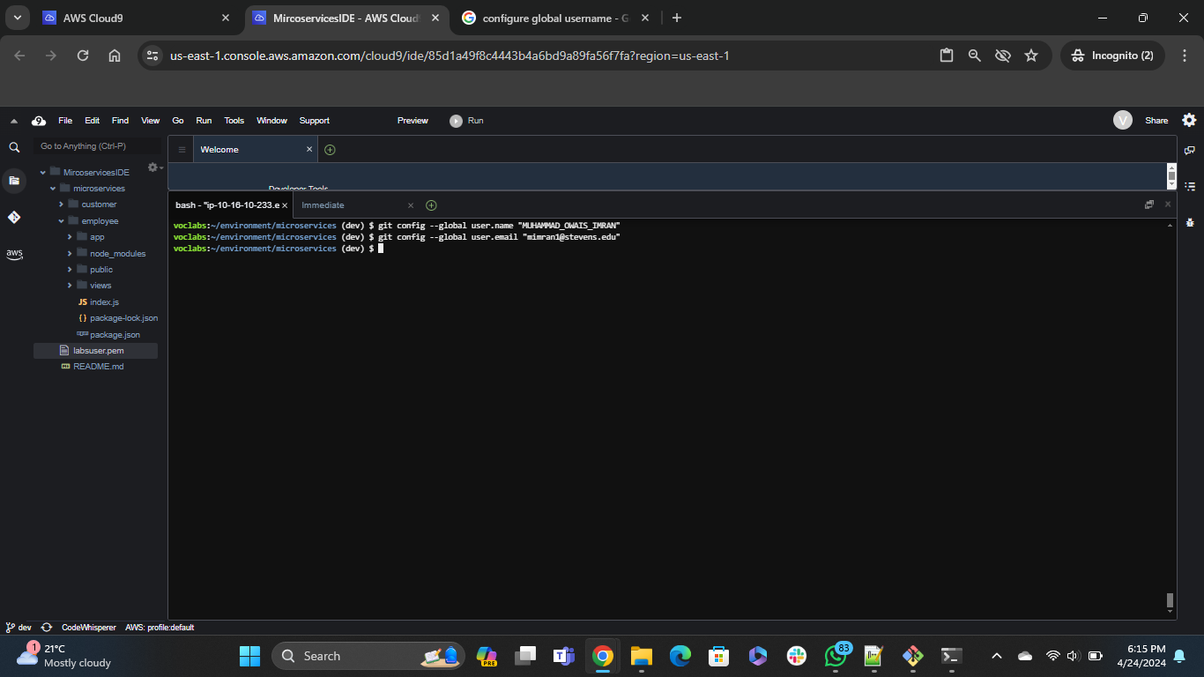

### **Significance & Importance of this Task**

This task helps us to determine:

* How cloud-based IDE can help in code sharing
* How to use Git for version control and code control
* Use case for AWS Cloud9 and CodeCommit

## **Phase 4: Configuring the application as two microservices and testing them in Docker containers**

### **Task 4.1: Adjust the AWS Cloud9 instance security group settings**

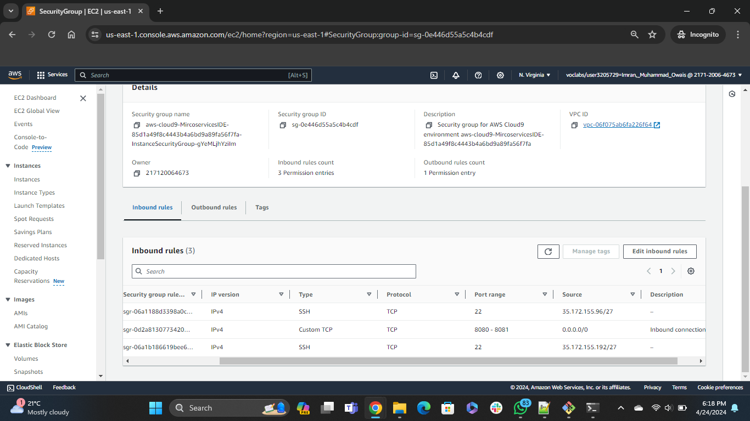

### **Task 4.2: Modify the source code of the customer microservice**

1. Edit the customer/app/controller/supplier.controller.js file so that the remaining functions provide only the read-only actions that you want customers to be able to perform.
2. Edit the customer/app/models/supplier.model.js file. Delete the unnecessary functions in it so that what remains are only read-only functions.
3. Later in the project, when you deploy the microservices behind an Application Load Balancer, you will want employees to be able to navigate from the main customer page to the area of the web application where they can add, edit, or delete supplier entries. To support this, edit the customer/views/nav.html file
4. You don't want customers to see the Add a new supplier button or any edit buttons next to supplier rows. To implement these changes, edit the customer/views/supplier-list-all.html file
5. Because the customer microservice doesn't need to support read-write actions, DELETE the following .html files from the customer/views directory
6. Edit the customer/index.js file as needed to account for the fact that the node application will now run on Docker containers

Screenshots of all steps attached:

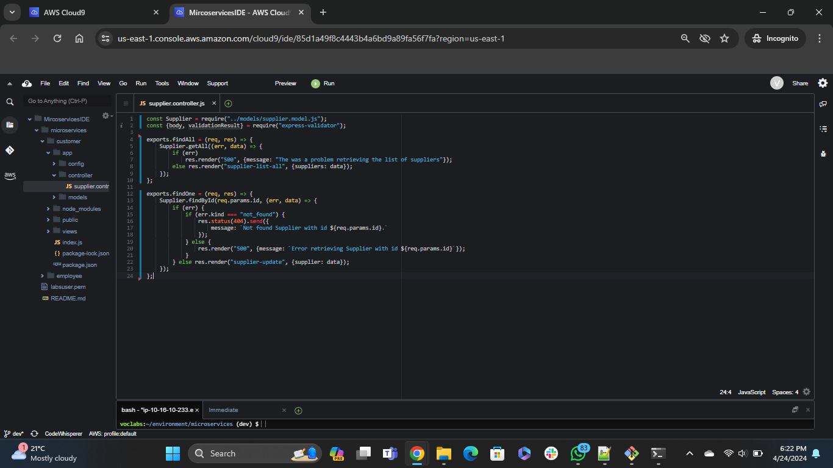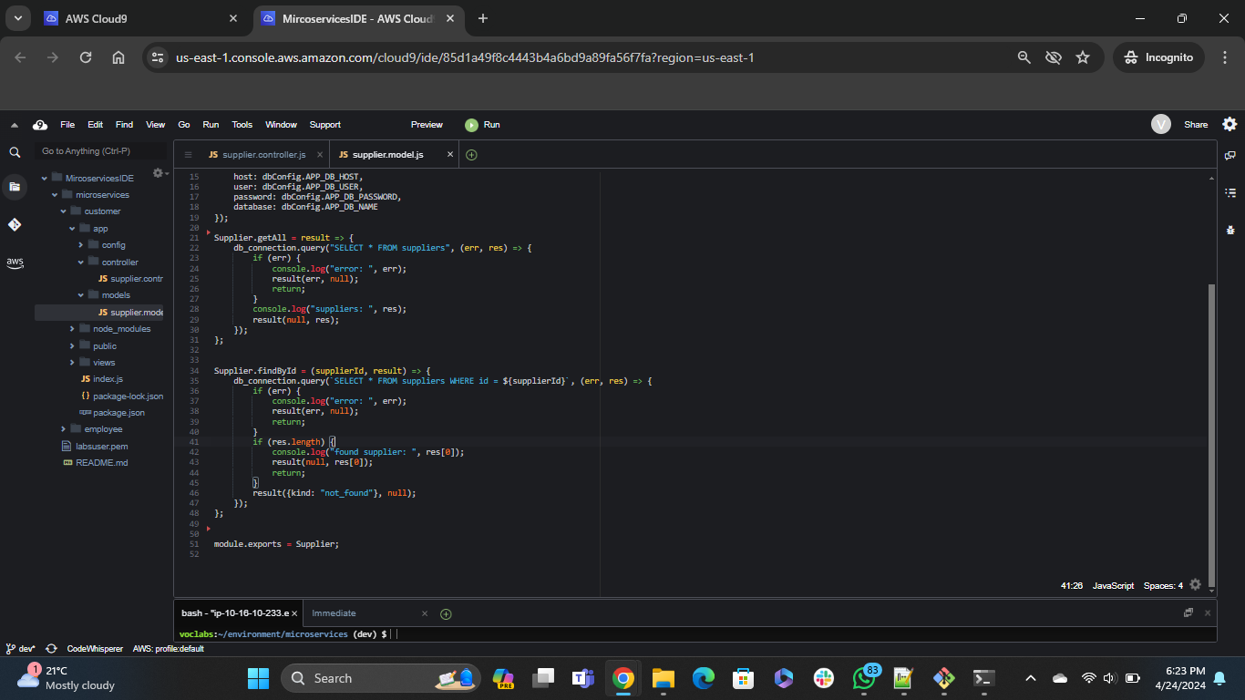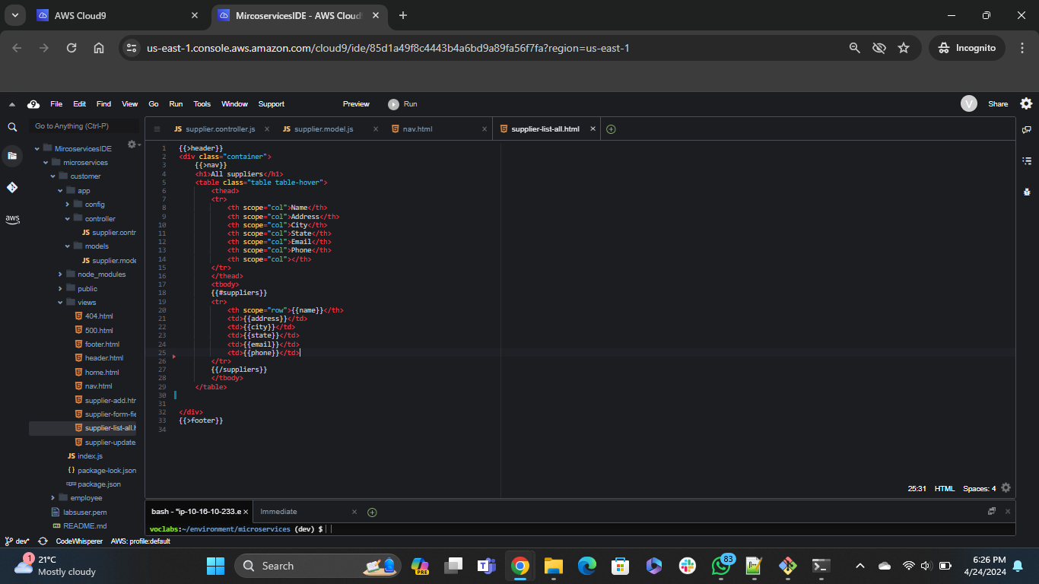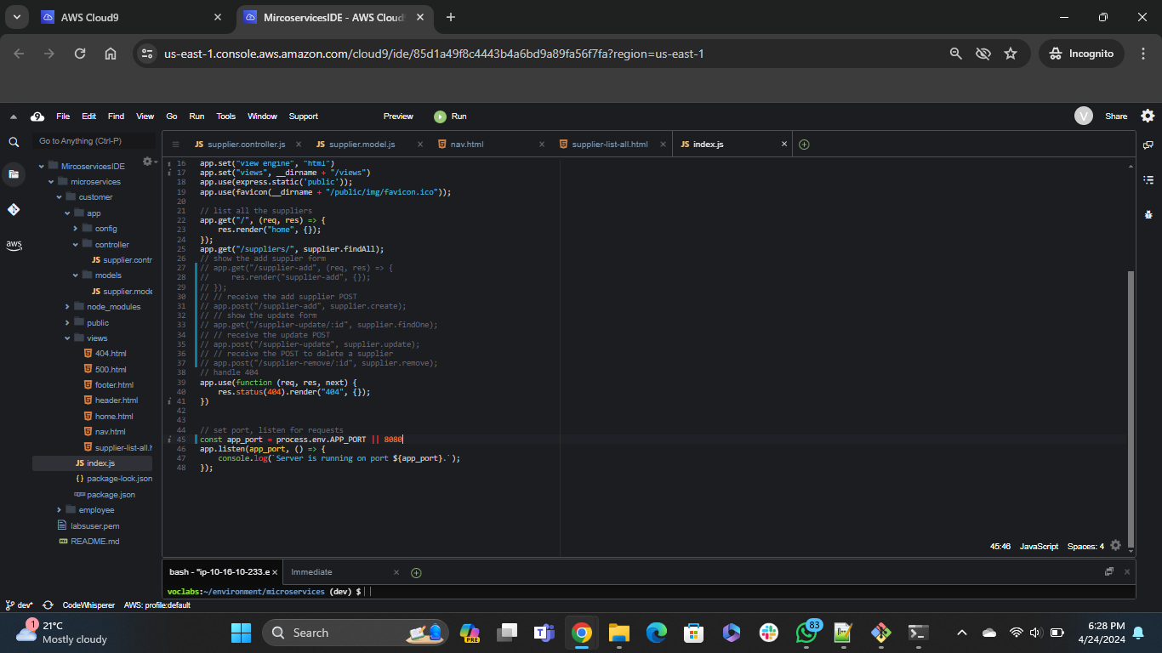

### **Task 4.3: Create the customer microservice Dockerfile and launch a test container**

1. Create a Dockerfile for customer, Build it, run to launch a test container, and test the application if customer microservice is working as expected.

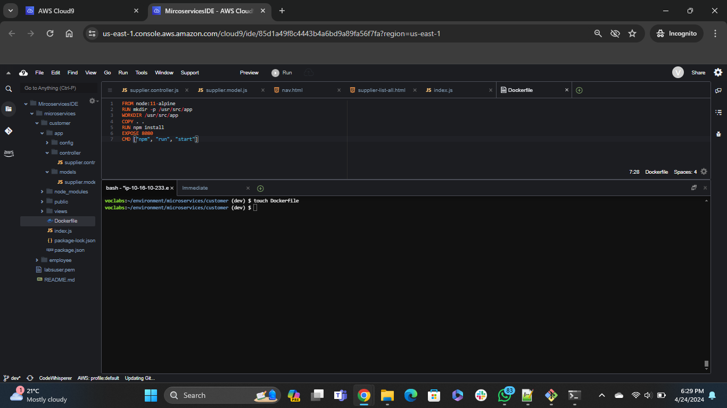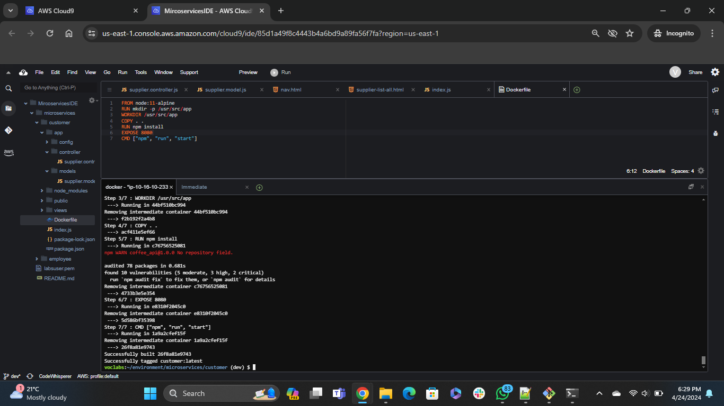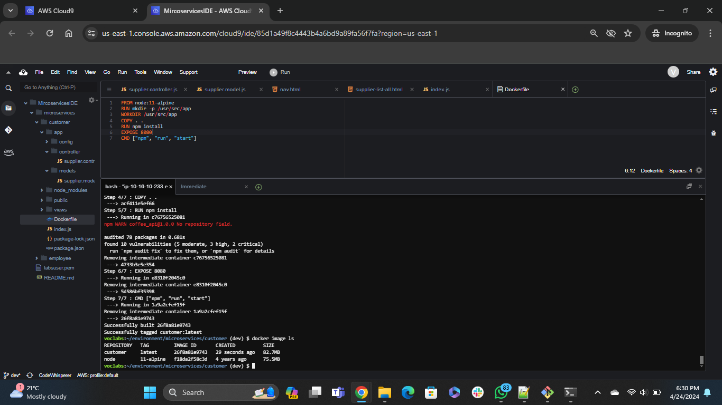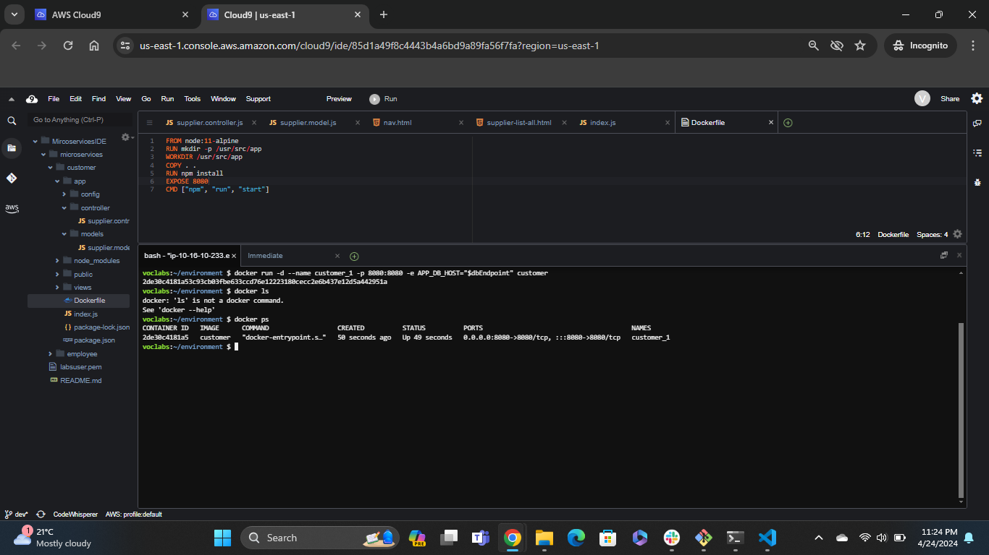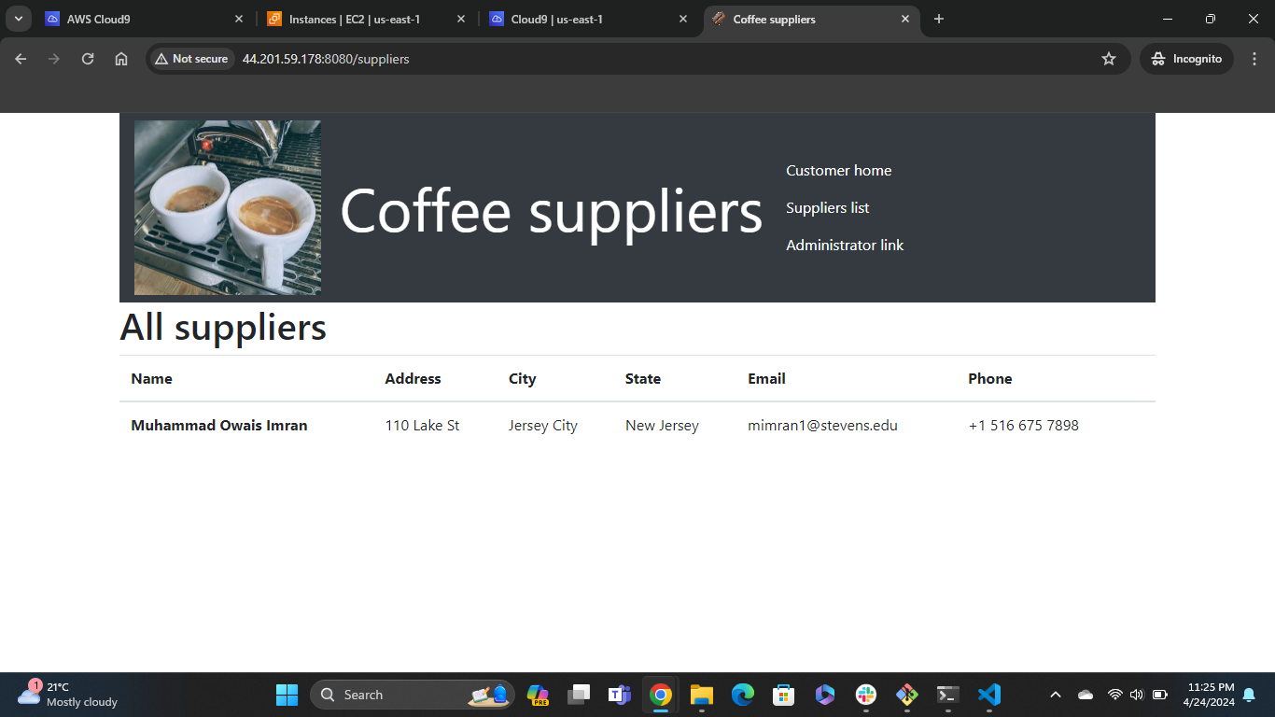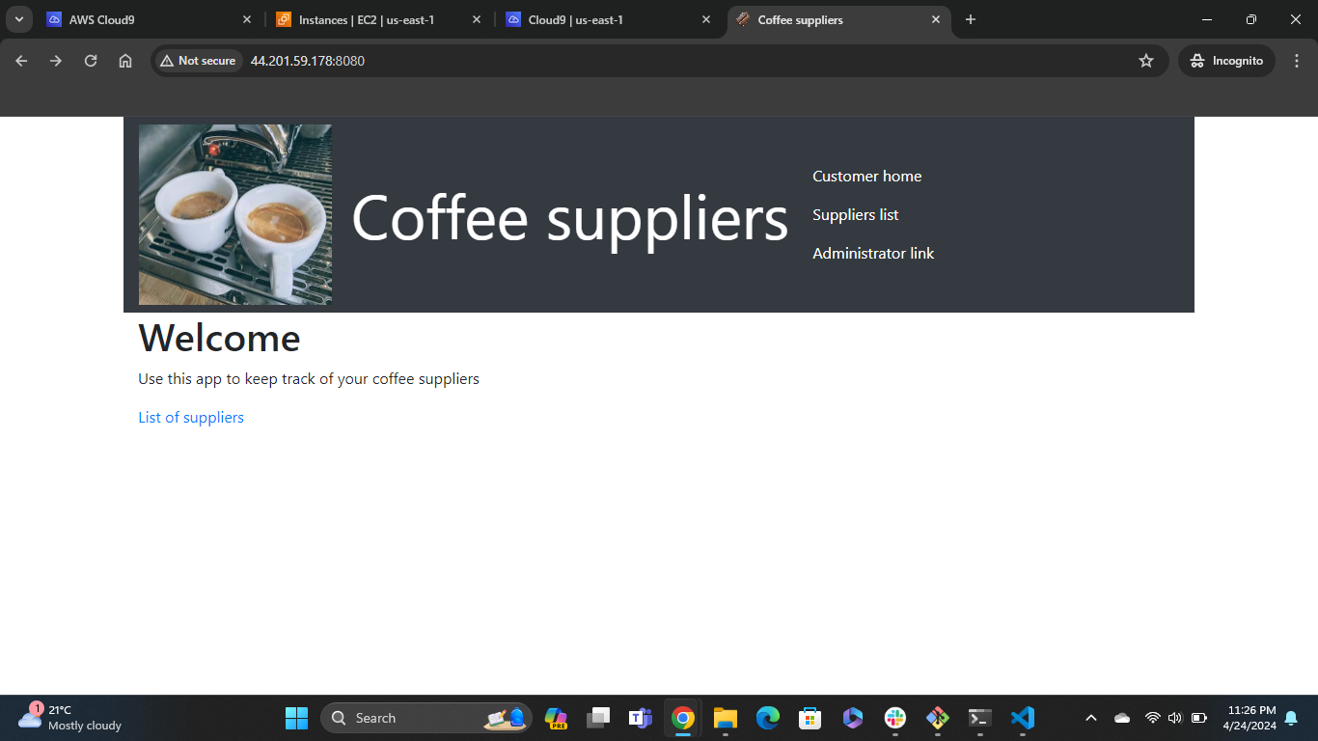

1. Commit the code onto Github and verify if it is updated on Codecommit

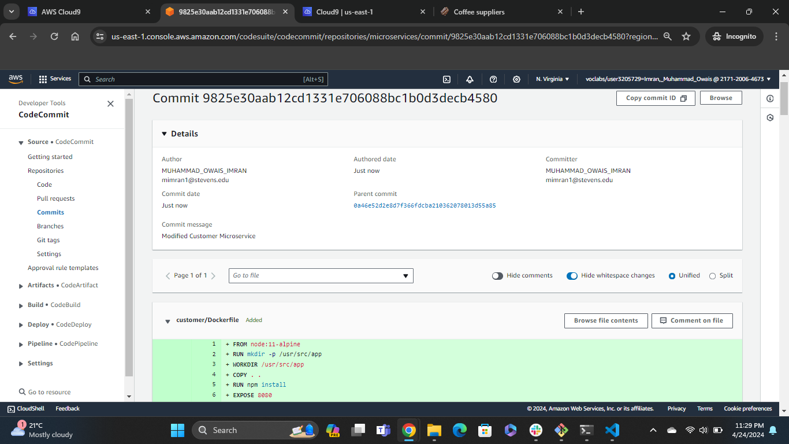

### **Task 4.4: Modify the source code of the employee microservice**

1. In the employee/app/controller/supplier.controller.js file, for all the redirect calls, prepend /admin to the path
2. In the employee/index.js file, update the app.get calls, app.post calls, and a port number
3. In the employee/views/supplier-add.html and employee/views/supplier-update.html files, for the form action paths, prepend /admin to the path
4. n the employee/views/supplier-list-all.html and employee/views/home.html files, for the HTML paths, prepend /admin to the path.
5. In the employee/views/header.html file, modify the title to be Manage coffee suppliers
6. Edit the employee/views/nav.html file.

Screenshots of all steps attached below:

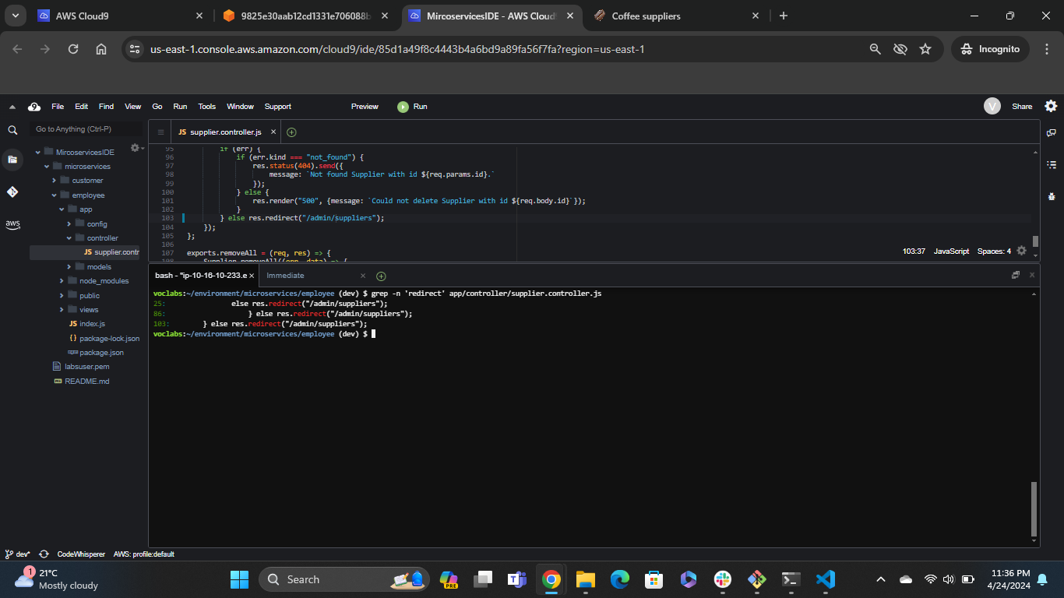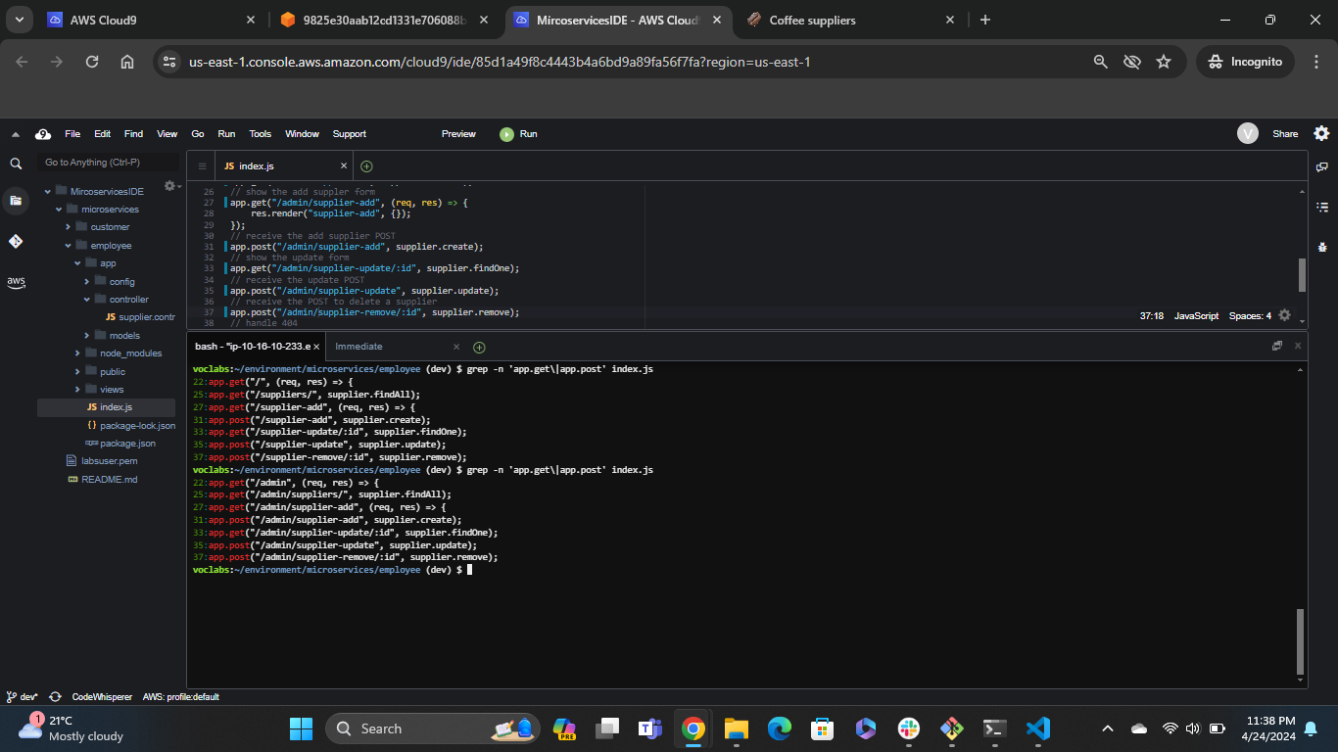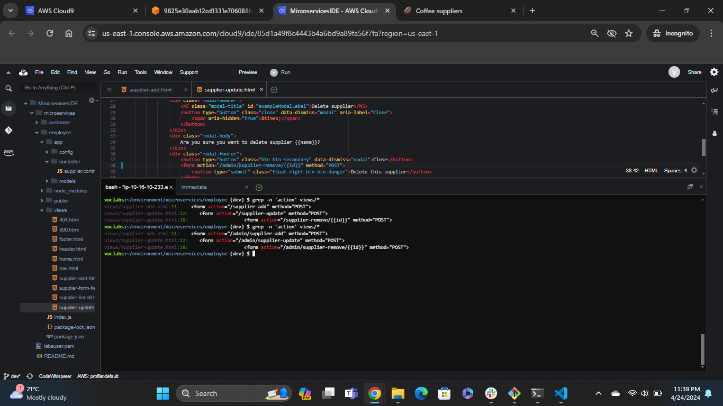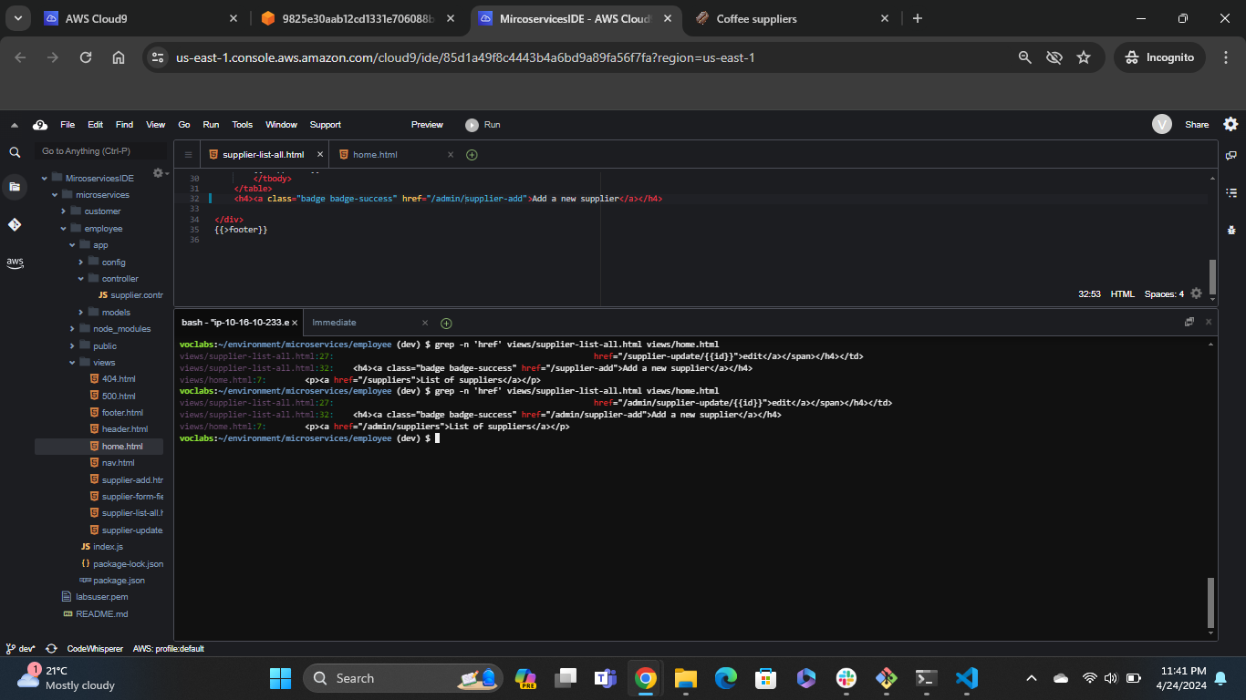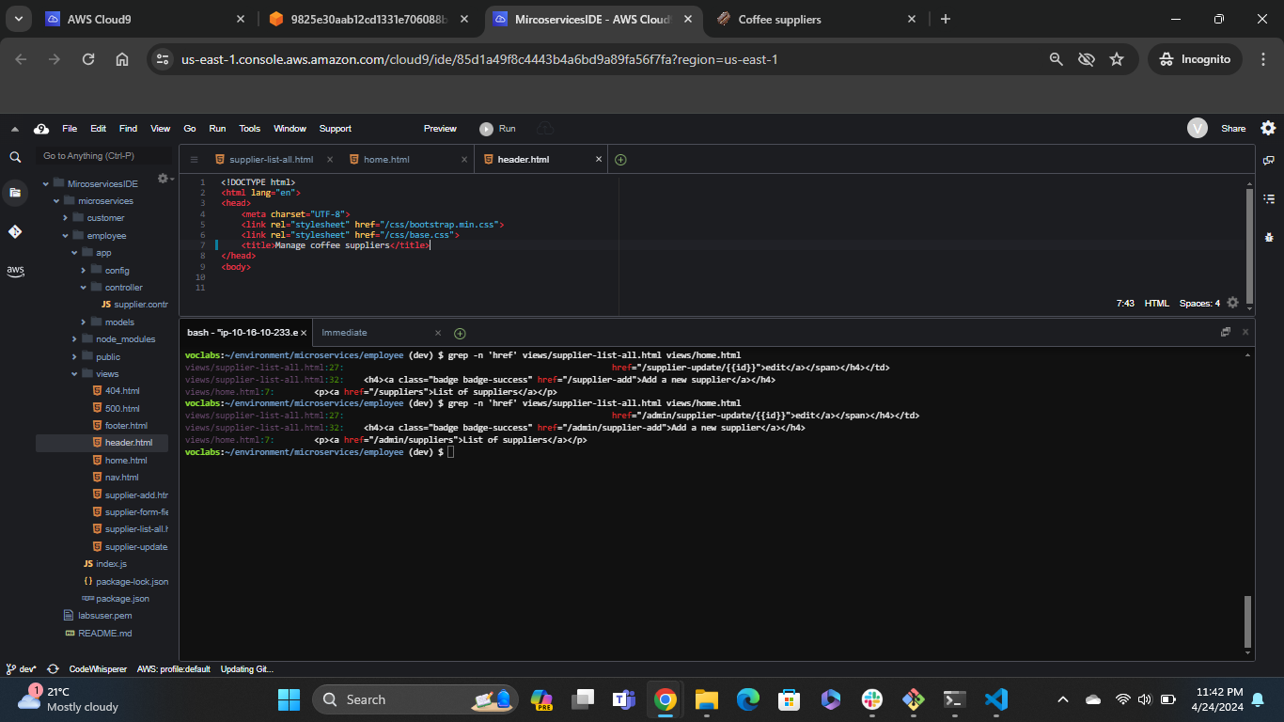

### **Task 4.5: Create the employee microservice Dockerfile and launch a test container**

Create a Dockerfile for employee, Build it, run to launch a test container, and test the application if employee microservice is working as expected.

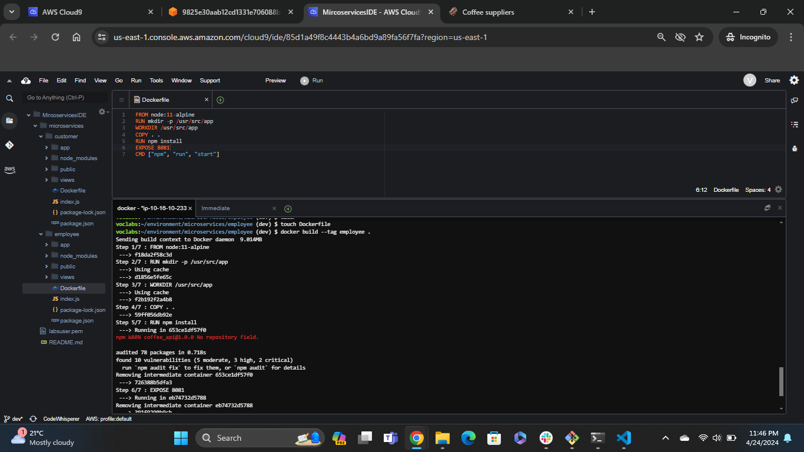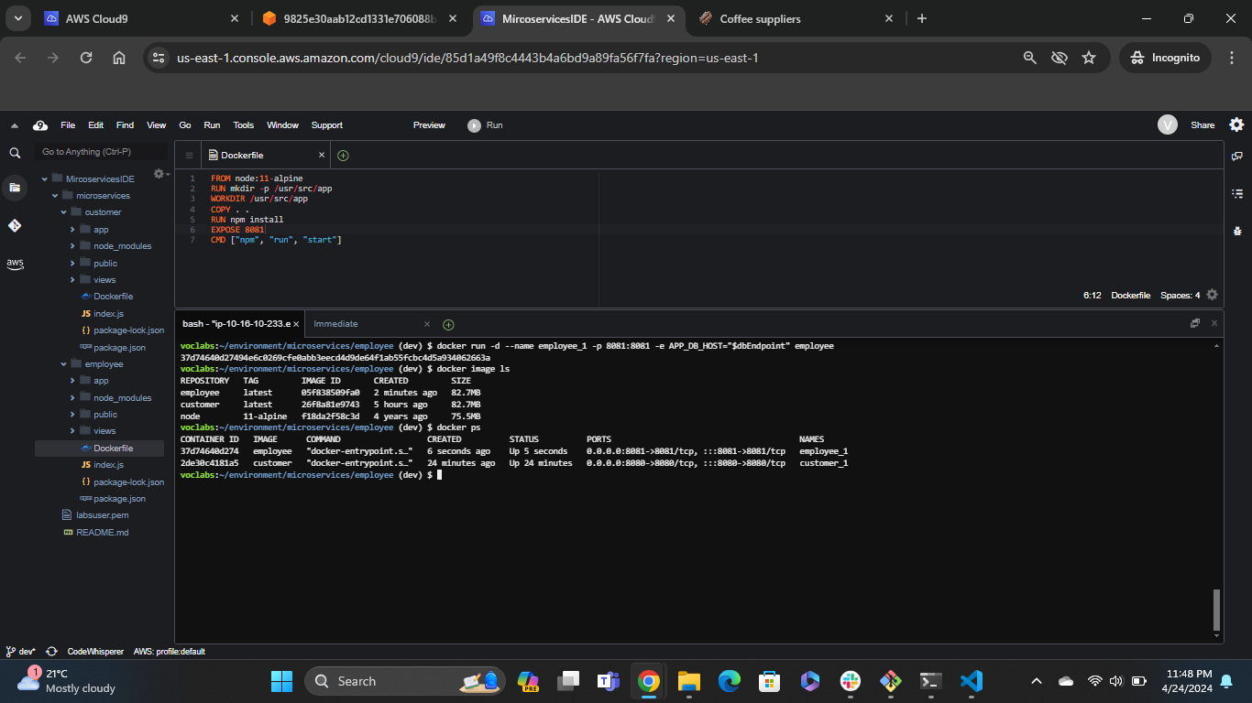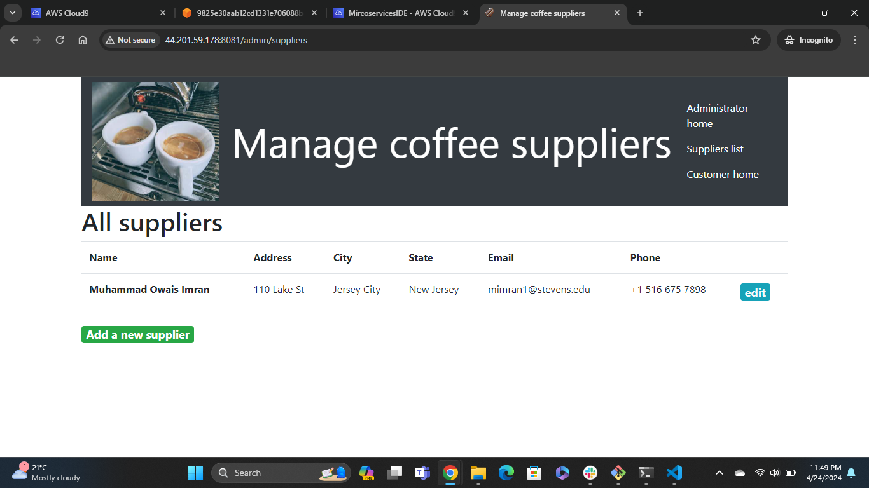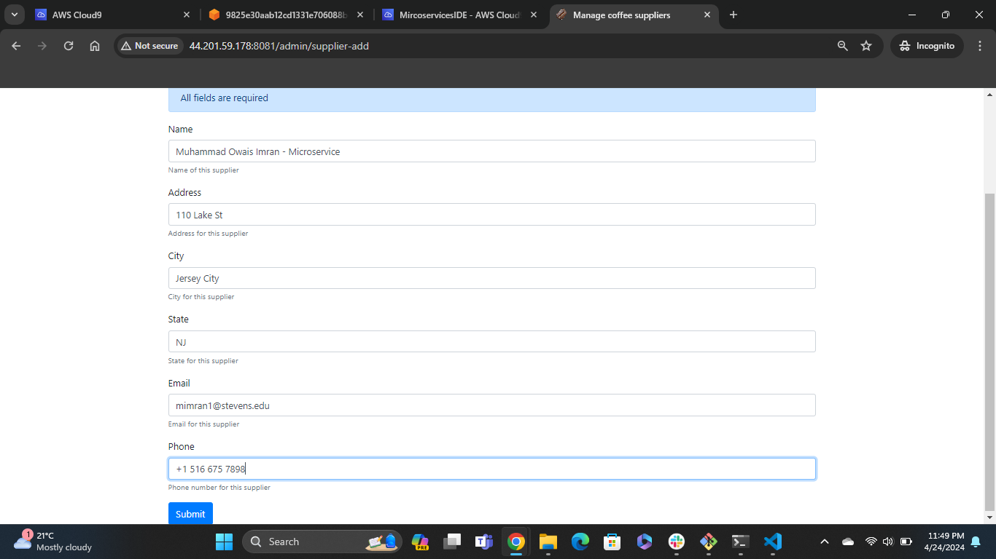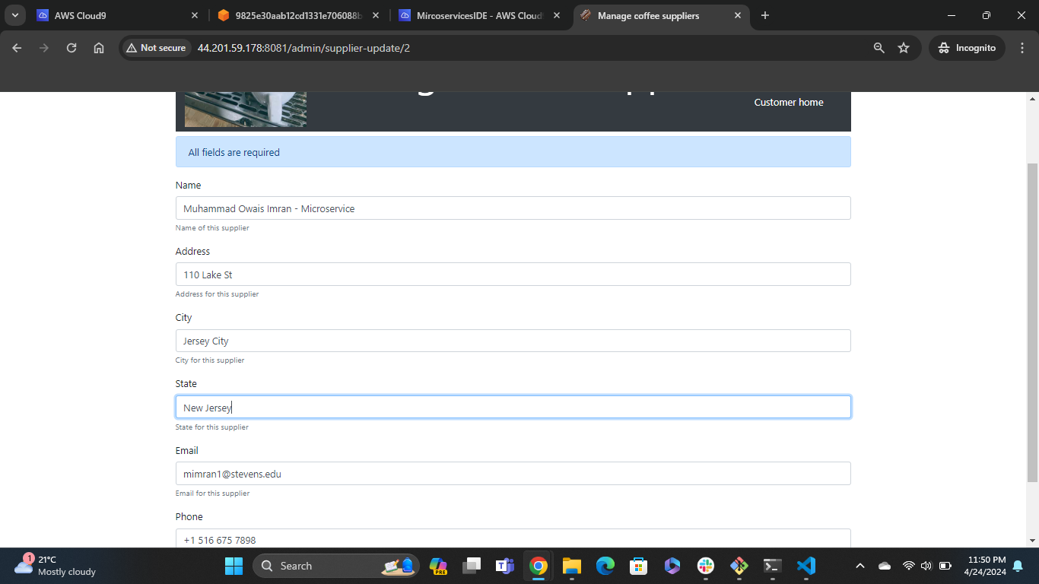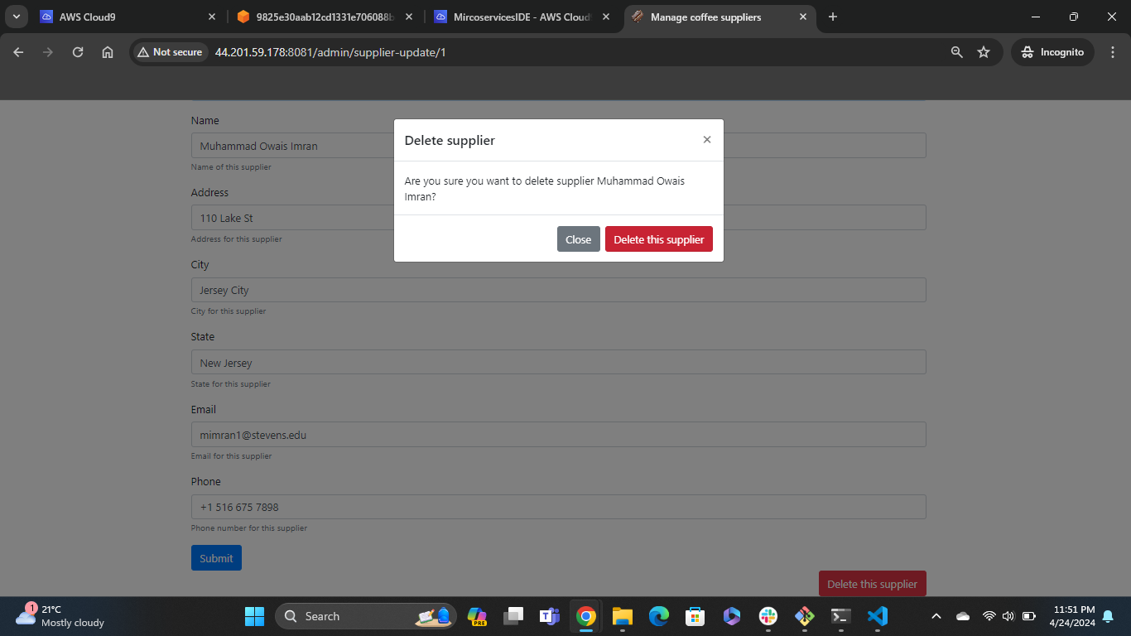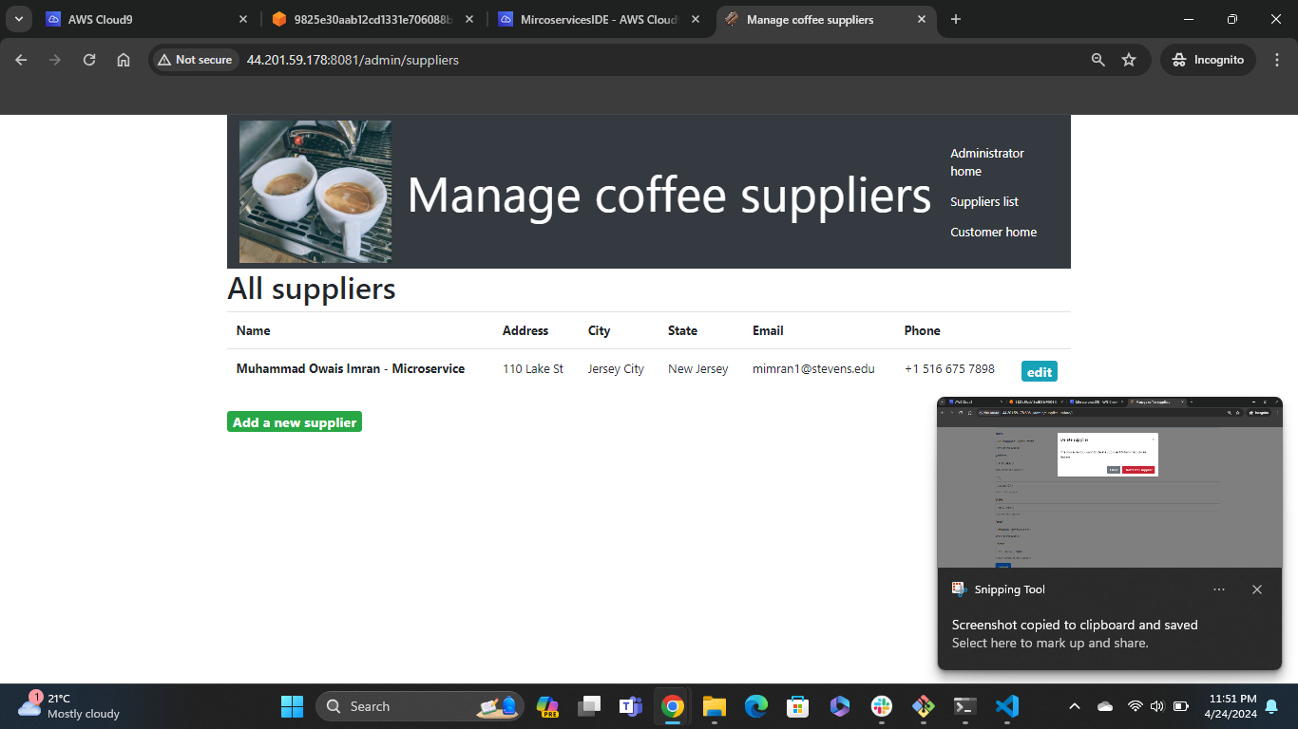

Verifying the status of all the containers with the command docker ps:

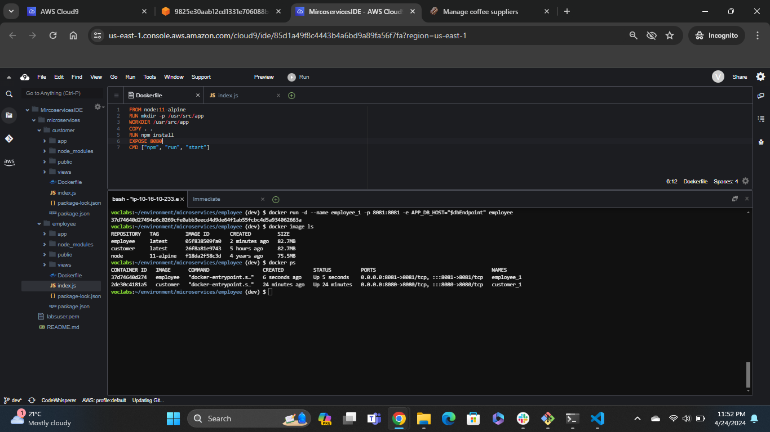

### **Task 4.6: Adjust the employee microservice port and rebuild the image**

1. Edit the employee/index.js and employee/Dockerfile files to change the port from 8081 to 8080

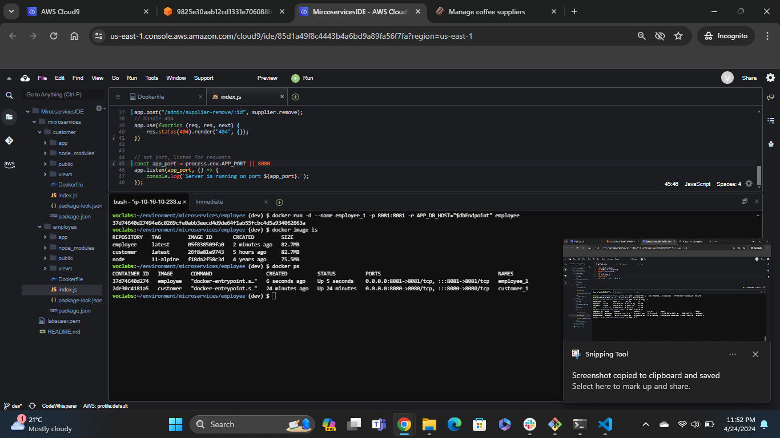

1. Rebuild the Docker image for the employee microservice

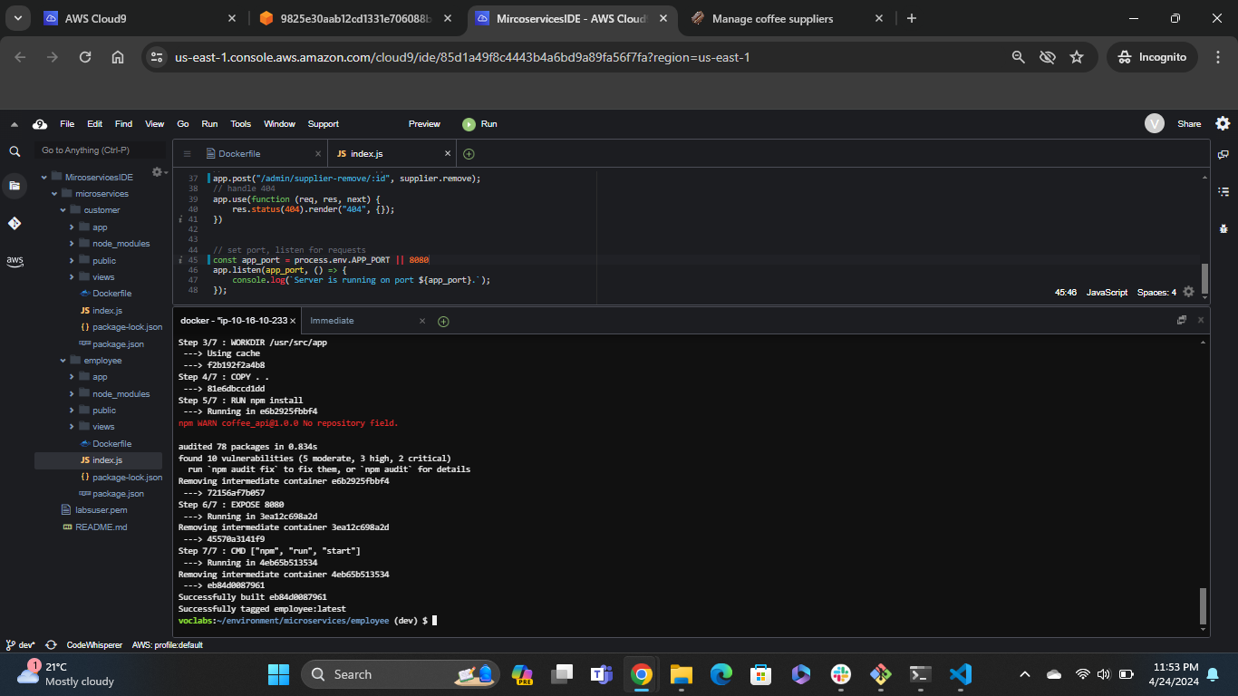

### **Task 4.7: Check code into CodeCommit**

Push the updated code on to Code Commit

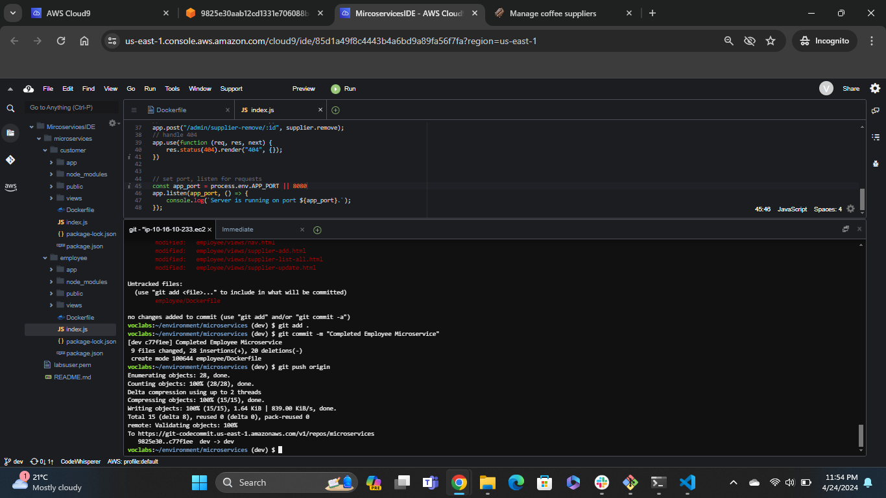

Verifying the code update on CodeCommit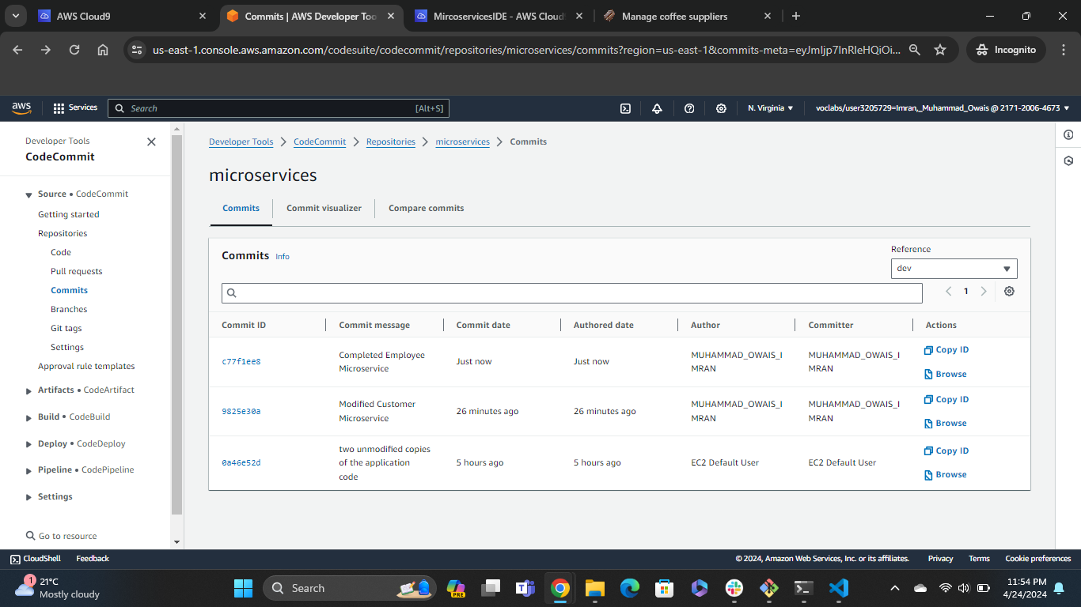

### **Significance & Importance of this Task**

This task helps us in learning:

* How to use the EC2 instance as a source for running docker containers and use various port of the EC2 instance for hosting different parts of application traffic.
* How Security groups can help in controlling traffic access to/from EC2 instance.
* Basic strategy of how microservice should work and communicate with other microservices.

## **Phase 5: Creating ECR repositories, an ECS cluster, task definitions, and AppSpec files**

### **Task 5.1: Create ECR repositories and upload the Docker images**

1. Create ECR Repositories for storing docker image of employee and customer microservices, screenshot of creating ECR for customer attached, same procedure followed for employee as well

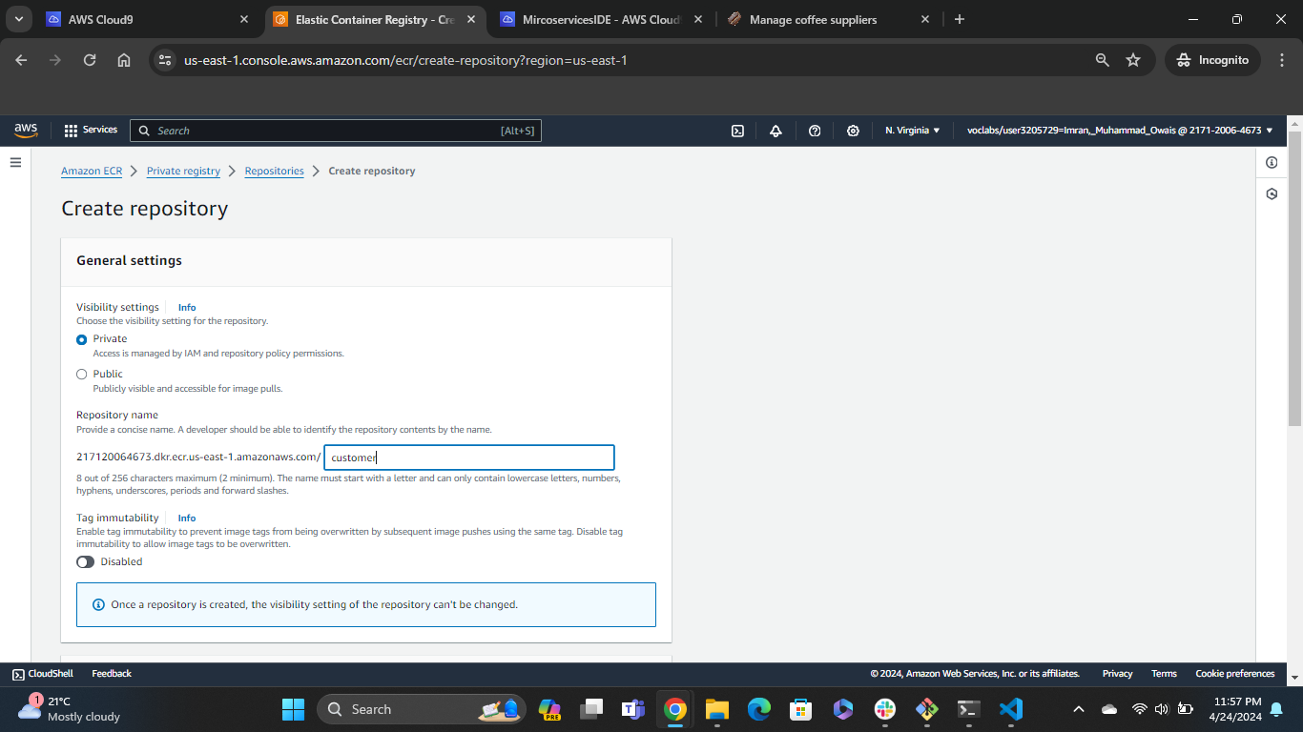

1. Verifying if the ECR are created.

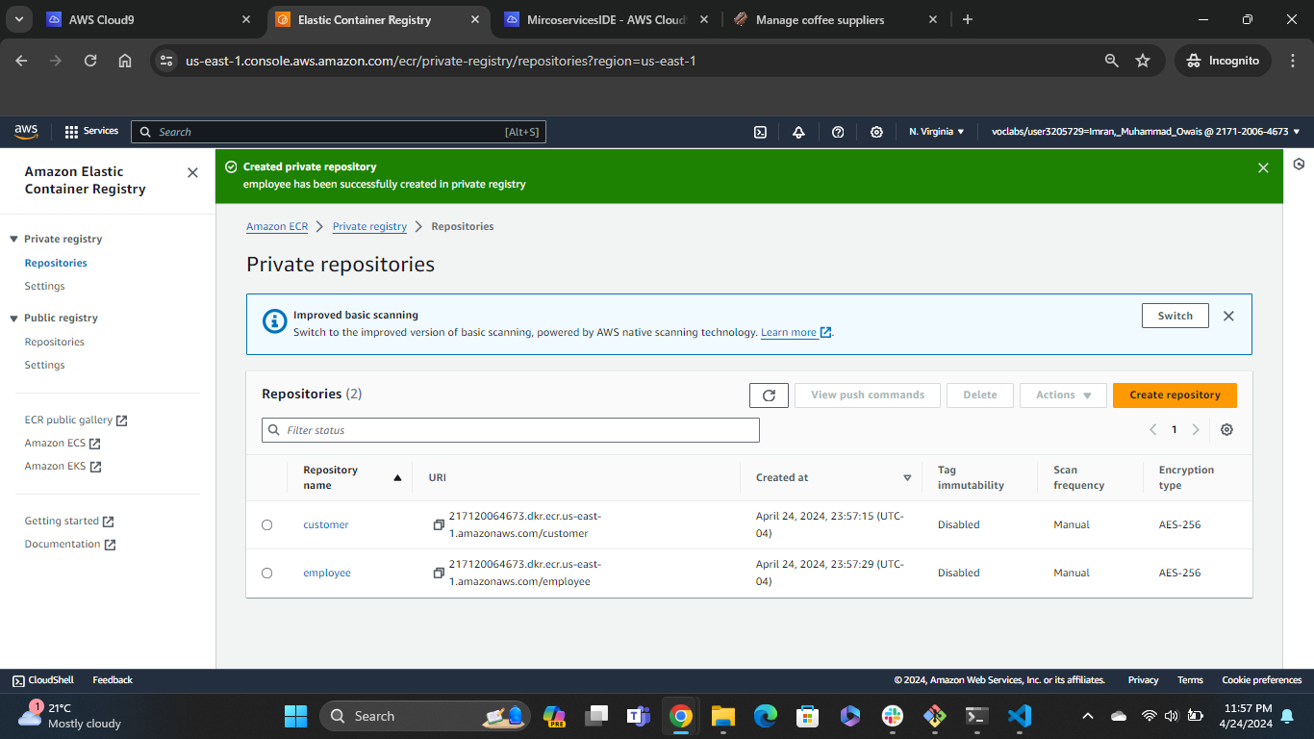

1. Updating Push policy for ECR repositories so that CodePipeline can push new build onto ECR.

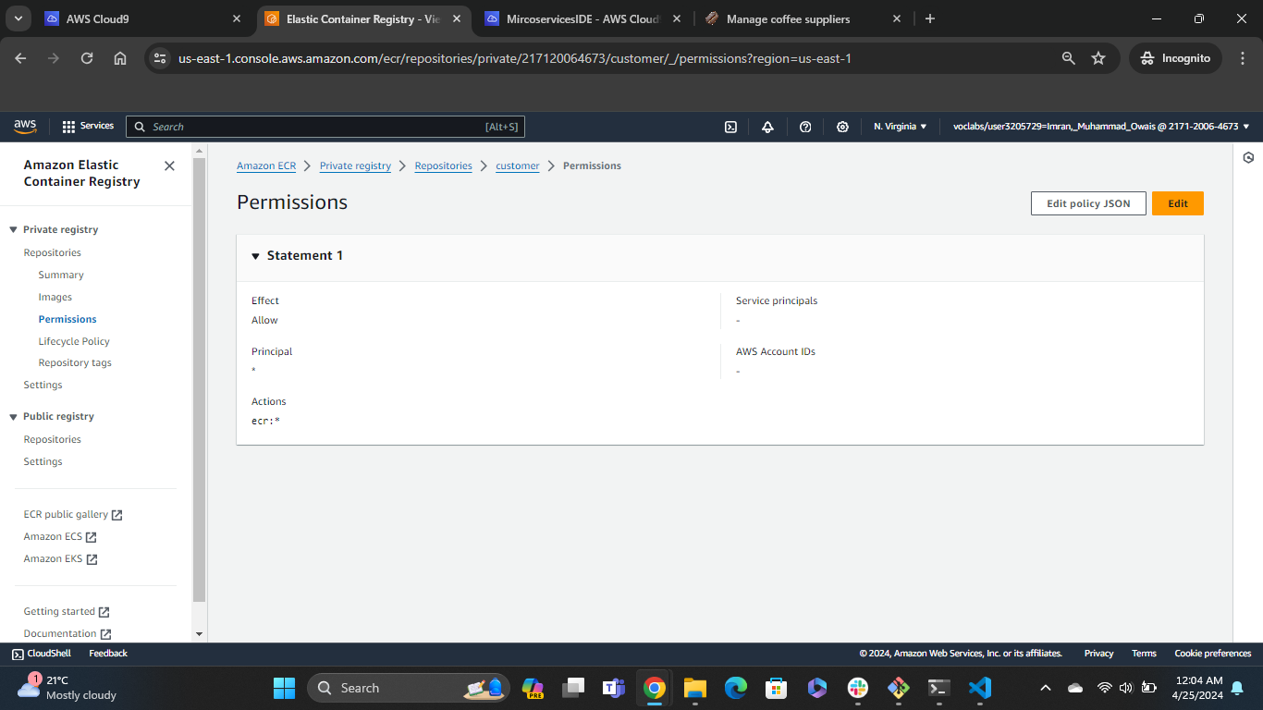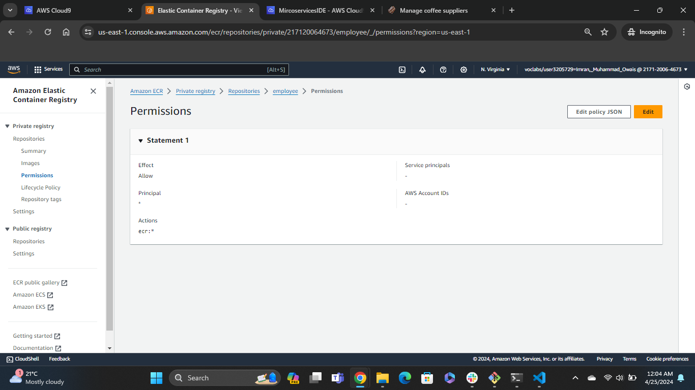

1. Tag the images created for customer (Task4.3) and employee (Task4.6), and push them onto relevant ECR repositories, and verify if image is pushed onto ECR with latest tag.

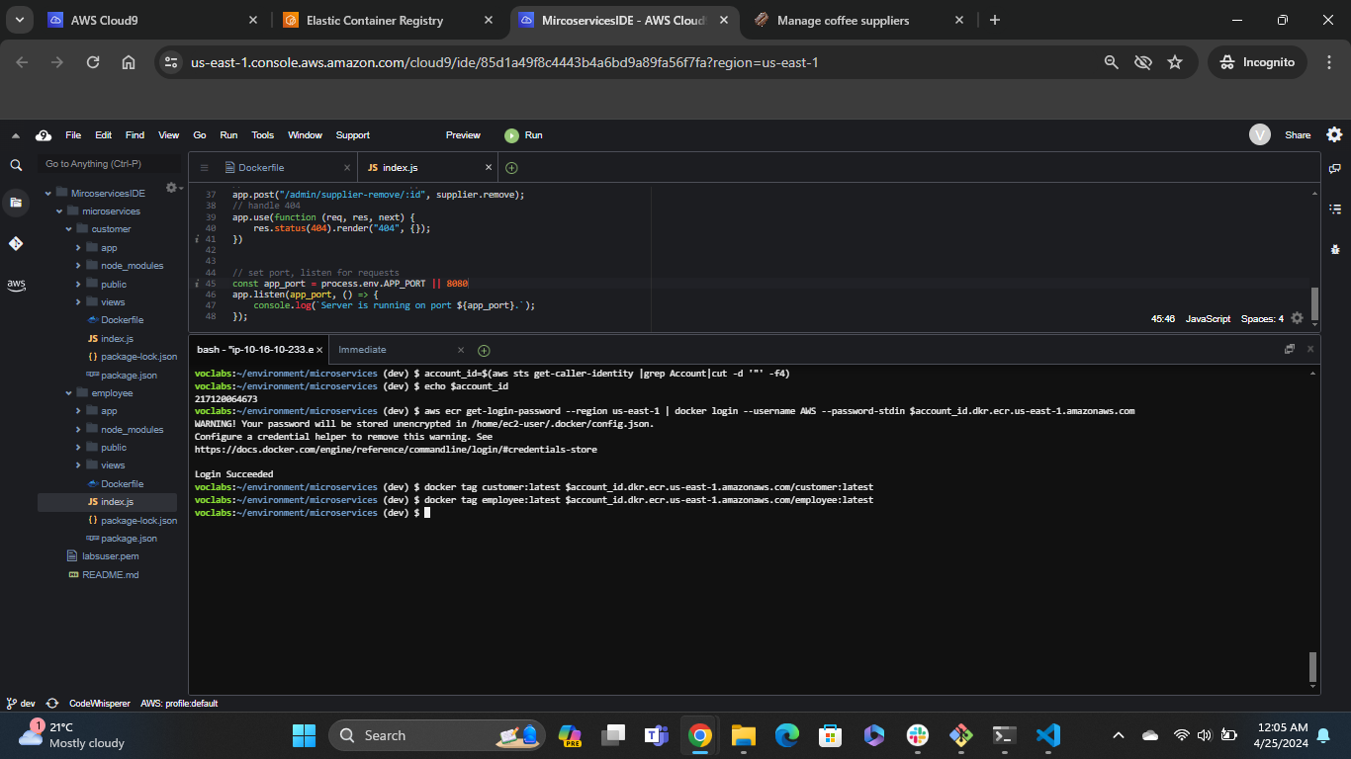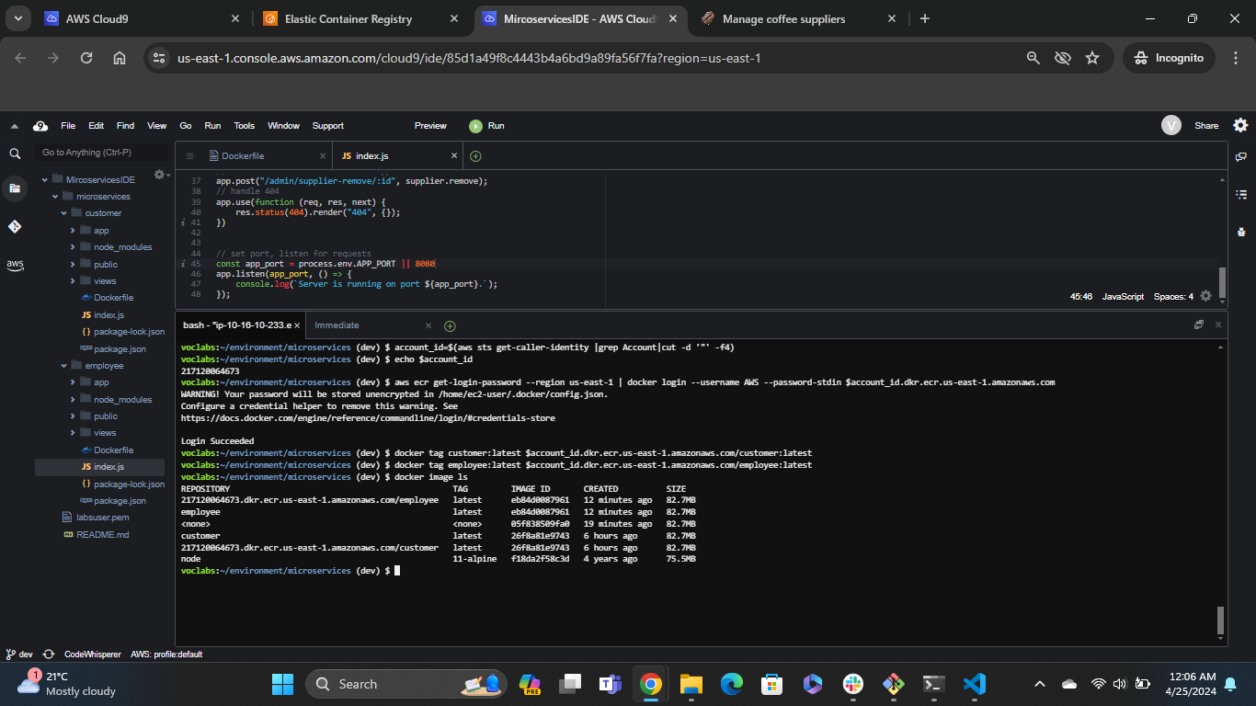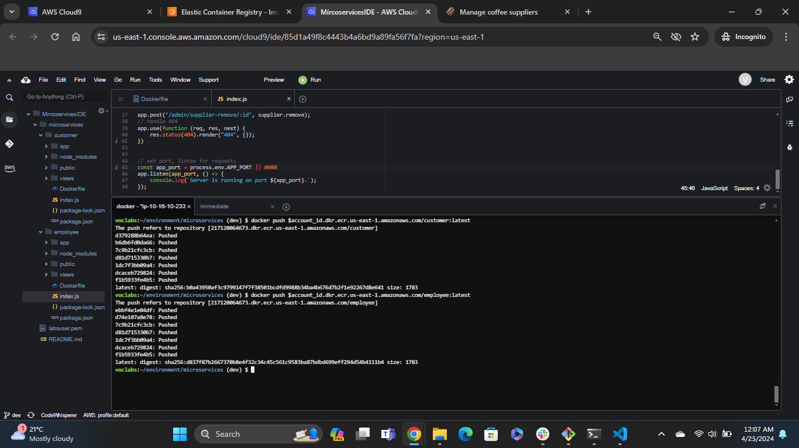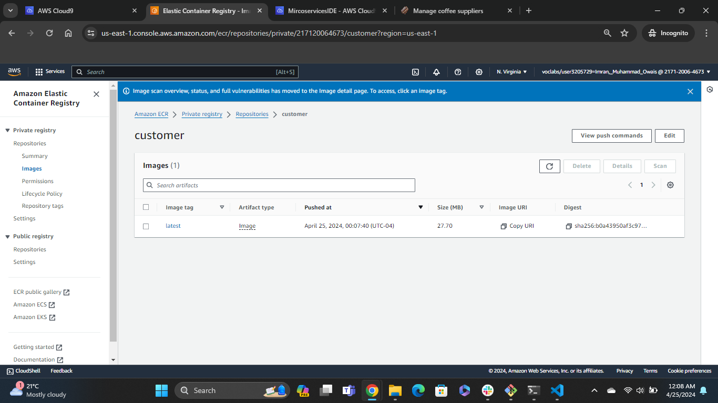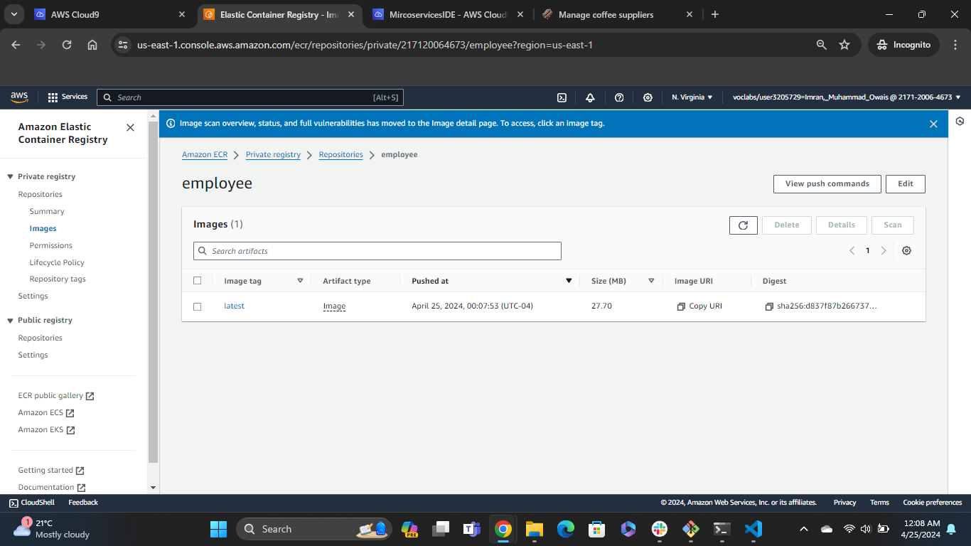

### **Task 5.2: Create an ECS cluster**

1. Create a serverless AWS Fargate cluster that is named microservices-serverlesscluster

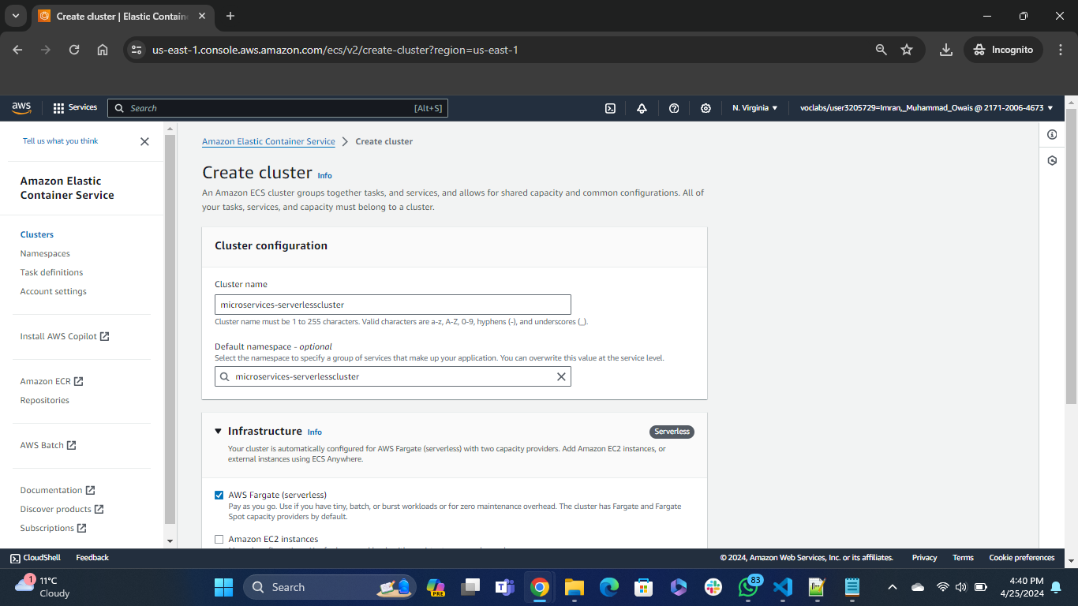

### **Task 5.3: Create a CodeCommit repository to store deployment files**

1. Create a code commit repository by the name of deployment

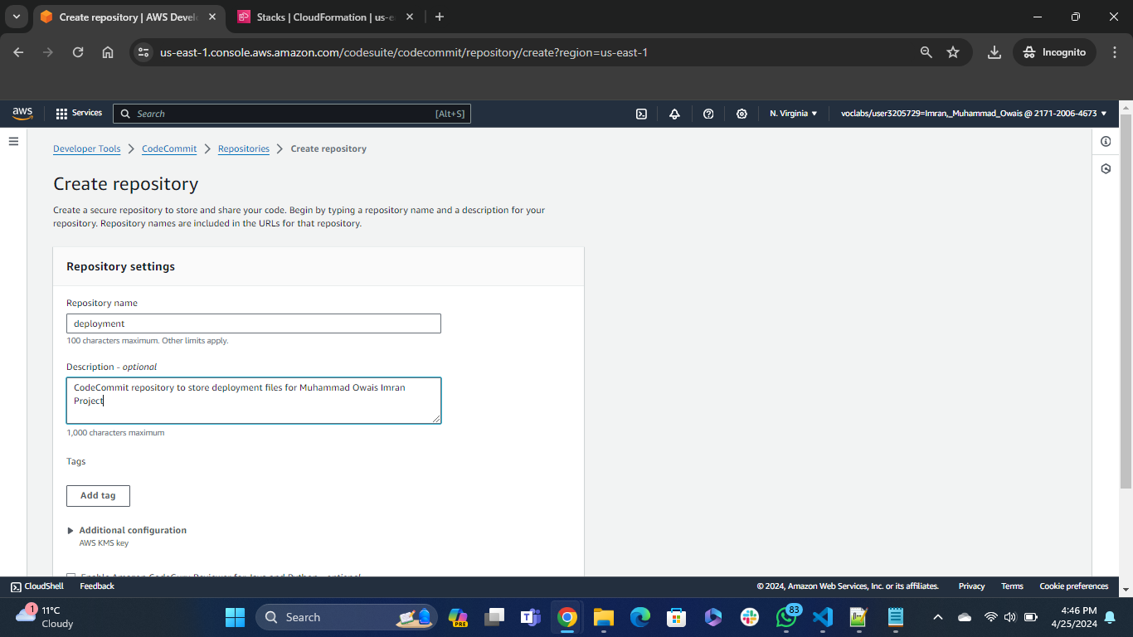

1. Verifying if the repository is created.

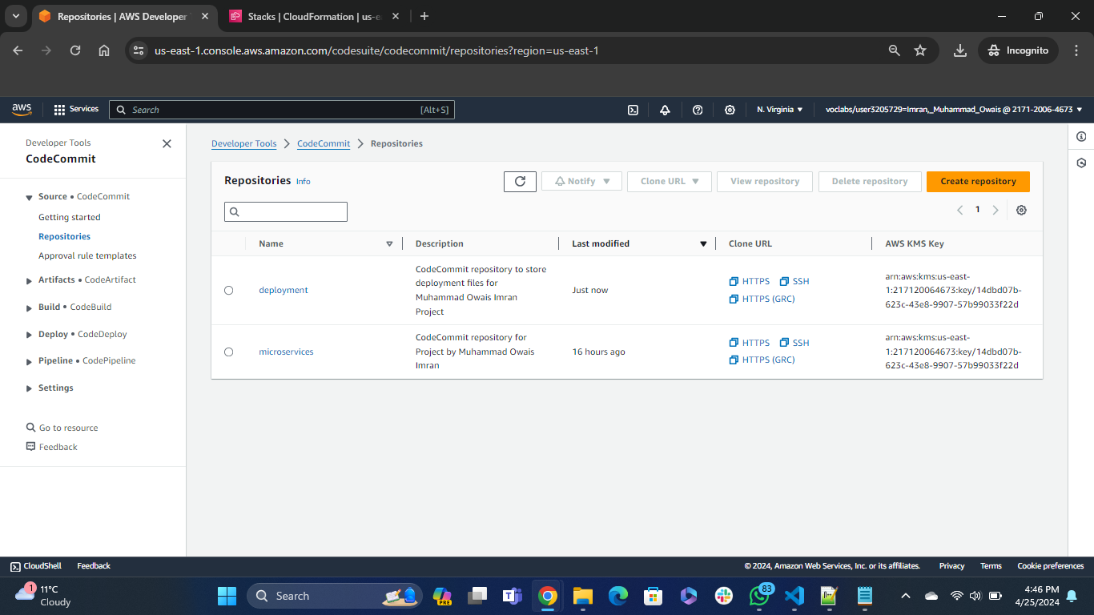

1. Initialize an empty git repository and creating a branch named dev.

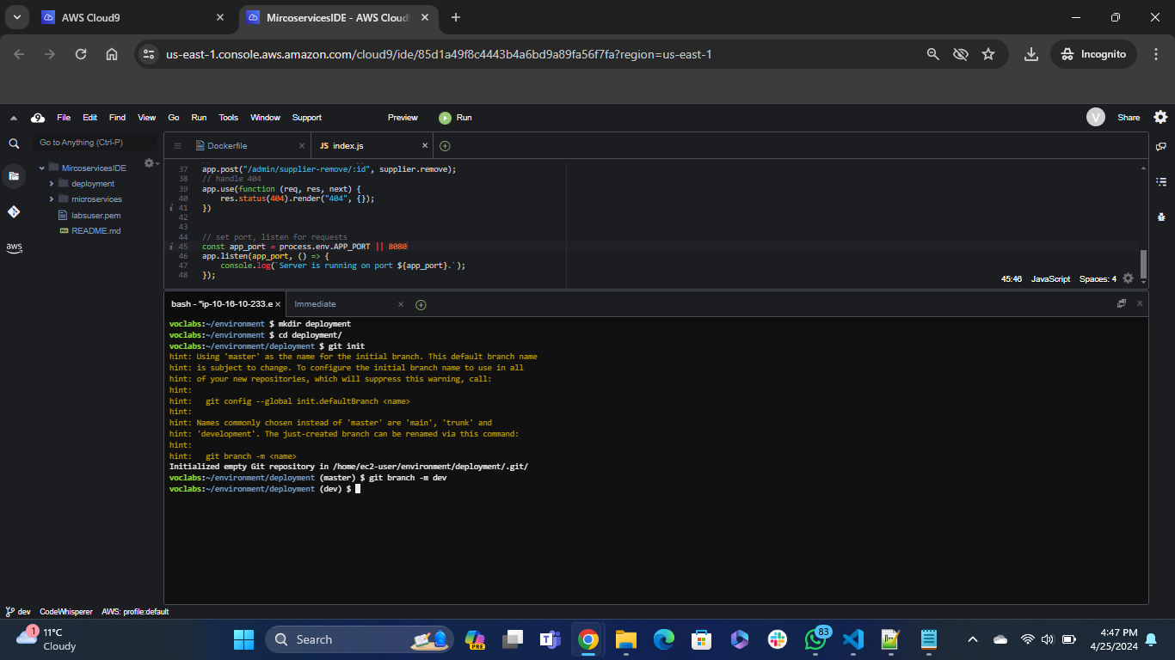

### **Task 5.4: Create task definition files for each microservice and register them with Amazon ECS**

1. In the AWS Cloud9 IDE, create a new directory by the name of deployment on ~/environment
2. Create a file taskdef-customer.json

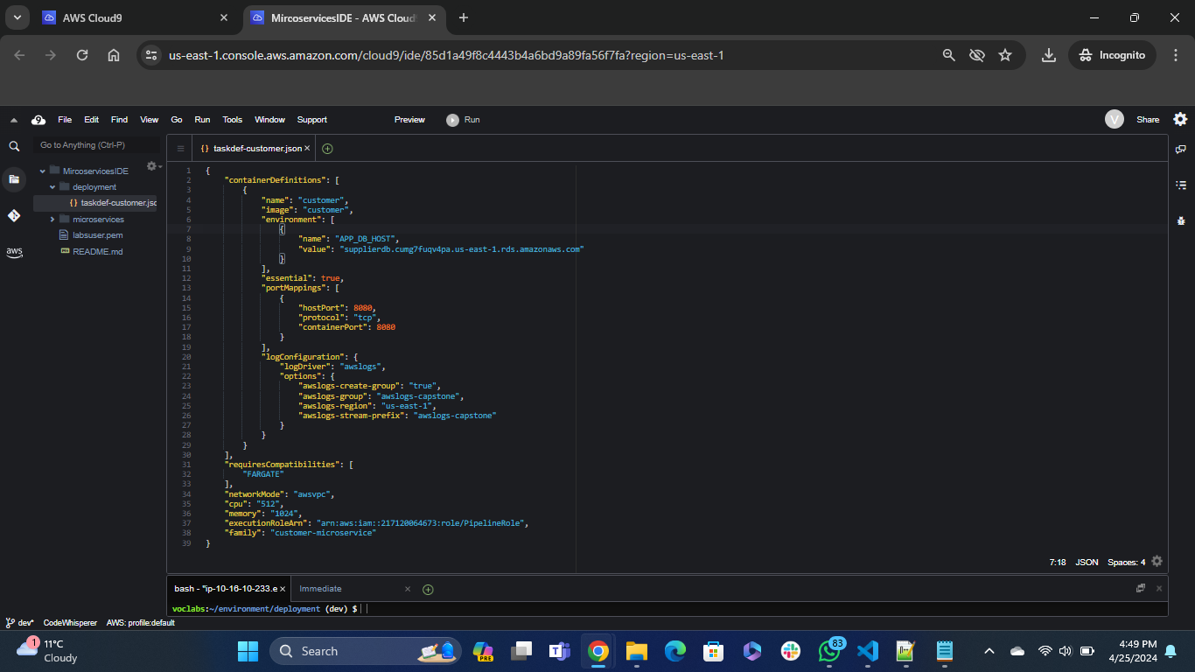

1. Register this service onto ECR, and verify.

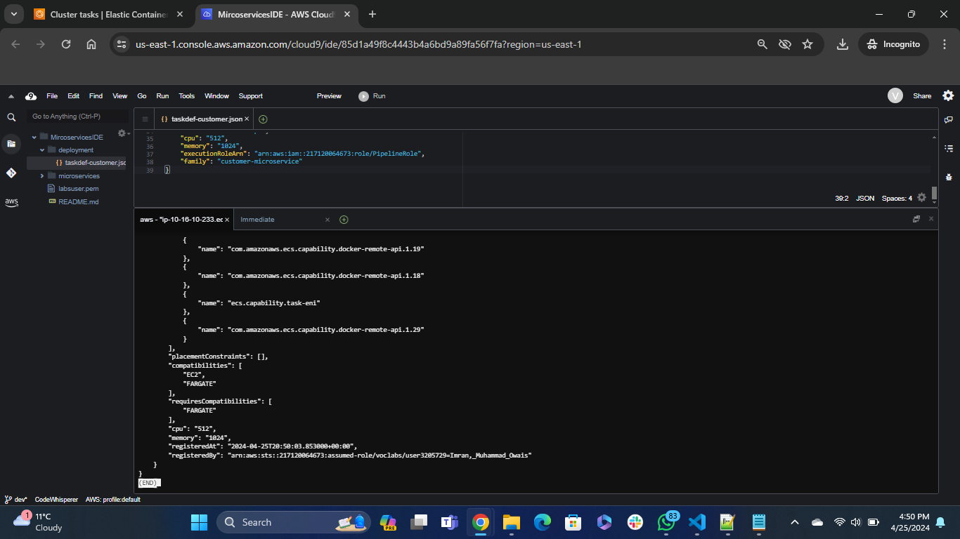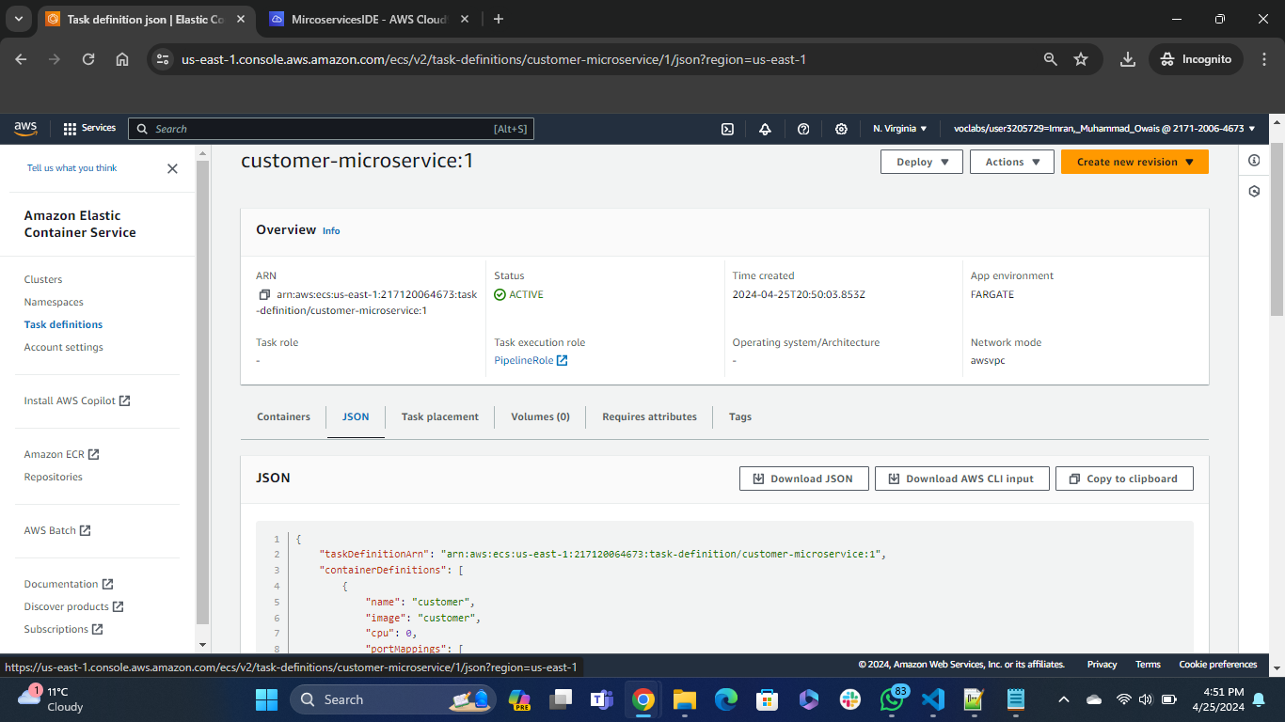

1. Create a file for taskdef-employee.json and copy the contents of taskdef-customer. After you paste in the code, change the three occurrences of customer to employee, and register the service onto ECS. Copy and replace is done using the following commands:

* cat taskdef-customer.json > taskdef-employee.json
* sed -i “s/customer/employee/g” ./taskdef-employee.json

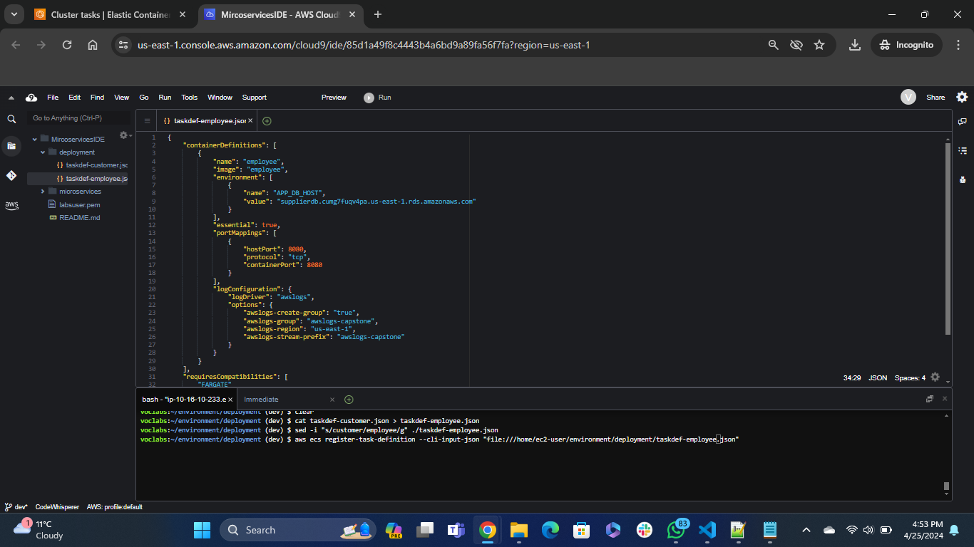

Verify if the service was registered successfully onto ECR.

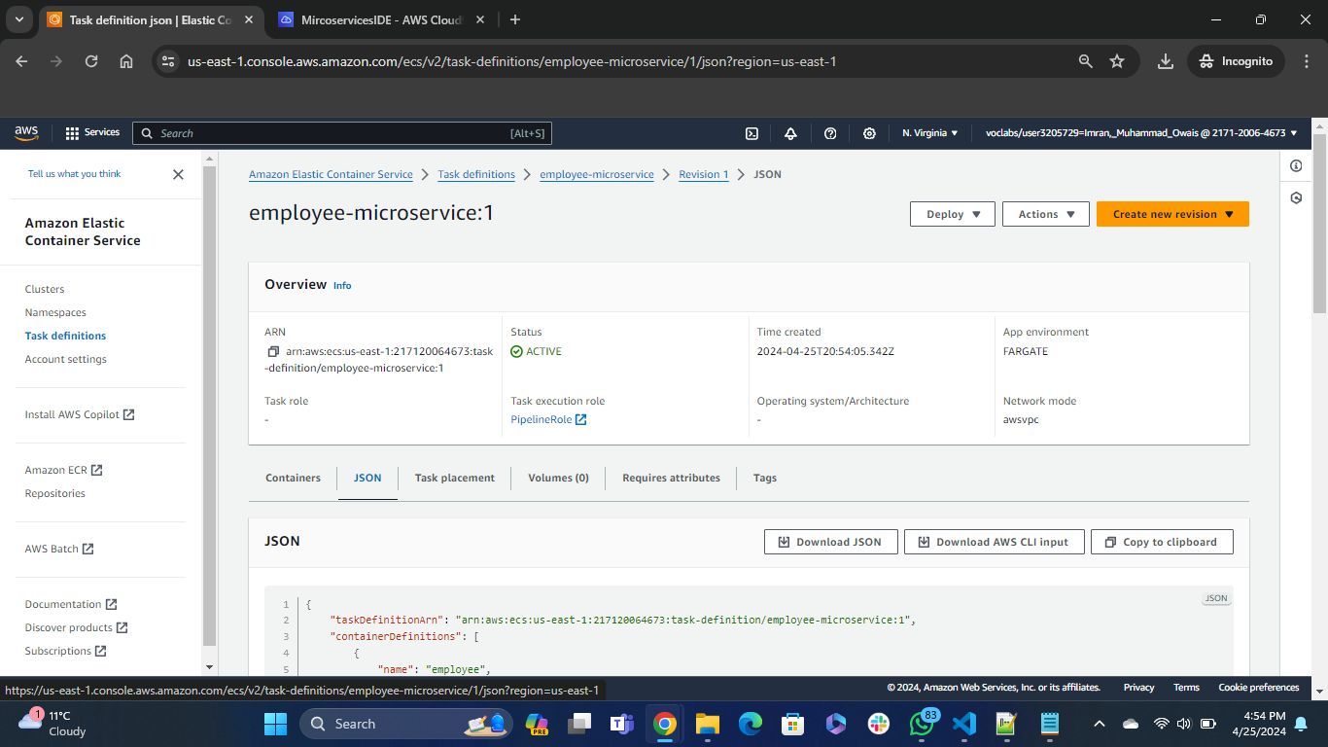

### **Task 5.5: Create AppSpec files for CodeDeploy for each microservice**

1. Create an AppSpec file for the customer microservice
   1. In the deployment directory, create a new file named appspec-customer.yaml

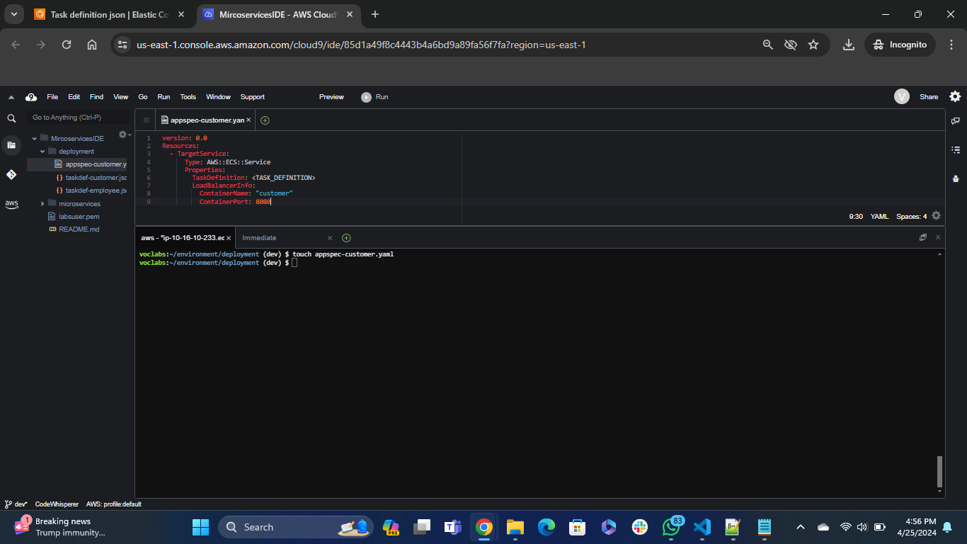

1. Create an AppSpec file for the employee microservice
   1. Name the file appspec-employee.yaml
   2. The contents of the file should be the same as the appspec-customer.yaml file. However, change customer`` on thecontainerNameline to be employee

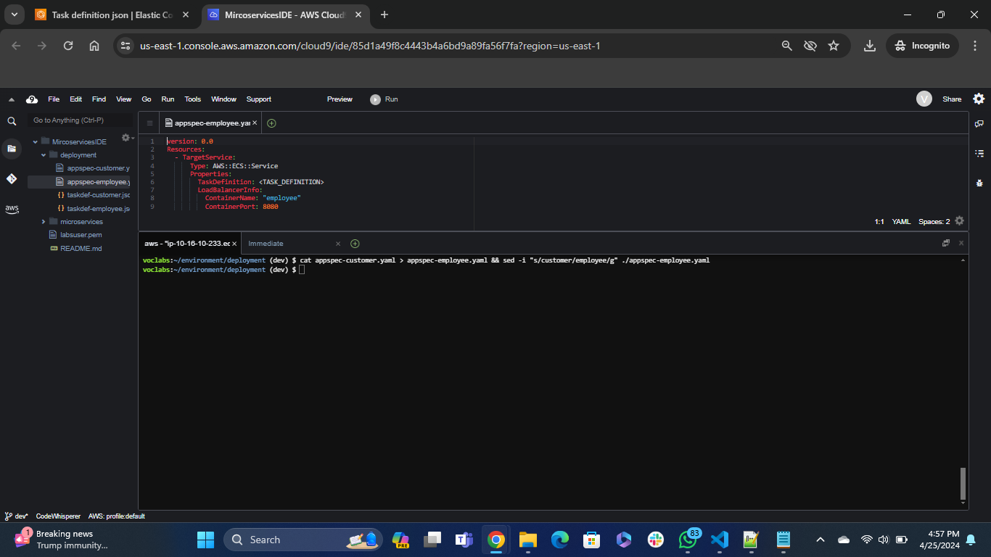

### **Task 5.6: Update files and check them into CodeCommit**

Edit the file taskdef-customer.json and taskdef-employee.json and replace image field value with “IMAGE1_NAME”. This value will be updated automatically by the codepipeline which will be created in the later steps.

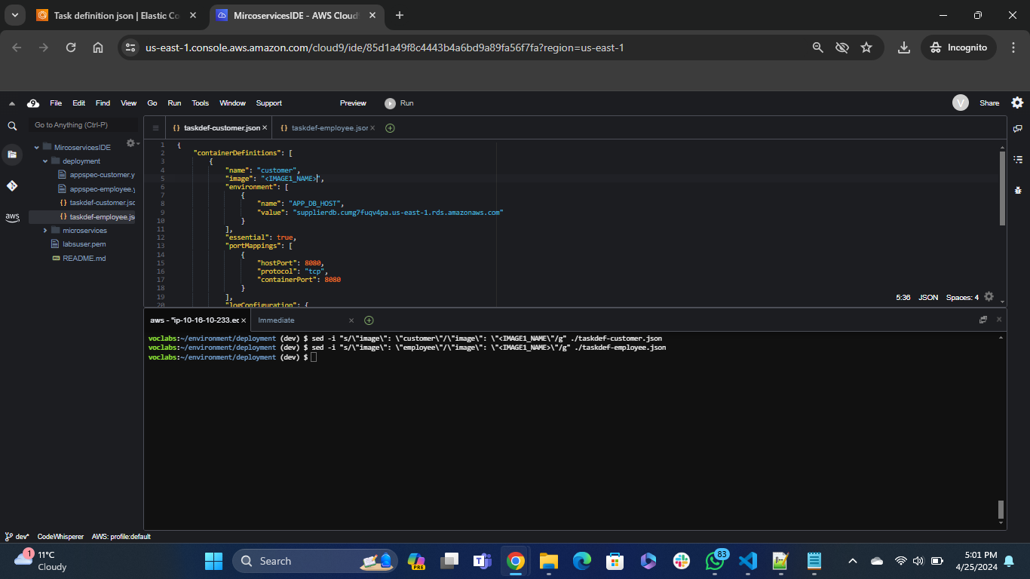

Commit the code onto code commit.

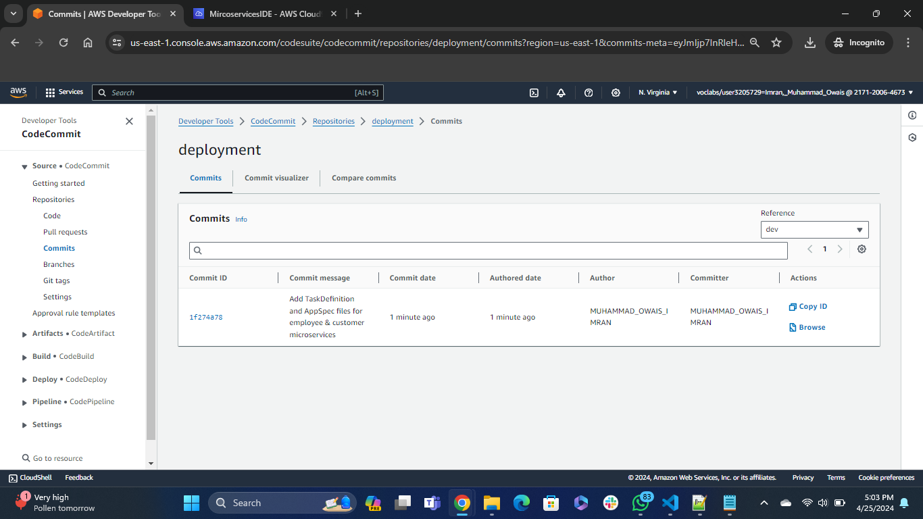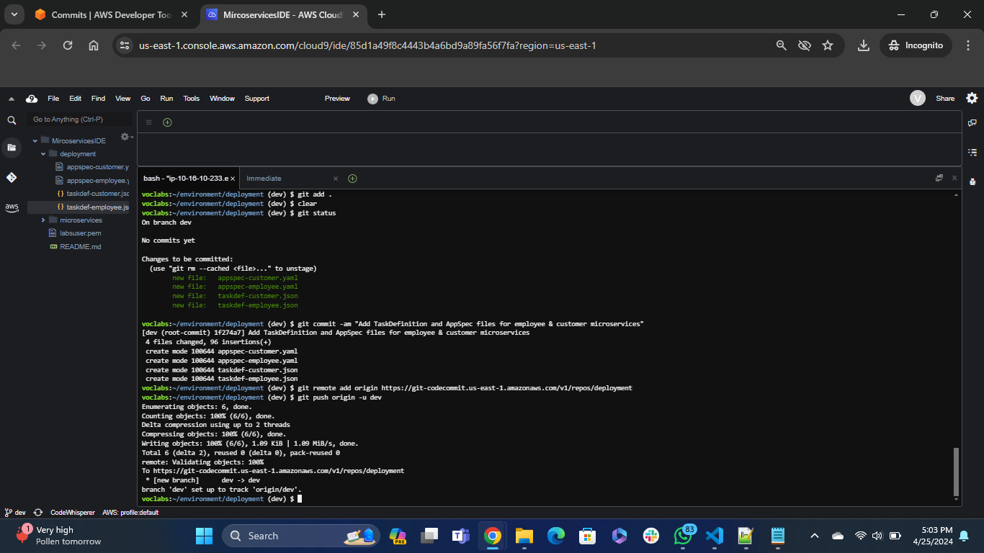

### **Significance & Importance of this Task**

This task has the following outcomes:

* Learning the use case of ECR
* How to create an ECS cluster
* Difference between Task and Service of an ECS
* How to Define AppSpec for CodeDeployment, and Task Definition for ECS
* How CodeDeployment helps in achieving CI/CD in an application Development to Deployment lifecycle

## **Phase 6: Creating target groups and an Application Load Balancer**

### **Task 6.1: Create four target groups**

1. For customer-microservice create target group with this config

Target Group Type: IP address

Target Group Name: customer-tg-one/customer-tg-two

Protocol: HTTP

Port: 8080

VPC: LabVPC

Health check path: /

1. For employee-microservice create target group with this config

Target Group Type: IP address

Target Group Name: employee-tg-one/employee-tg-two

Protocol: HTTP

Port: 8081

VPC: LabVPC

Health check path: /admin/suppliers

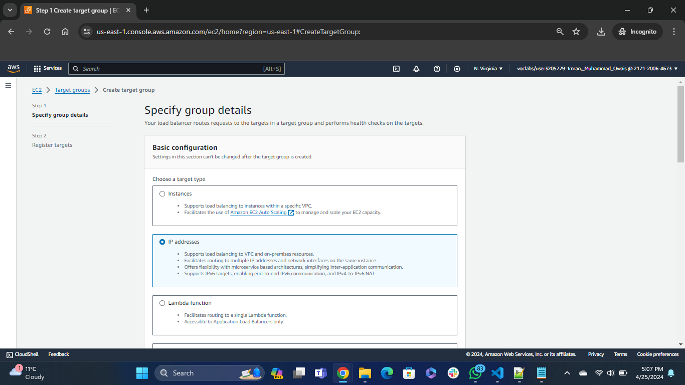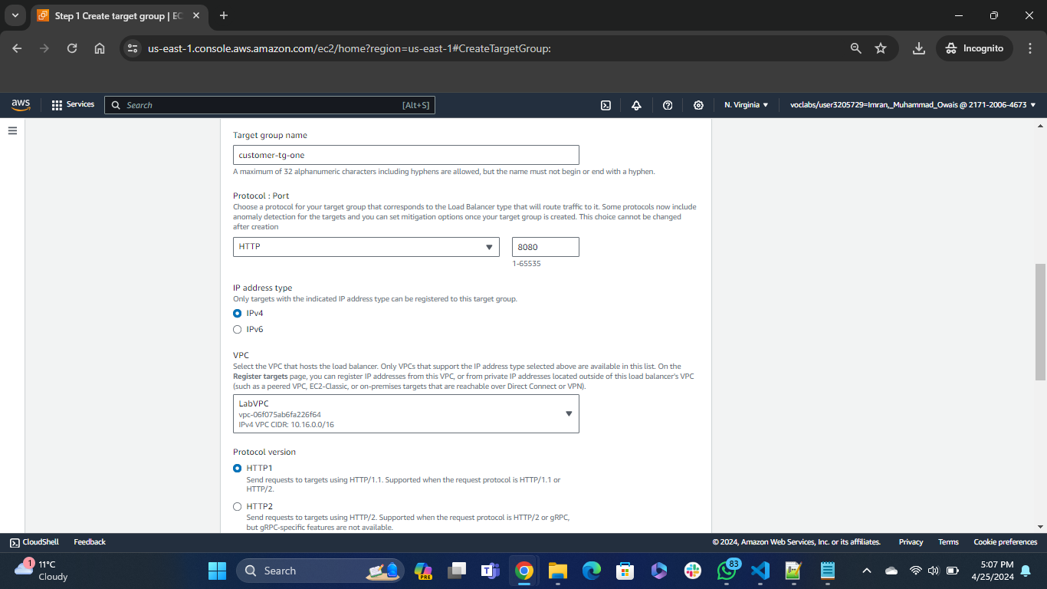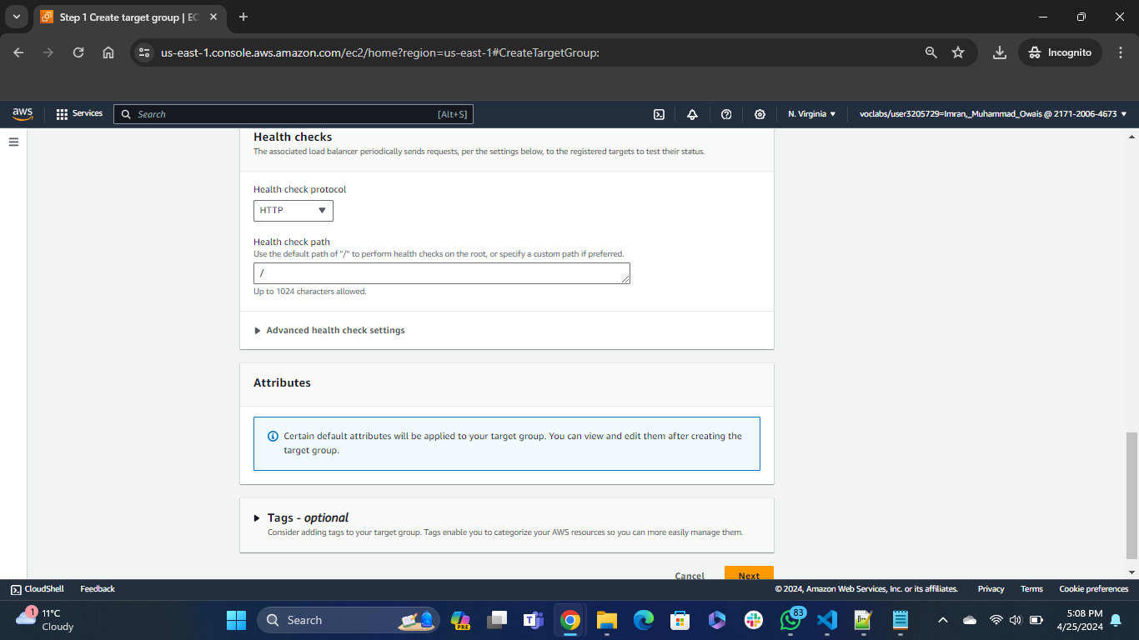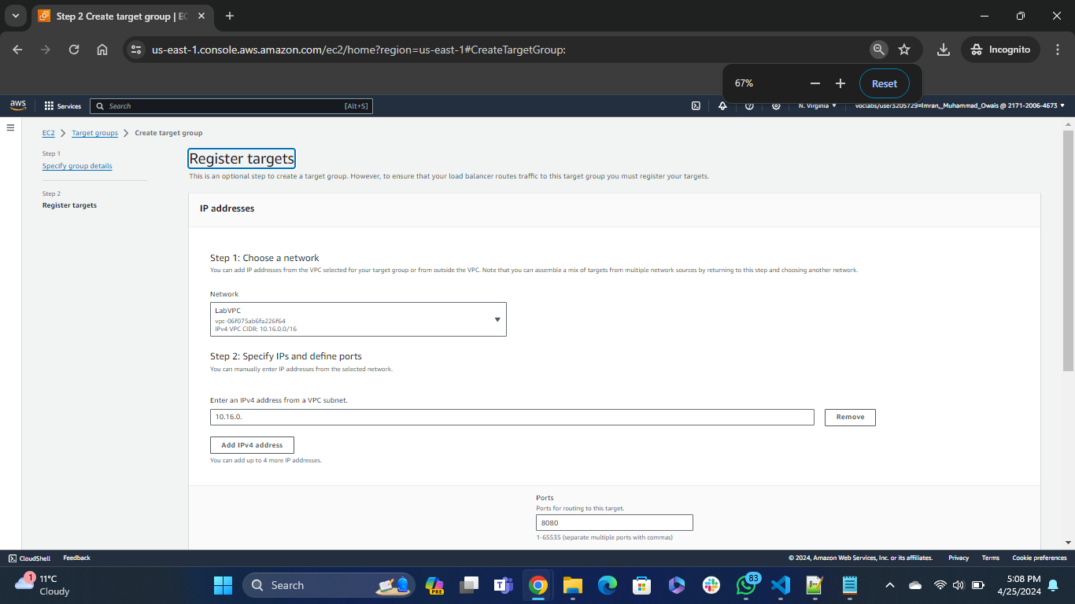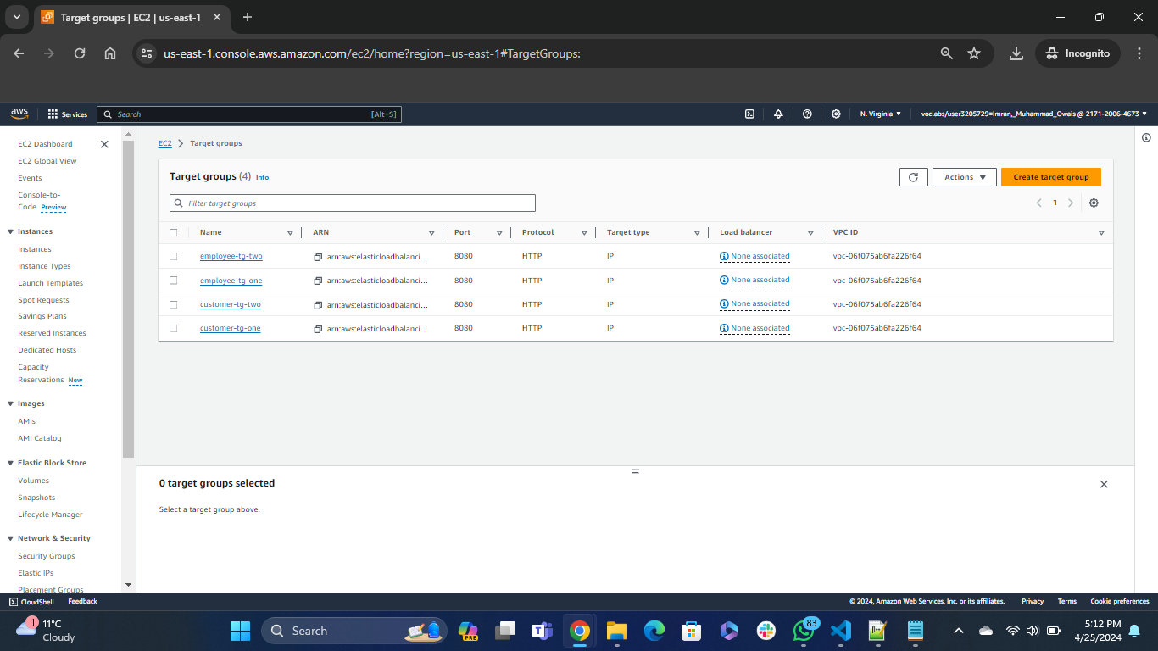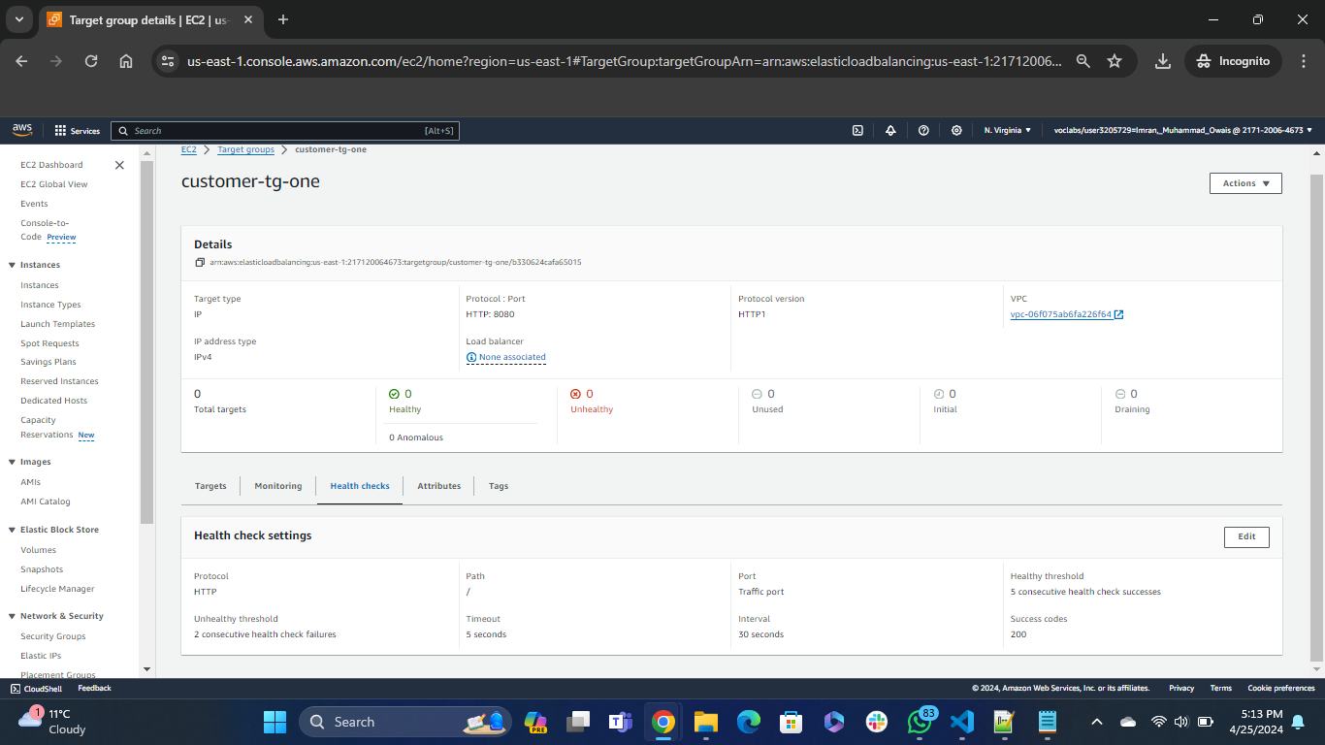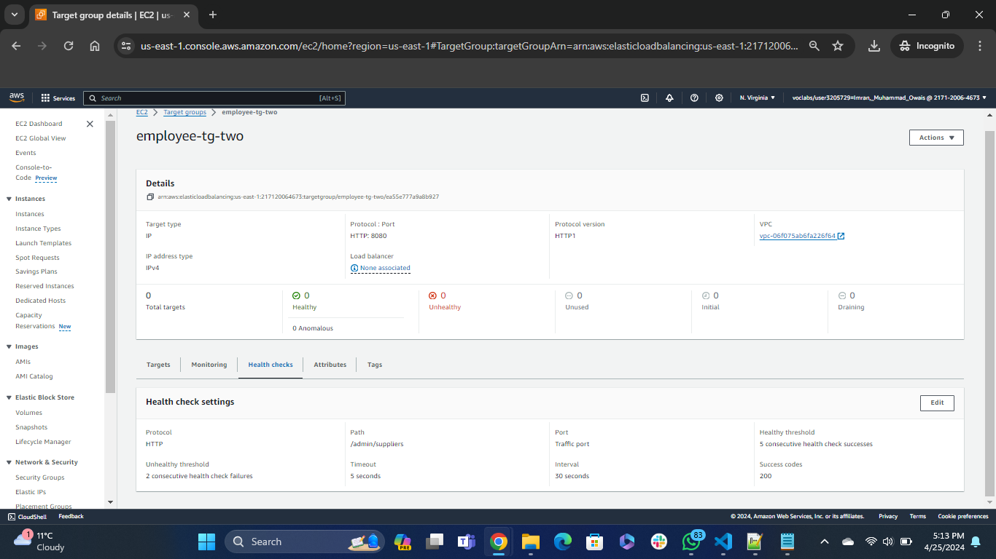

### **Task 6.2: Create a security group and an Application Load Balancer, and configure rules to route traffic**

1. New EC2 security group microservice-sg, and allow inbound traffic on port 80 and 8080 from anywhere IPv4.

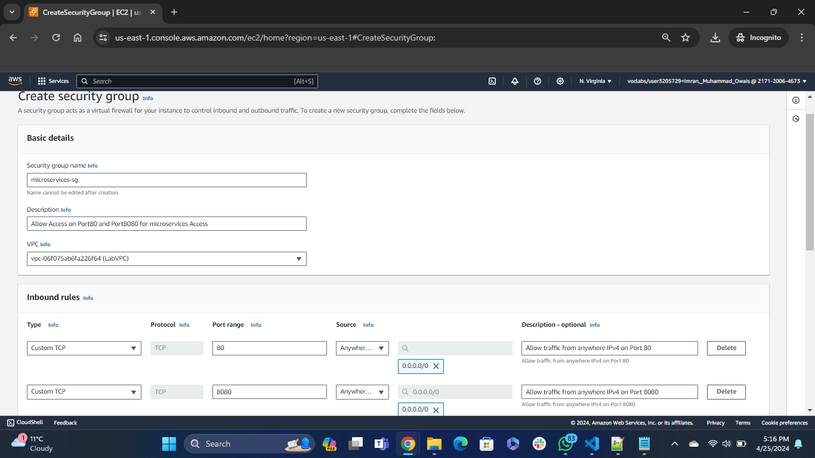

1. Create a LoadBalancer microservicesLB, making it internet facing for IPv4 address, in LabVPC, PublicSubnet1, and PublicSubnet2, and use the sg created in above step. Also configure two listeners, each listener will have two rules.

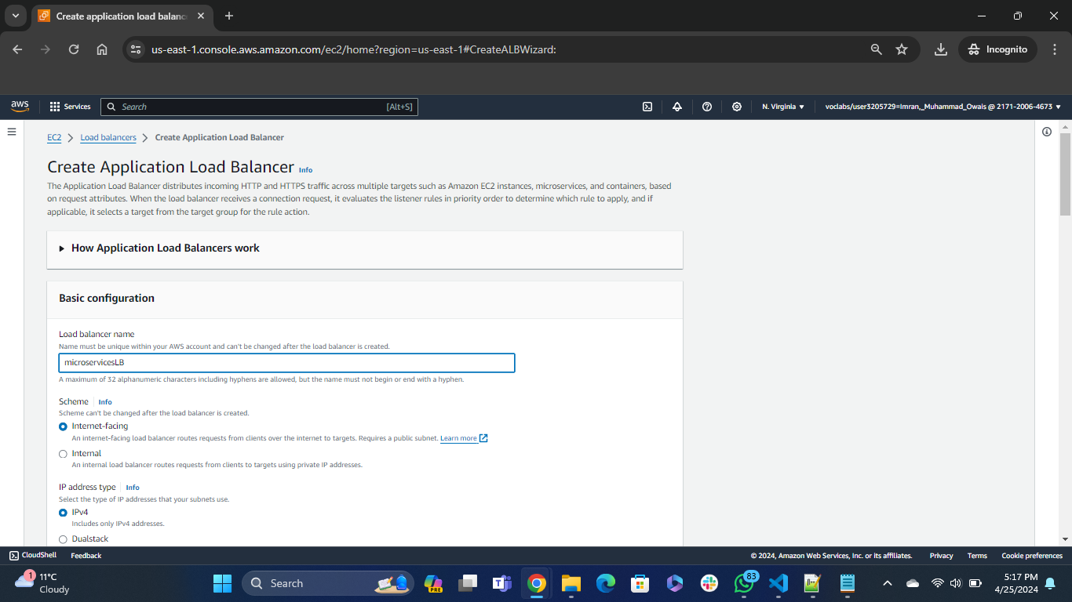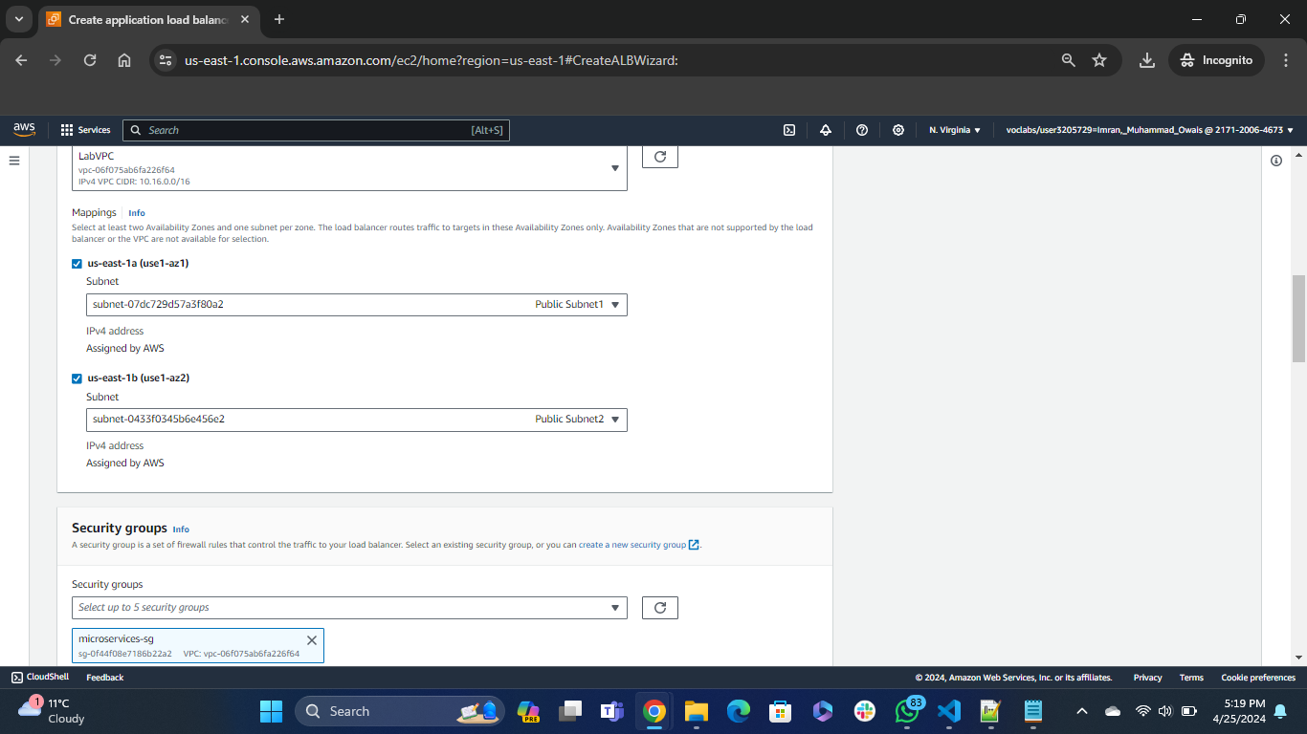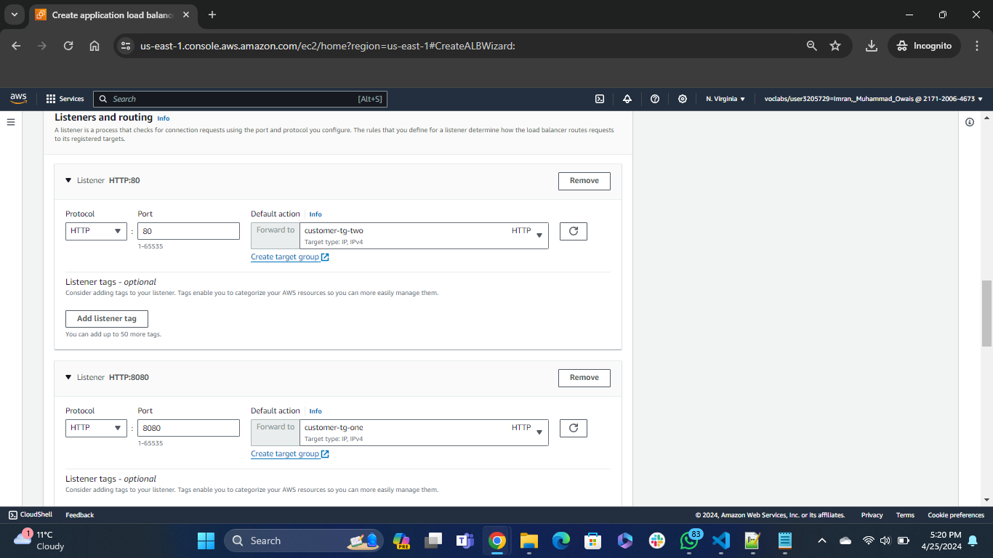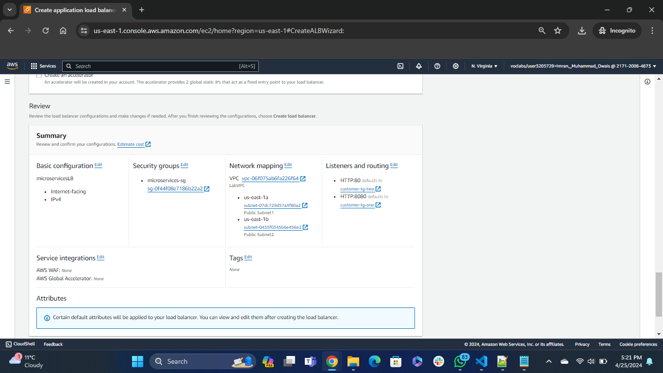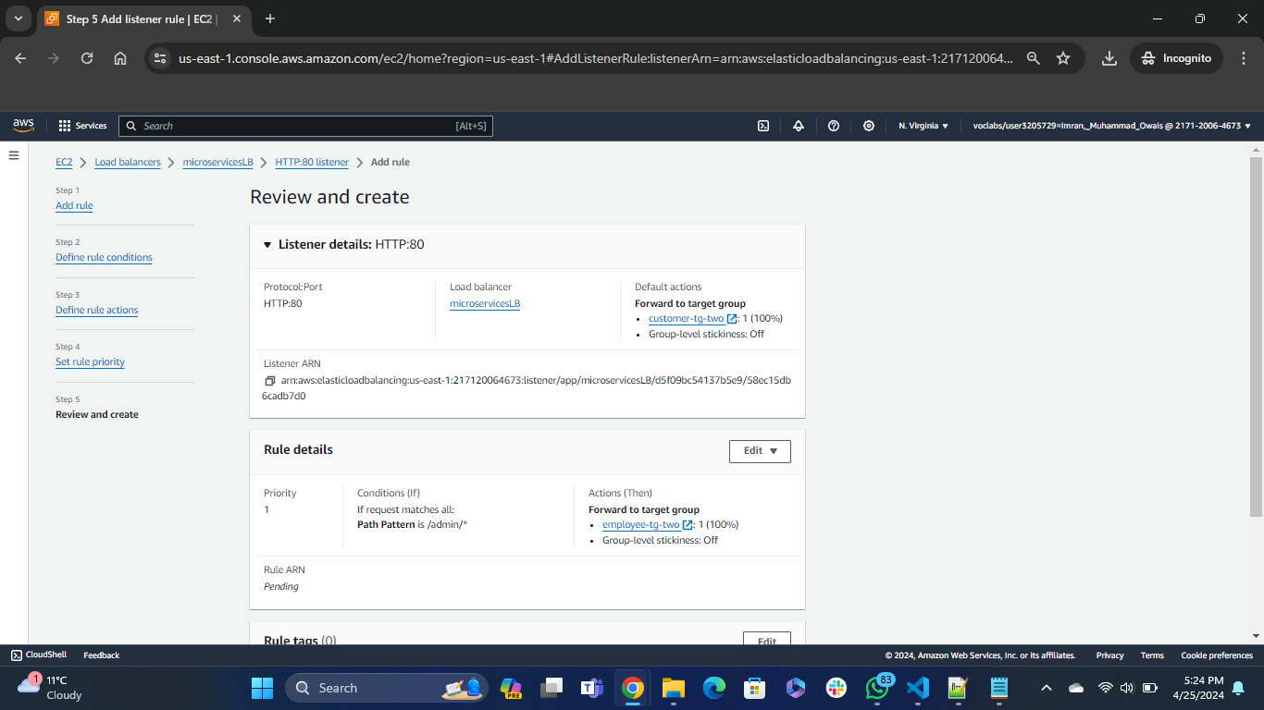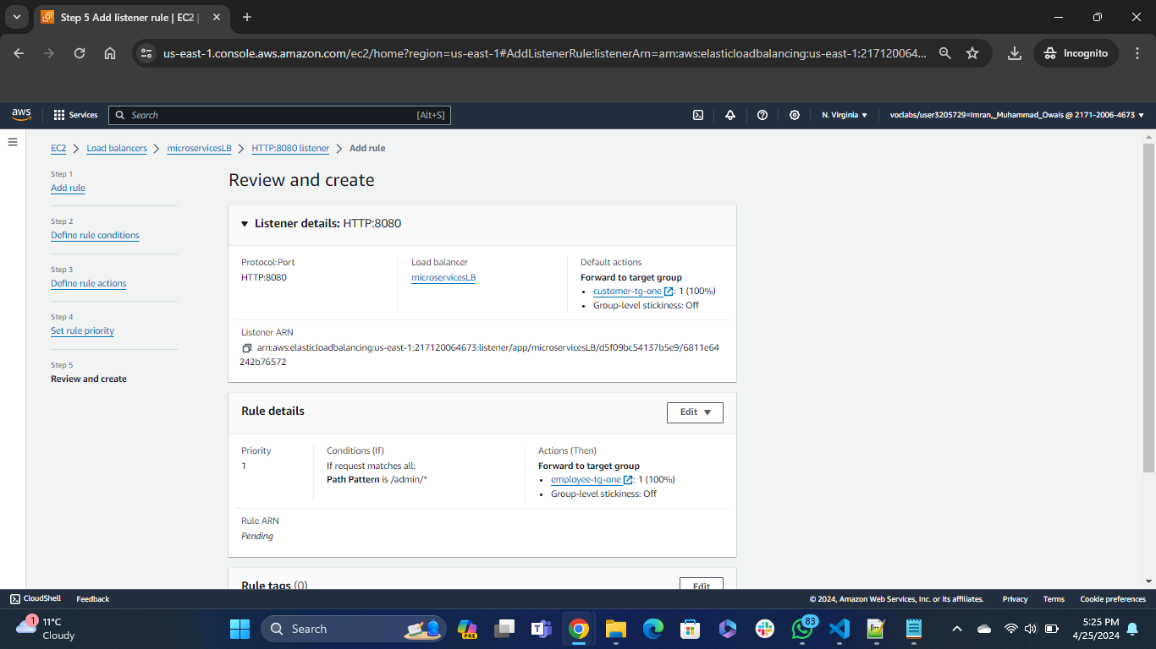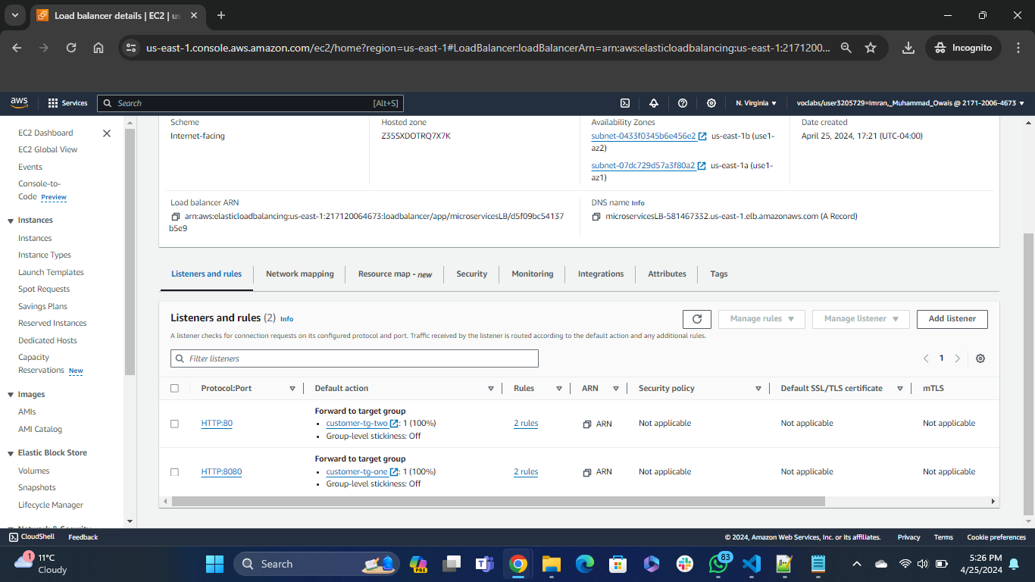

### **Significance & Importance of this Task**

This task helps us in implementing:

* How target groups work and the way they can be used to route traffic between production and test environments based on pre-defined host port and application logic
* The reason of health check
* How load balancer control and decides that on which request, the traffic should be sent to which application host port.

## **Phase 7: Creating two Amazon ECS services**

### **Task 7.1: Create the ECS service for the customer microservice**

1. In the deployment directory in Cloud9, create a new file named create-customer-microservice-tg-two.json

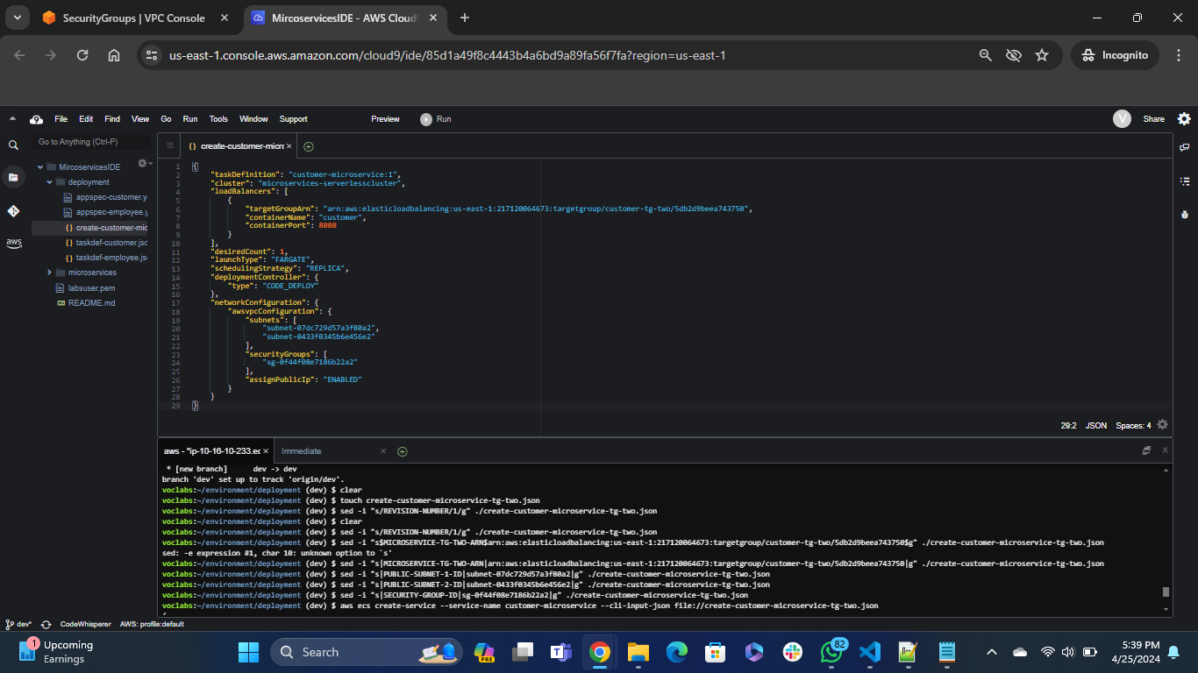

### **Task 7.2: Create the Amazon ECS service for the employee microservice**

1. In the deployment directory in Cloud9, create a new file named create-employee-microservice-tg-two.json

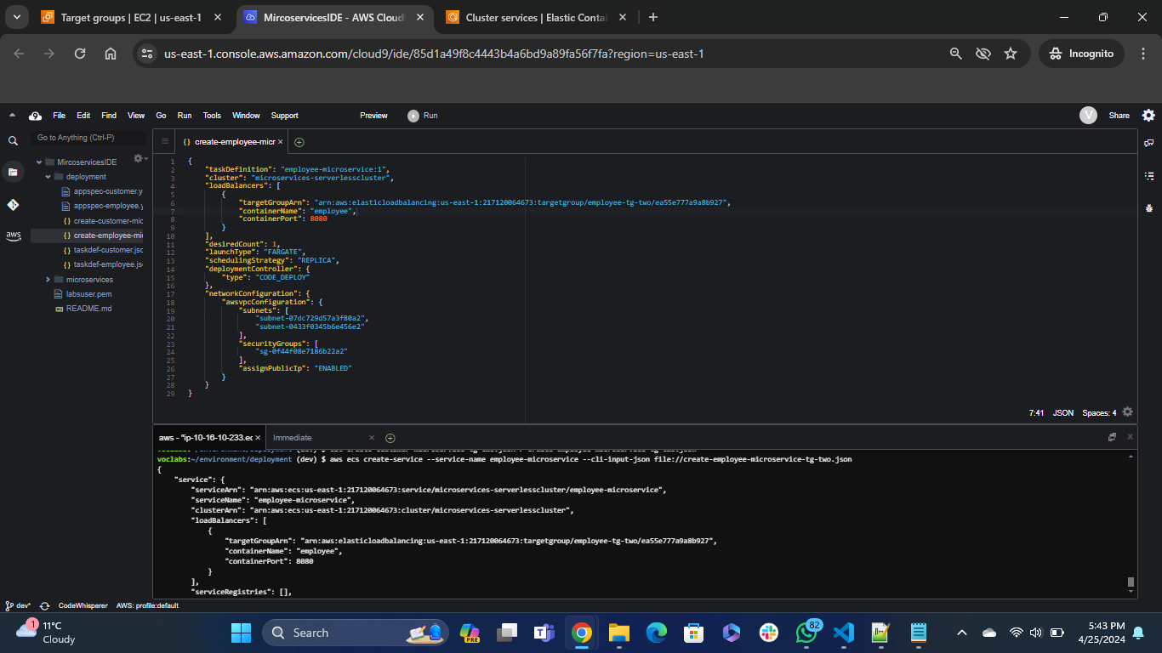

Verifying task in AWS ECS

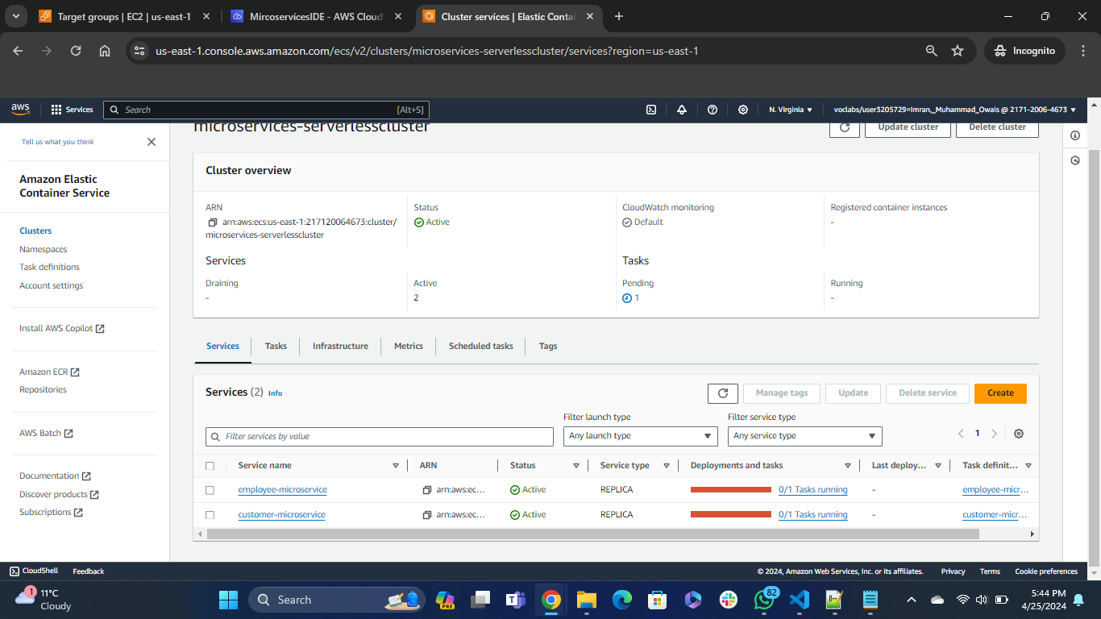

### **Significance & Importance of this Task**

This task helps us in implementing:

* How Create Services on AWS ECS to deploy different microservices by pulling their images from an AWS ECR repository.

## **Phase 8: Configuring CodeDeploy and CodePipeline**

### **Task 8.1: Create a CodeDeploy application and deployment groups**

1. Create AWS CodeDeploy application by the name of microservices.

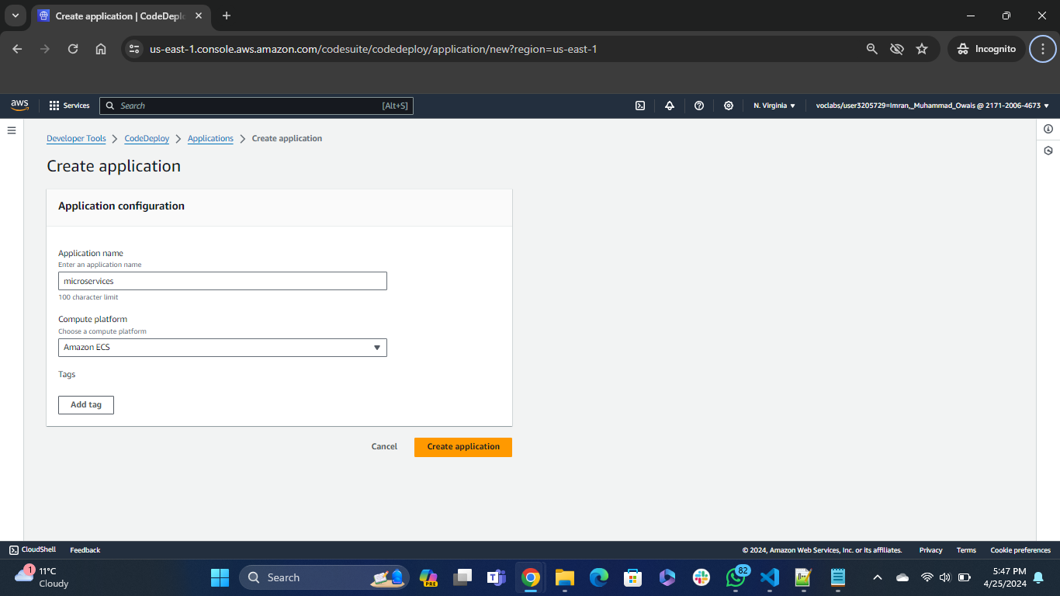

1. Create a Deployment Group for the microservices-customer with the below config

Deployment Group name: microservices-customer

Service Role: ARN for DeployRole

Environment Configuration:

ECS Cluster Name: microservices-serverlesscluster

ECS Service Name: customer-microservice

Load Balancer Section:

Load balancer name: microservicesLB

Production Listener Port: HTTP: 80

Test Listener Port: HTTP: 8080

Target group 1 name: customer-tg-two

Target group 2 name: customer-tg-one

Deployment Settings:

Traffic Rerouting: Reroute traffic immediately

Deployment Configuration: CodeDeployDefault.ECSAllAtOnce

Original Revision termination: Days: 0, Hours: 0, Minutes: 5

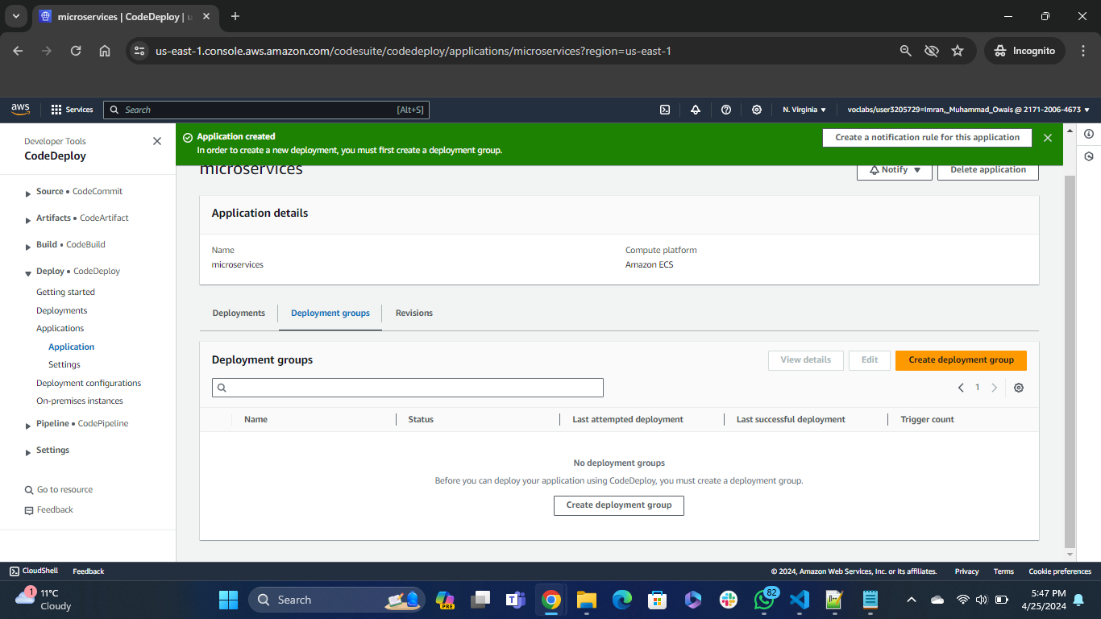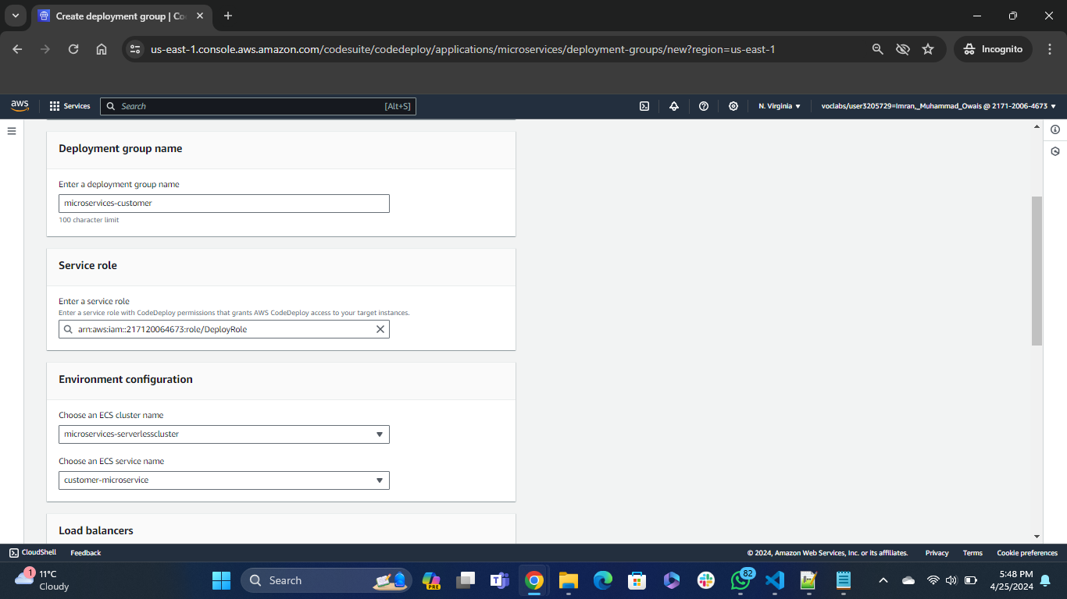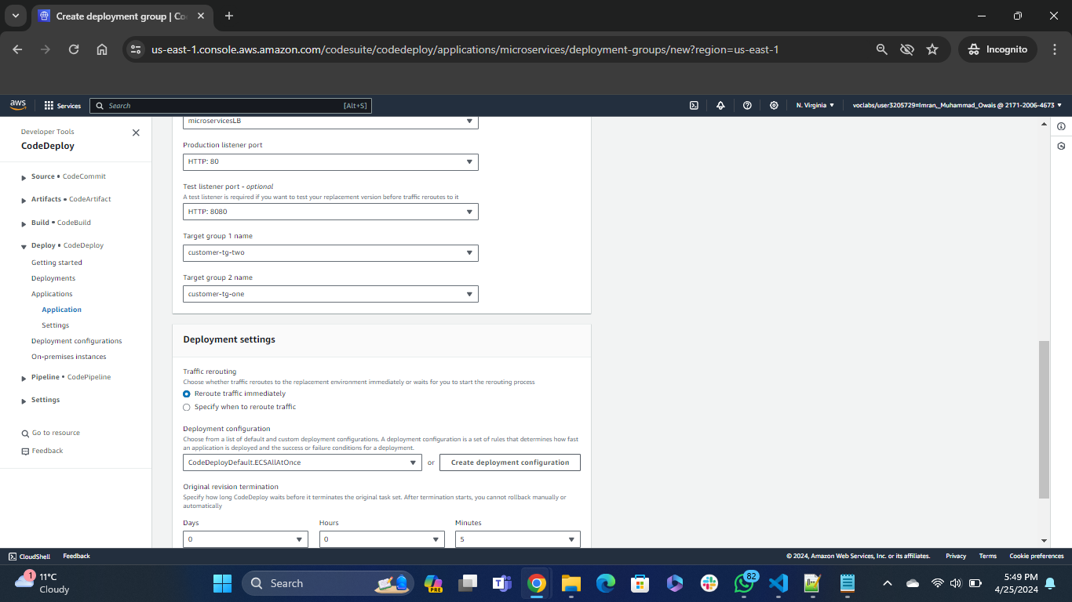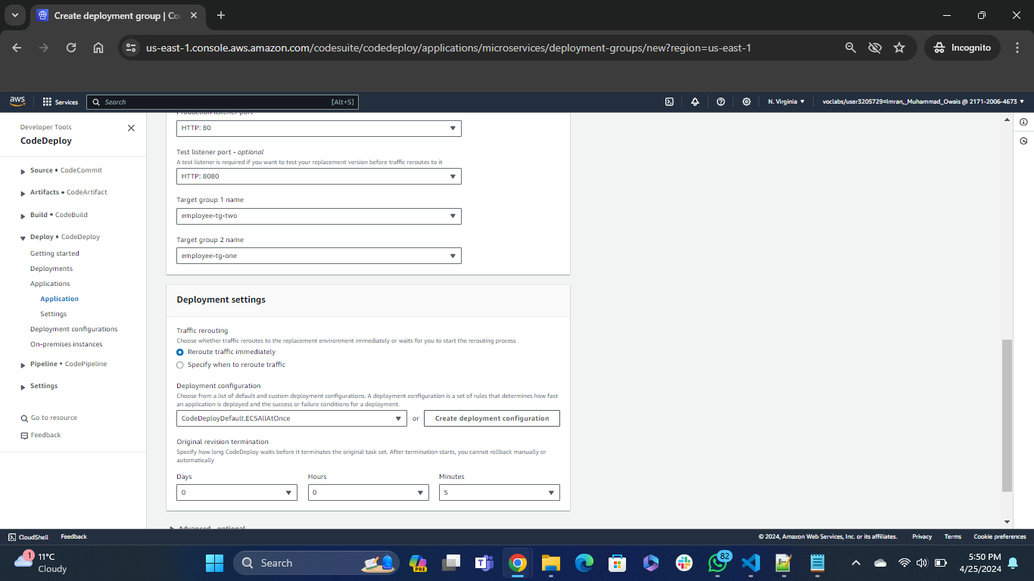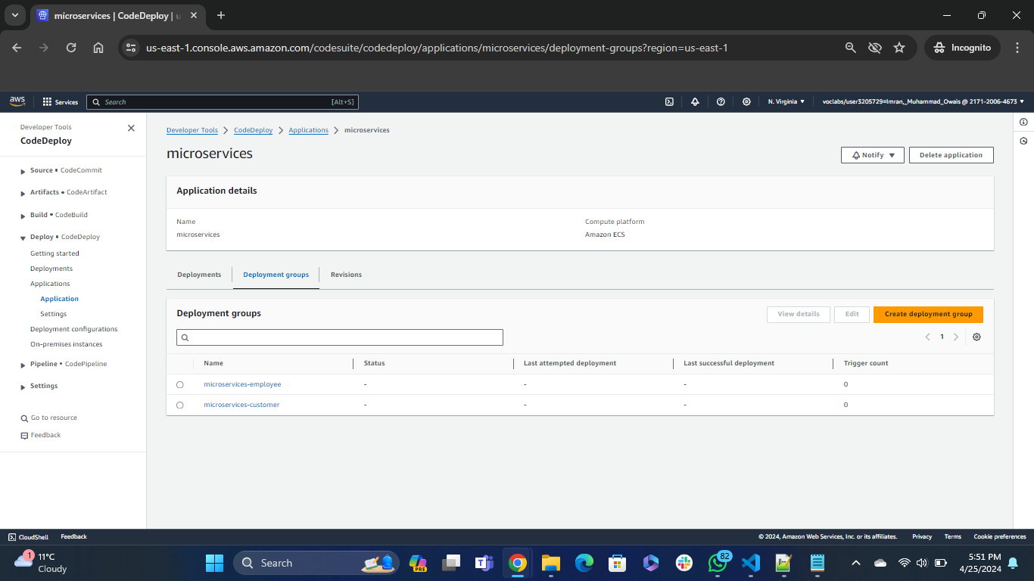

1. Create a Deployment Group for the microservices-employee using the above step and change

* Deployment group name to microservice-employee
* ECS Service Name to employee-microservice
* Target group 1 Name to employee-tg-two
* Target group 2 Name to employee-tg-one

### **Task 8.2: Create a pipeline for the customer microservice**

1. Create a Pipeline for Customer Microservice using the name update-customer-microservice.
2. Edit the *update-customer-microservice* pipeline to add another *source*.
   1. In the **Edit: Source** section, choose **Edit stage**, then add an action with these details:
      1. **Action name:** Image
      2. **Action provider:** Amazon ECR
      3. **Repository name:** customer
      4. **Image tag:** latest
      5. **Output artifacts:** image-customer
3. Edit the *deploy* action of the *update-customer-microservice* pipeline.
   1. Edit the **update-customer-microservice** pipeline
      1. In the **Edit: Deploy** section, choose **Edit stage**, then add an input artifact as described below:
         1. On the **Deploy Amazon ECS (Blue/Green)** card, choose the edit (pencil) icon.
         2. Under **Input artifacts**, choose **Add** and then choose **image-customer**.

**Note:** You should now have *SourceArtifact* and *image-customer* as listed input artifacts.

* + 1. Under **Dynamically update task definition image**, for **Input artifact with image details**, choose **image-customer**.
    2. For **Placeholder text in the task definition**, enter IMAGE1_NAME

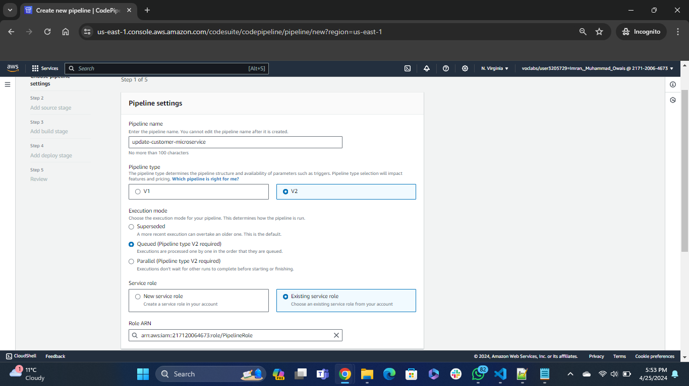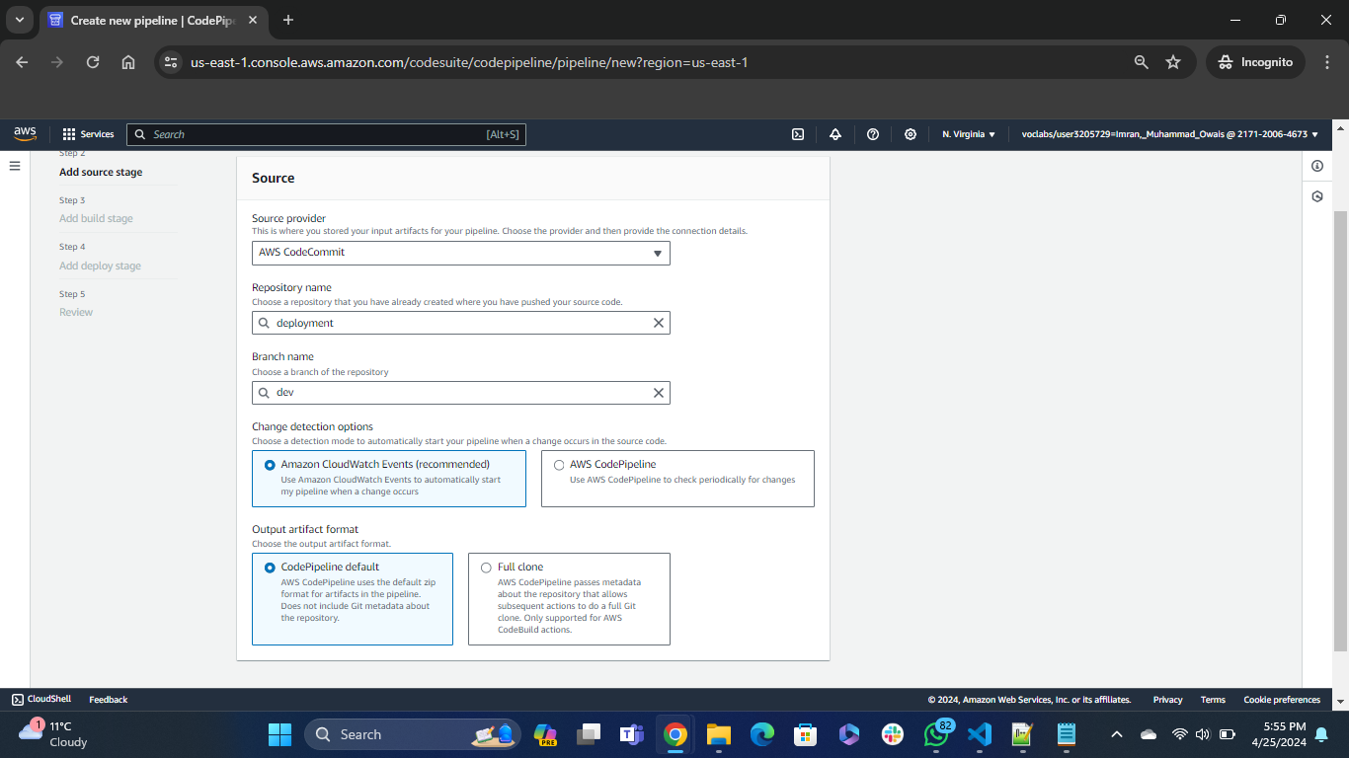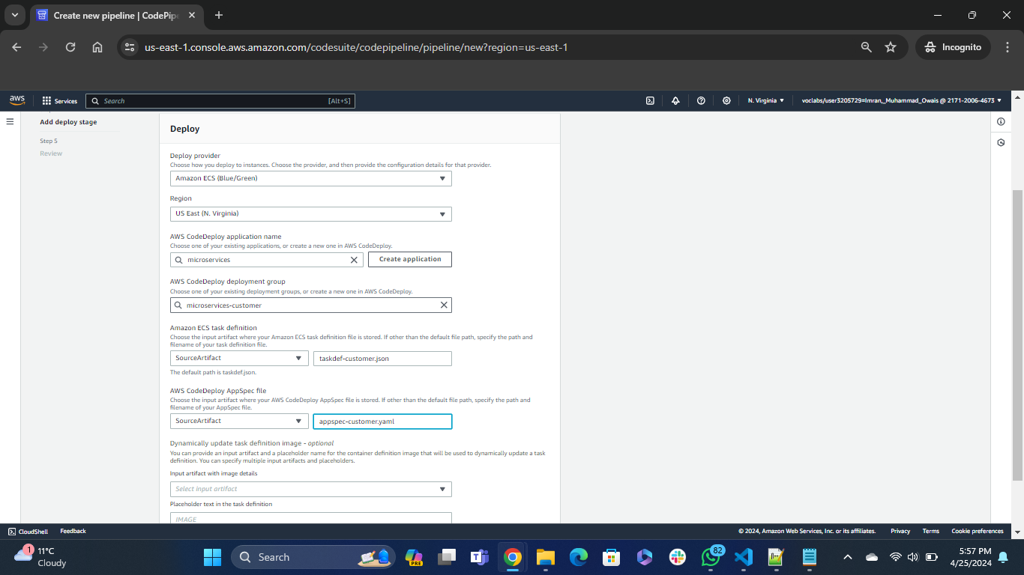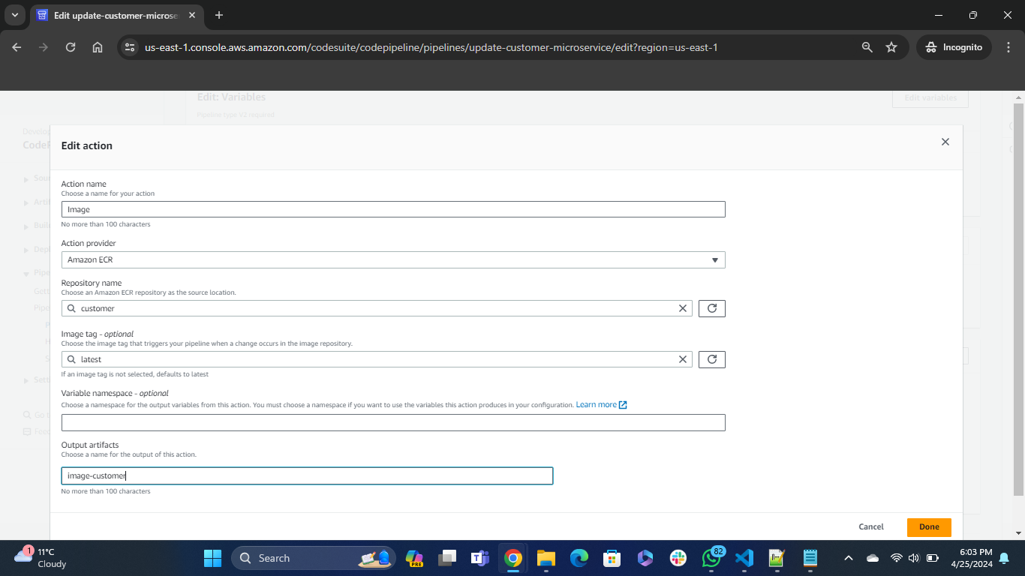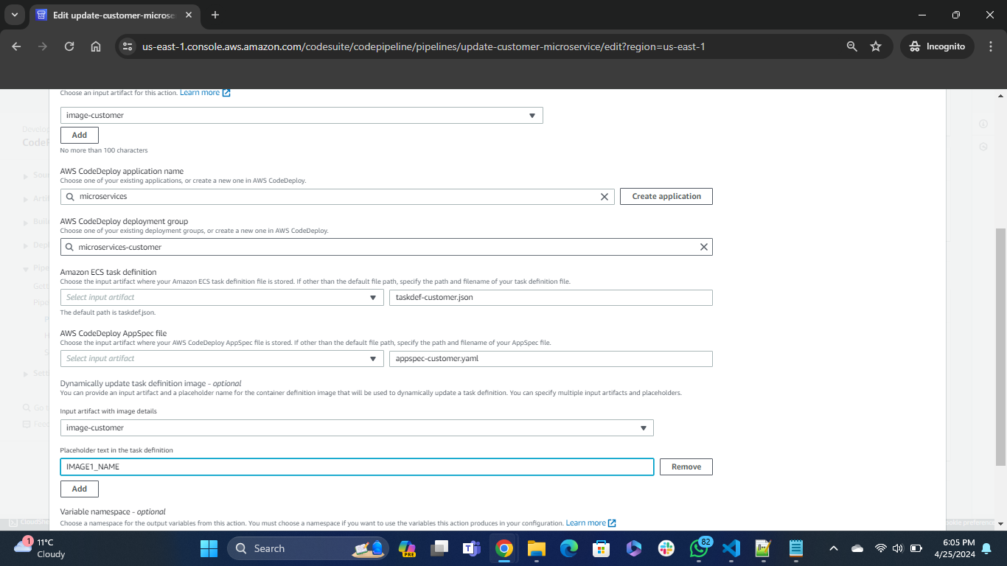

### **Task 8.3: Test the CI/CD pipeline for the customer microservice**

1. Launch a deployment of the customer microservice on Amazon ECS on Fargate by Clicking on Release Change on Codepipeline

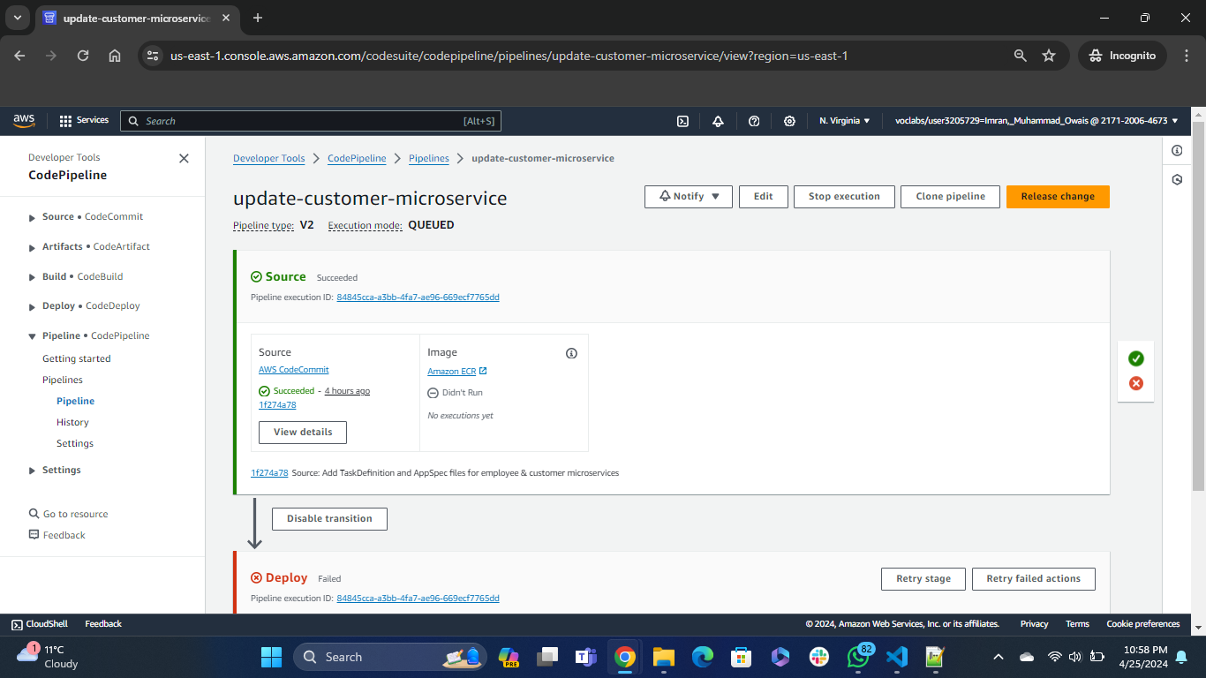

1. Observe the progress in CodeDeploy.

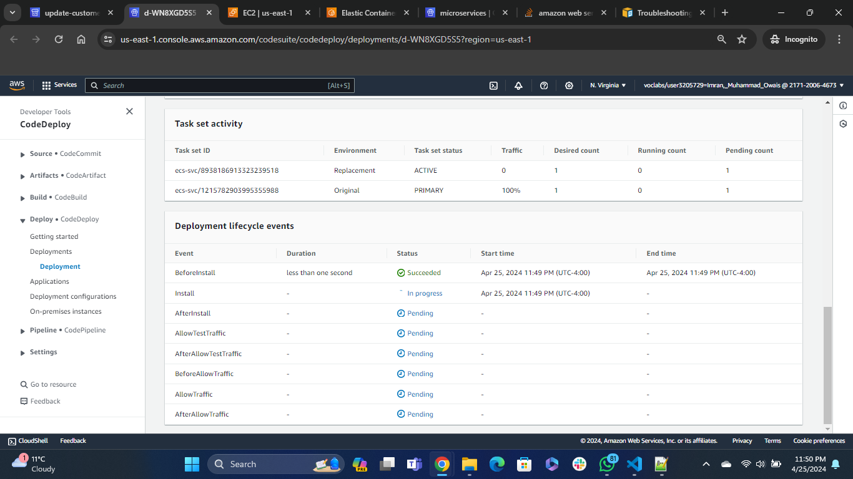

1. Load the customer microservice in a new tab and see if it is working properly by copying the DNS name of LoadBalancer.

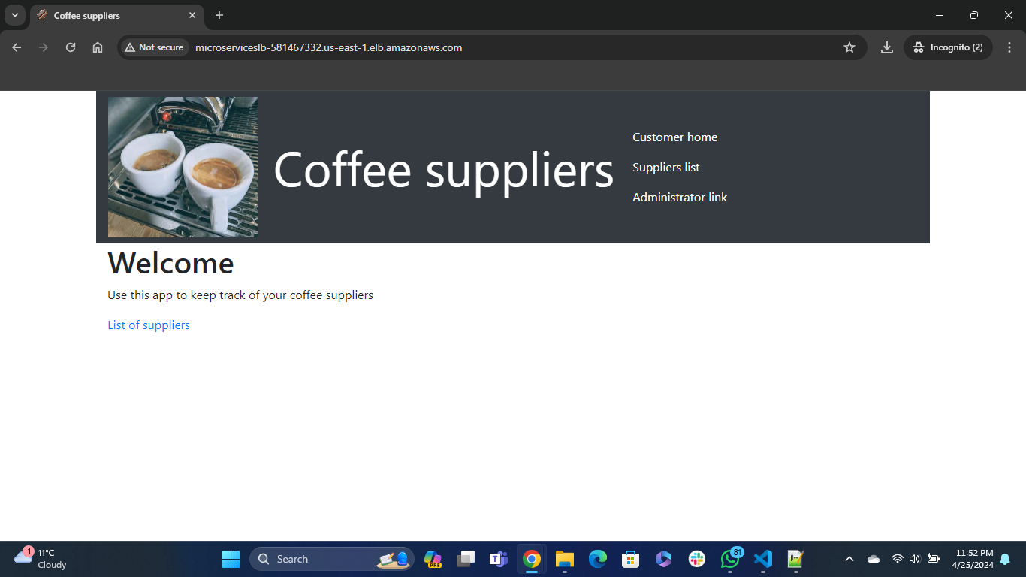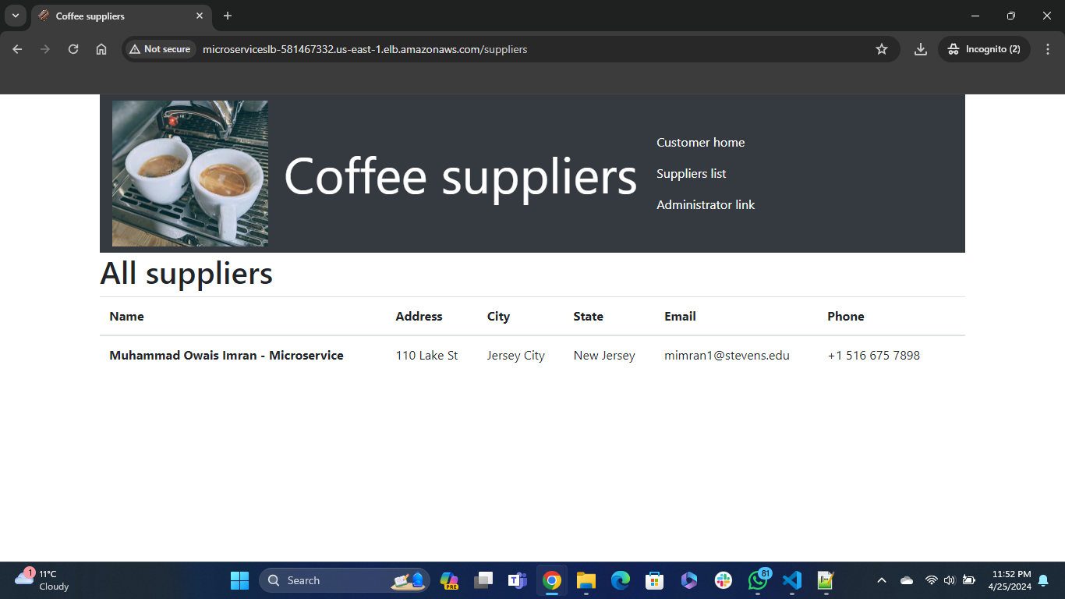

1. Observe the ECS cluster services and load balancer target group setting (we can see that the forward to option of both listener rule is now same due to traffic forwarding and test deployment successful

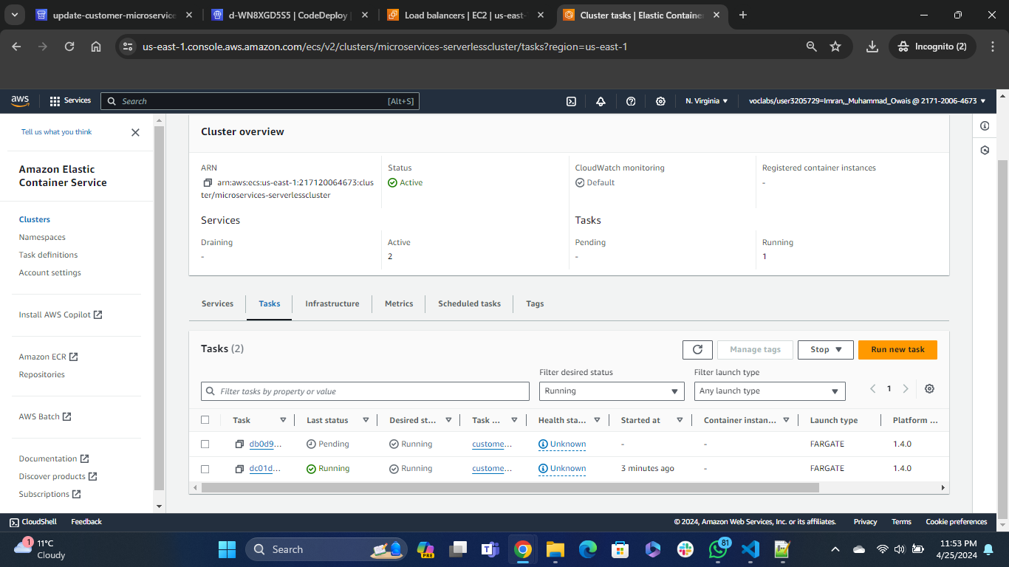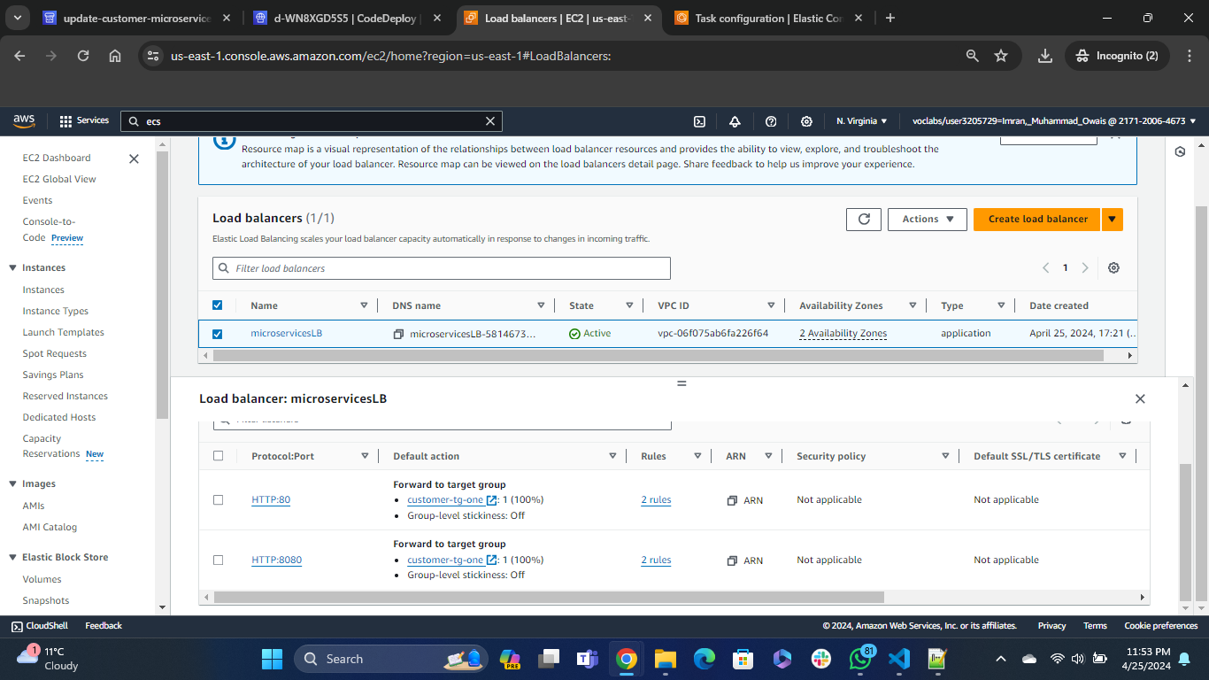

### **Task 8.4: Create a pipeline for the employee microservice**

1. Create a Pipeline for Employee Microservice using the name update-employee-microservice.
2. Edit the *update-employee-microservice* pipeline to add another *source*.
   1. In the **Edit: Source** section, choose **Edit stage**, then add an action with these details:
      1. **Action name:** Image
      2. **Action provider:** Amazon ECR
      3. **Repository name:** employee
      4. **Image tag:** latest
      5. **Output artifacts:** image-employee
3. Edit the *deploy* action of the *update-employee-microservice* pipeline.
   1. Edit the **update-employee-microservice** pipeline
      1. In the **Edit: Deploy** section, choose **Edit stage**, then add an input artifact as described below:
         1. On the **Deploy Amazon ECS (Blue/Green)** card, choose the edit (pencil) icon.
         2. Under **Input artifacts**, choose **Add** and then choose **image-employee**.

**Note:** You should now have *SourceArtifact* and *image-employee* as listed input artifacts.

* + 1. Under **Dynamically update task definition image**, for **Input artifact with image details**, choose **image-employee**.
    2. For **Placeholder text in the task definition**, enter IMAGE1_NAME

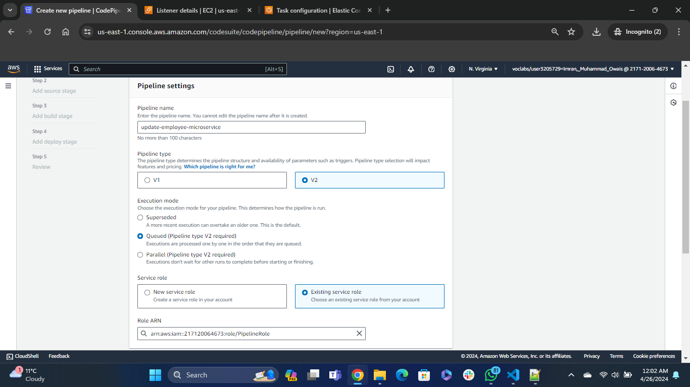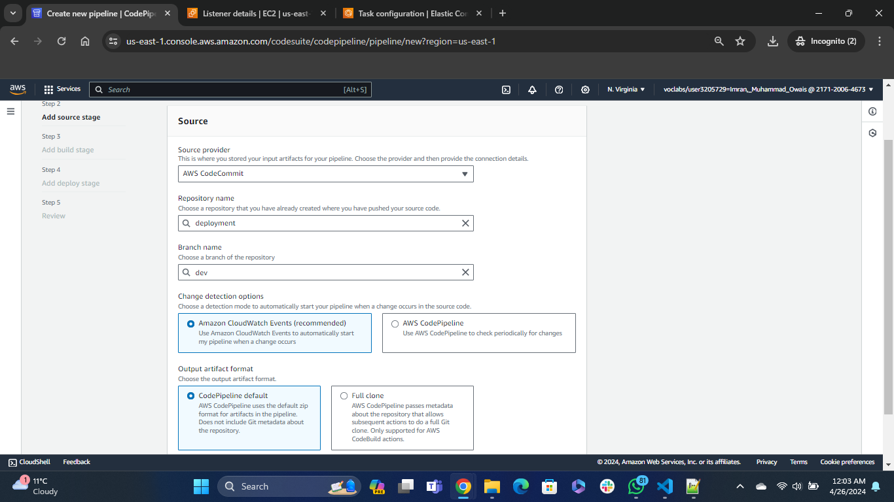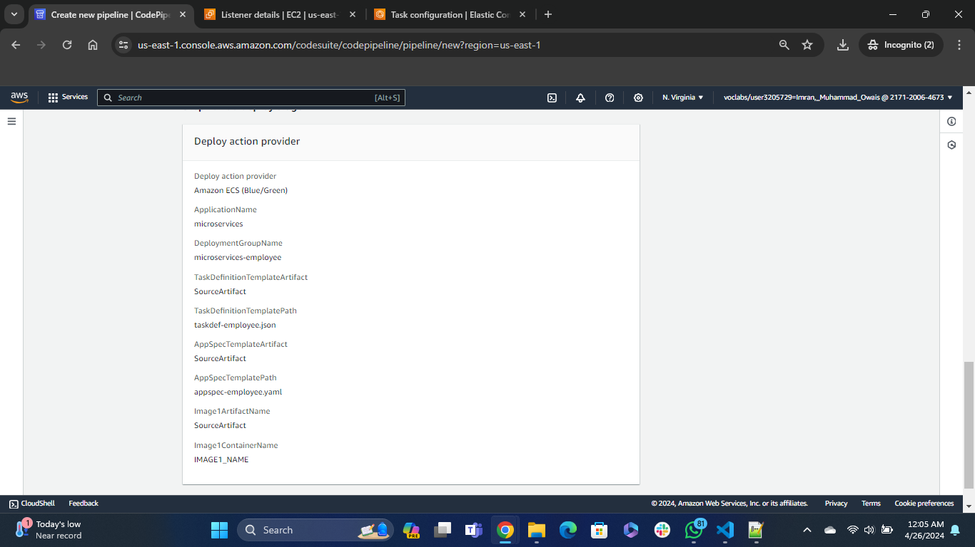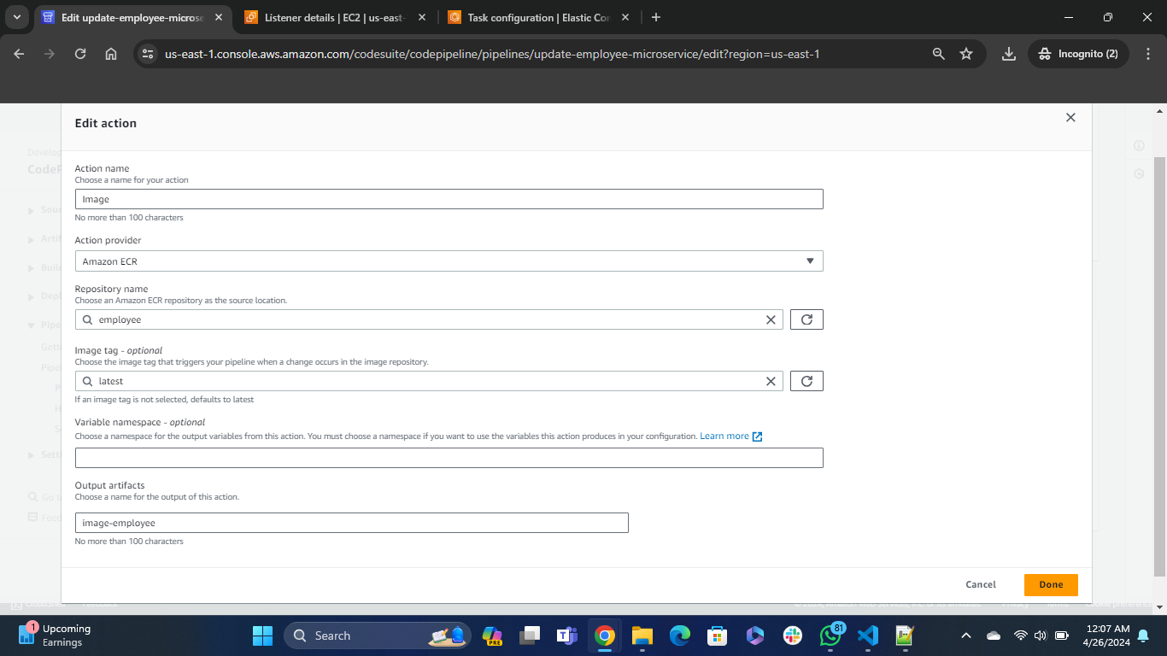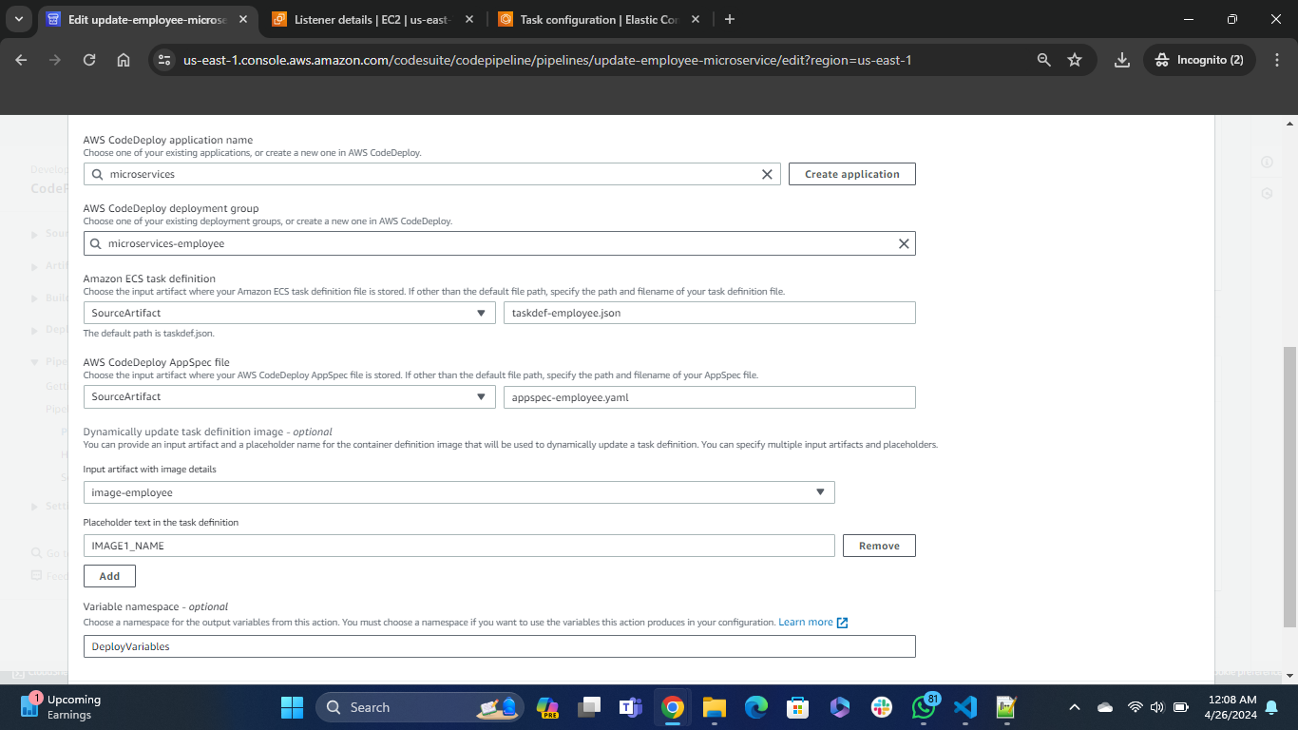

### **Task 8.5: Test the CI/CD pipeline for the employee microservice**

1. Launch a deployment of the employee microservice on Amazon ECS on Fargate by Clicking on Release Change on Codepipeline

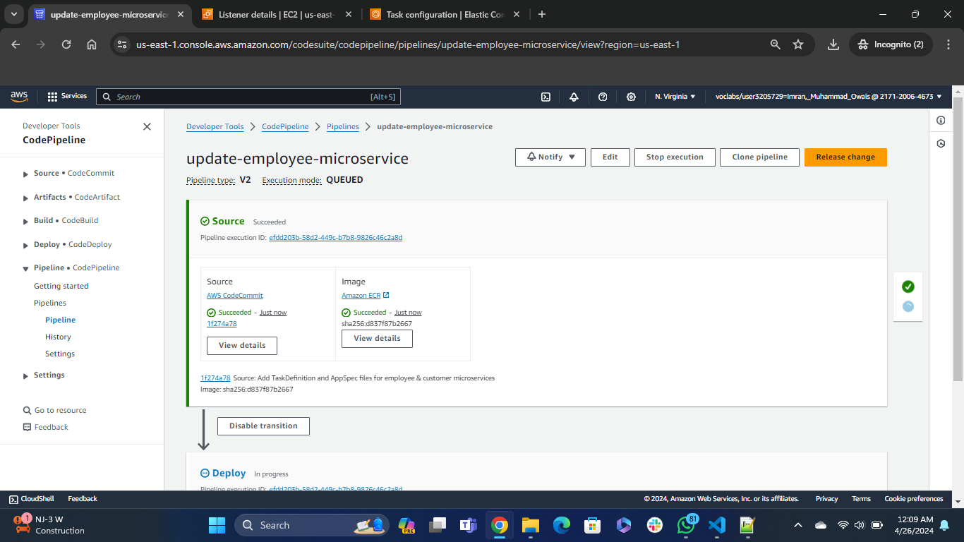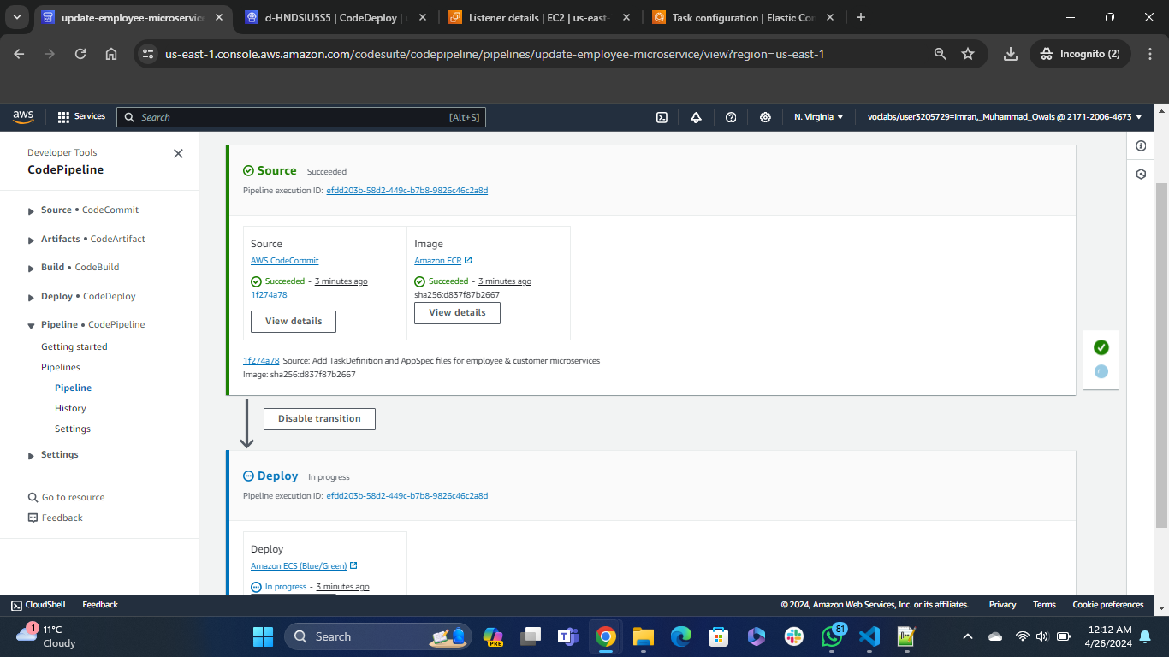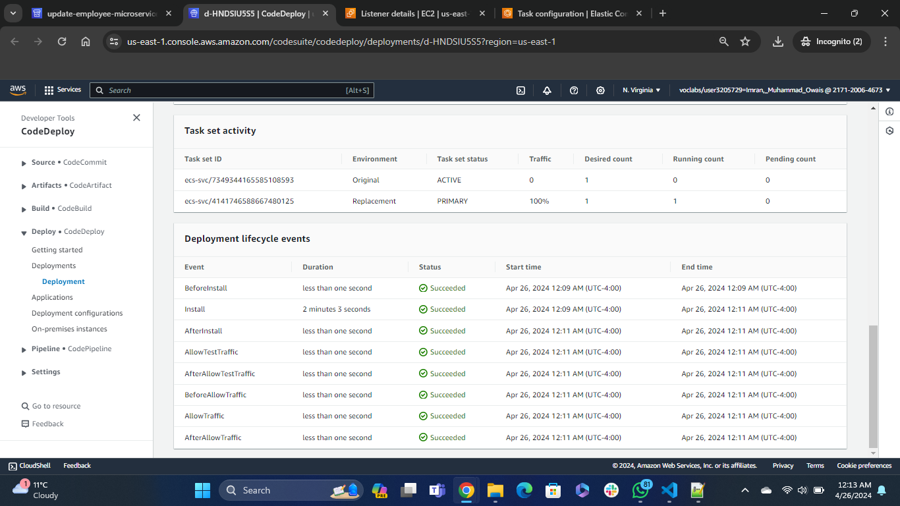

1. Check if admin link is working properly

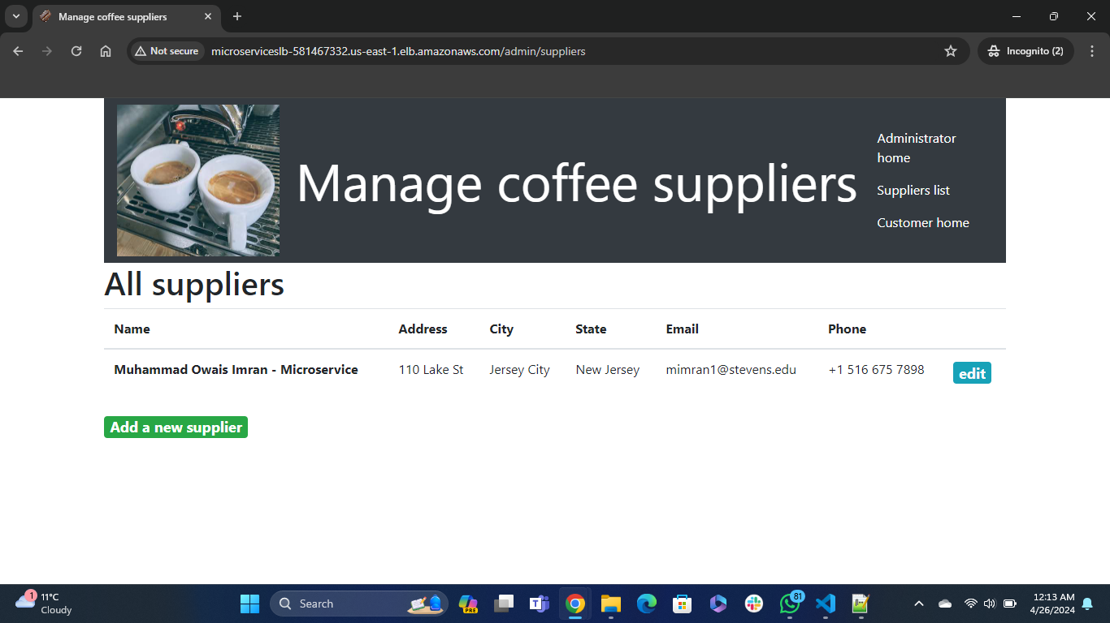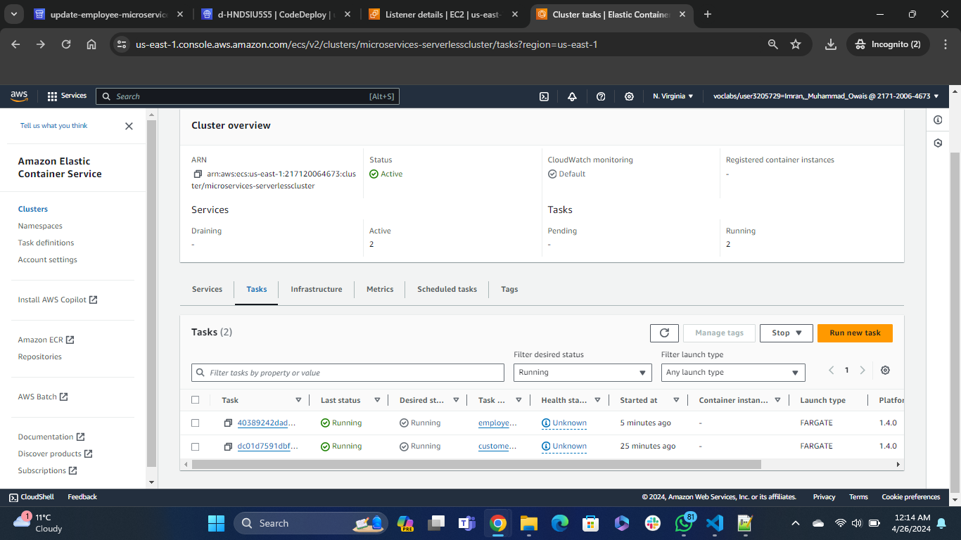

### **Significance & Importance of this Task**

This task helps us in implementing:

* How to automate this entire application deployment process with zero interaction of the developers with the production environment.
* The infrastructure and workflow of AWS CodePipeline and its integration with AWS CodeDeploy, AWS ECR, and AWS CodeCommit.

## **Phase 9: Adjusting the microservice code to cause a pipeline to run again**

### **Task 9.1: Limit access to the employee microservice**

1. Edit the rules for HTTP: 80 and HTTP:8080 listener rules to restrict access to /admin/* routes to your IP address only.

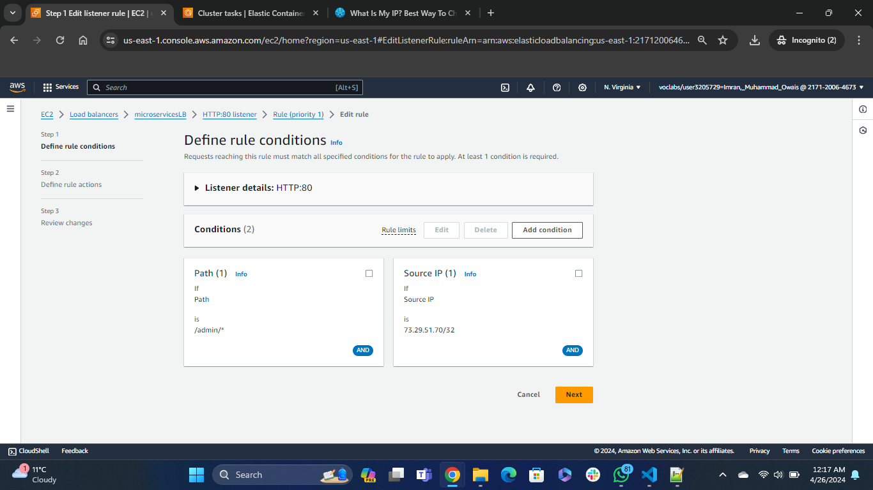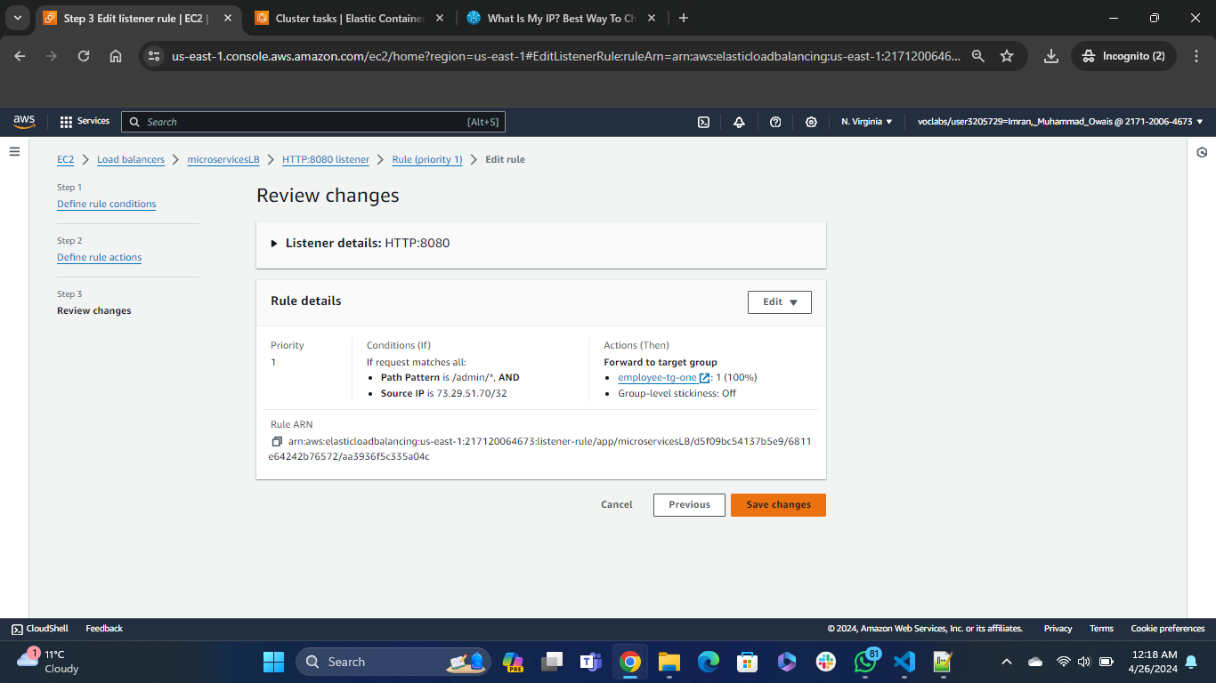

### **Task 9.2: Adjust the UI for the employee microservice and push the updated image to Amazon ECR**

1. Adjust the navigation bar theme of employee microservice from light to dark, and create a new docker image, and push the newly created docker image onto ECR to detect this change.
2. 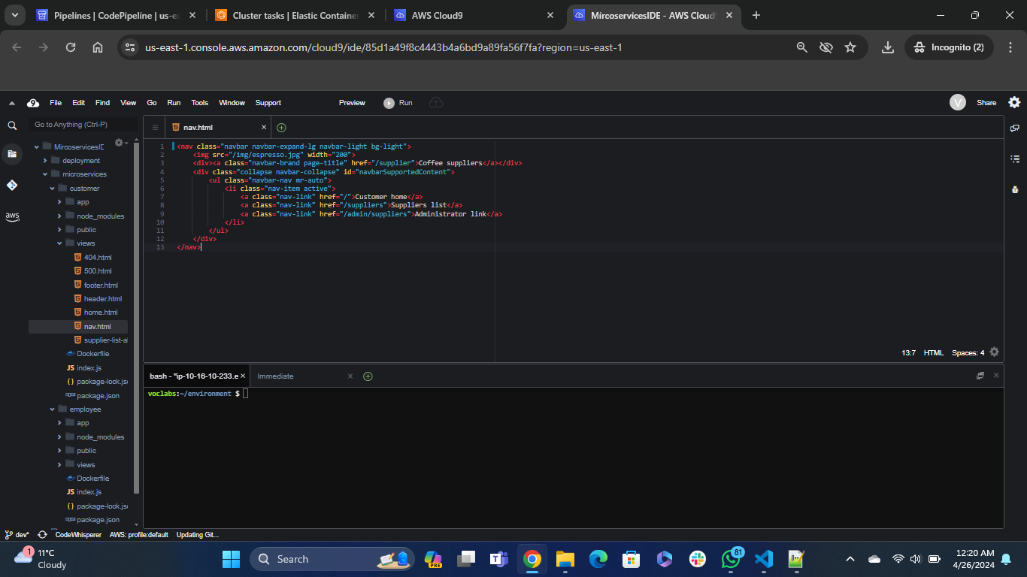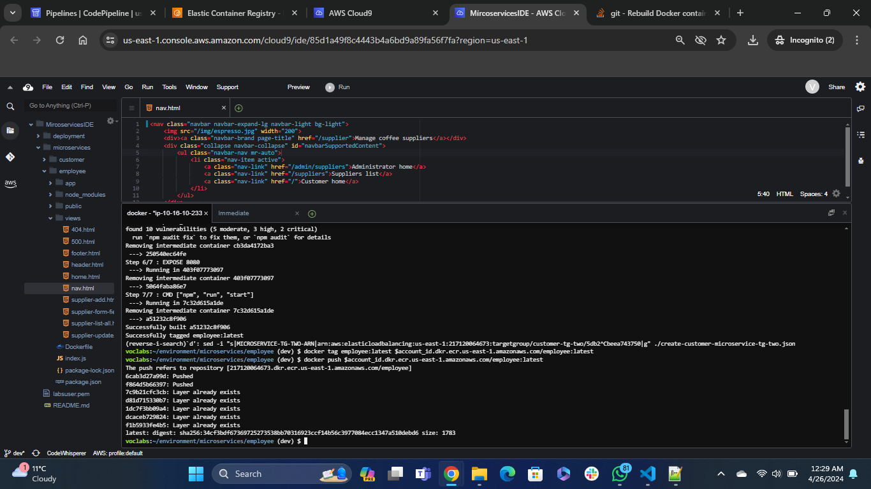

### **Task 9.3: Confirm that the employee pipeline ran and the microservice was updated**

1. Observe that the employee pipeline run was executed.

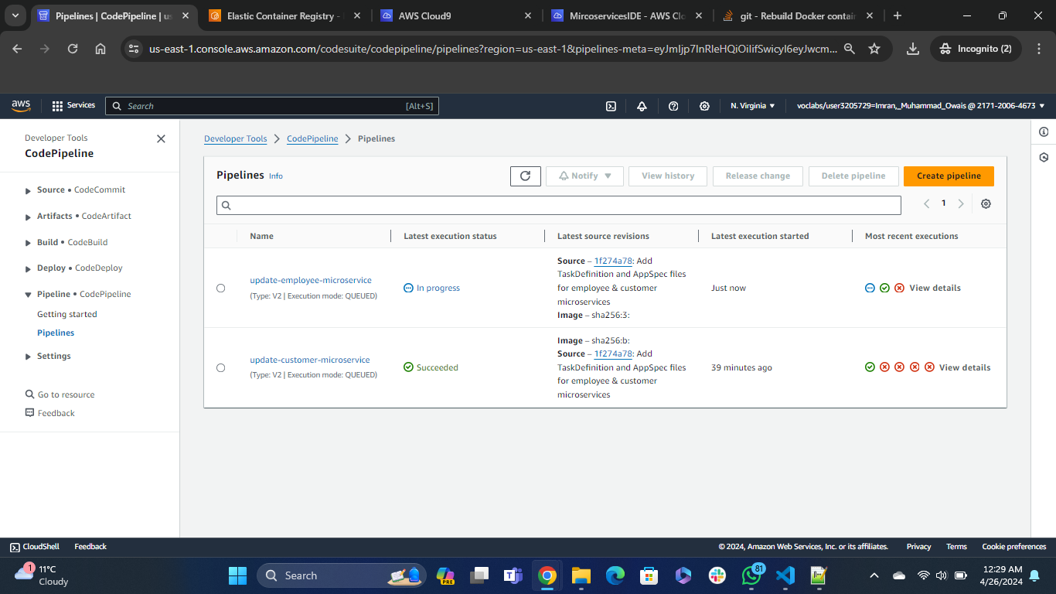

1. Verify after successful run, image was uploaded onto ECR.

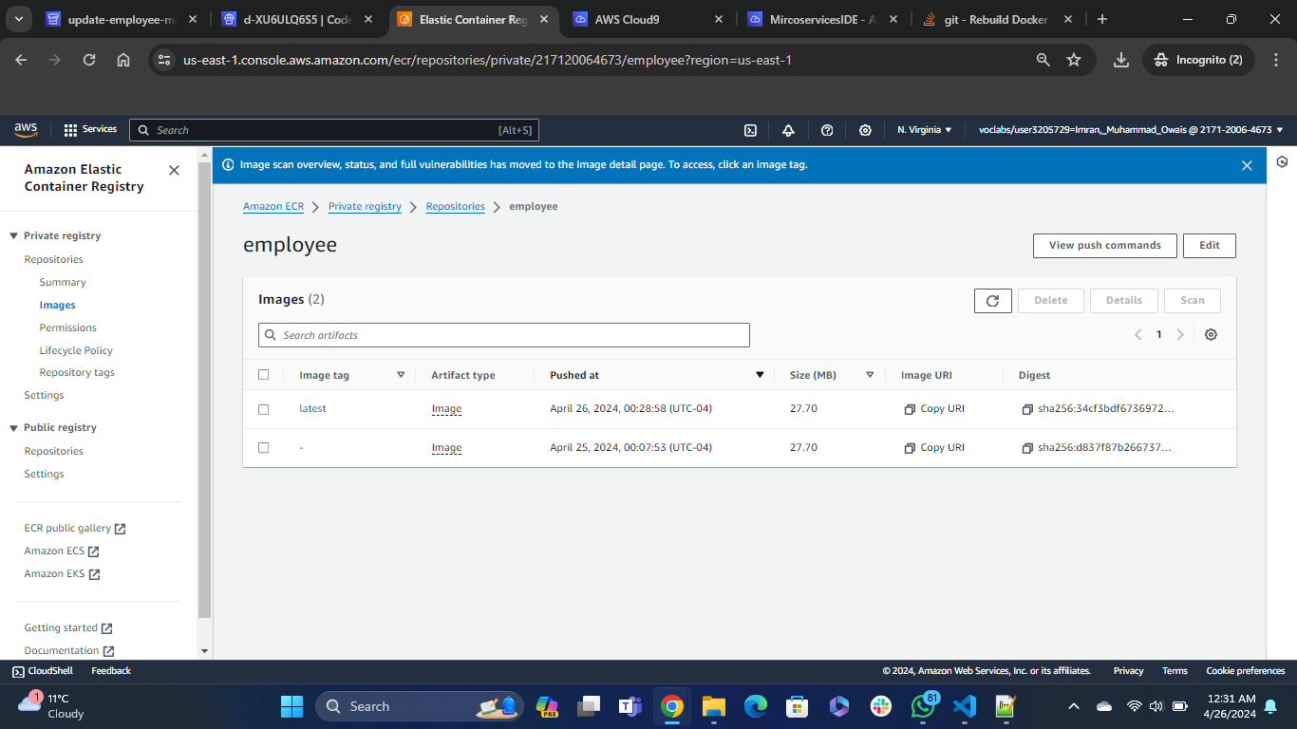

### **Task 9.4: Test access to the employee microservice**

1. Access website with the same machine IP

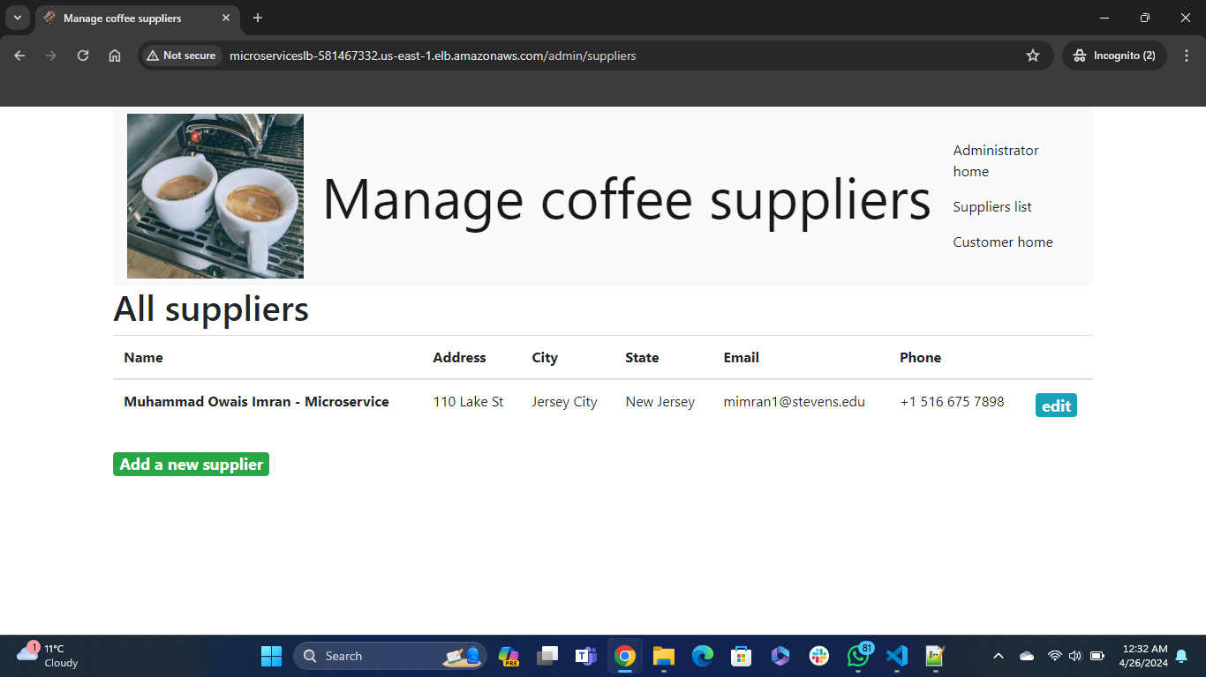

1. Access website with another device allocated a different Public IP

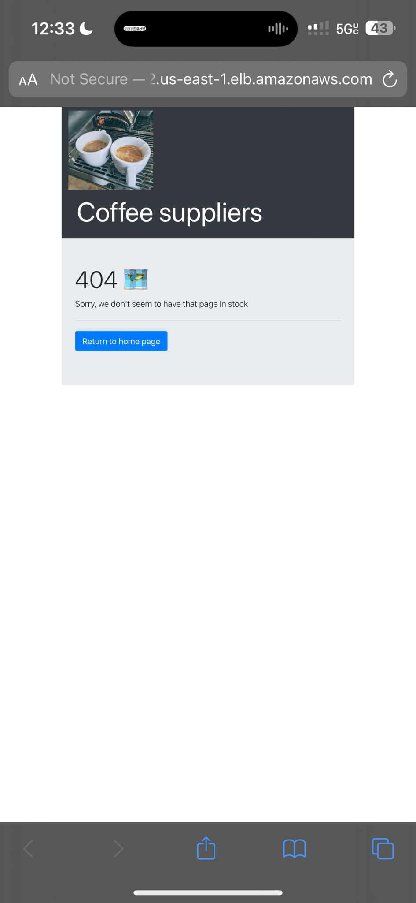

### **Task 9.5: Scale the customer microservice**

1. Update the customer microservice to run 3 containers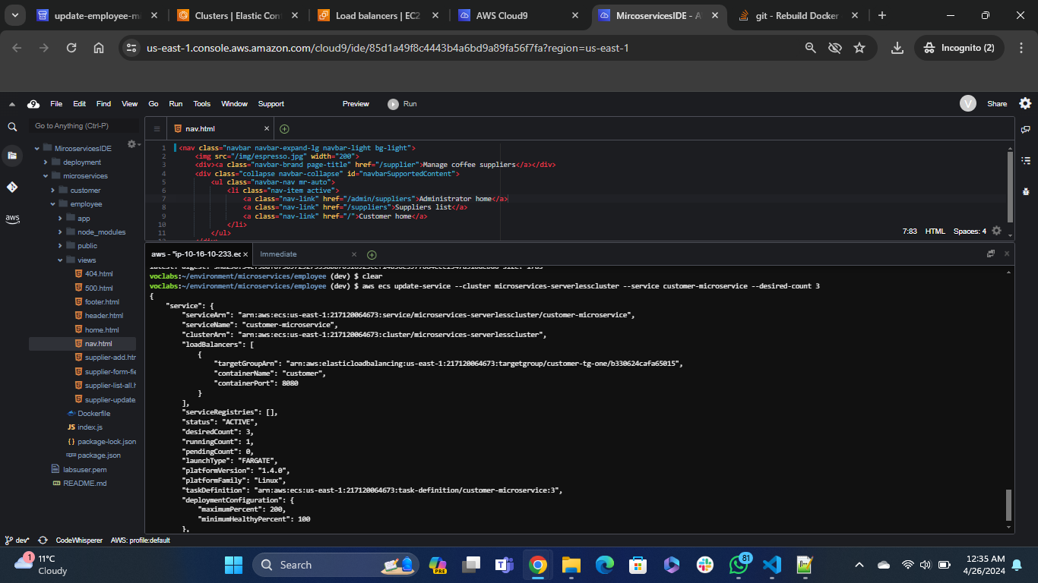
2. Check the change in ECS Tasks, we can see for customer service, running task are now x/3

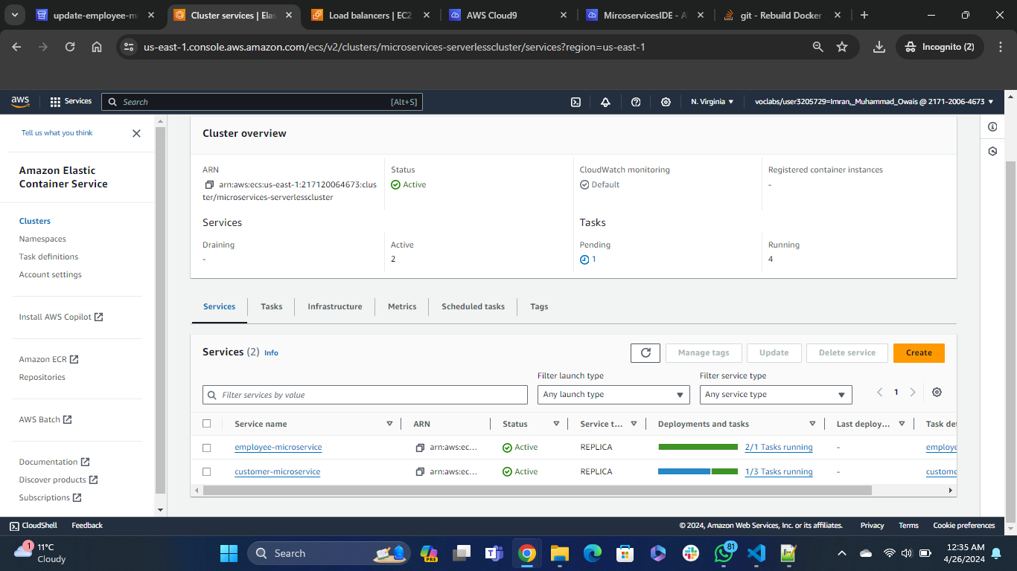

### **Significance & Importance of this Task**

This phase prepares us and gives us an overview of the immense power of AWS ECS and its services in terms of scalability and flexibility. It helps in realizing how easily we can upscale an application without doing any difficult server-side configuration. We just need to run a simple command, and within a few moments, our application can be scaled easily.

Moreover, we also learnt how microservice can help in upscaling a specific part of application as compared to monolithic architecture.

Example, the supplier part is something where the admin is responsible for adding/updating/deleting data, this part of application won’t be used by most of the application users, however the customer facing side can have a huge user base. So, if we were to use a monolithic architecture, we have to upscale the entire application, which would upscale the admin part of application as well, which won’t have any positive impact on resource consumption.